Deviation from ASME III Code rules for the design of Research Reactors

M. Wesley¹, R. Cocco¹

1) INVAP S.E, Av. Cmte. Luis Piedrabuena 4950, R8403CPV, S.C. de Bariloche, Argentina

Corresponding author: mwesley@invap.com.ar
rcocco@invap.com.ar

Abstract.

ASME Code, Section III: Rules for Construction of Nuclear Facility Components, is a code for Nuclear Power Plants (NPP). Then materials, stress limits and other design parameters are based on high pressure and high temperature requirements of NPP environment. The requirements of Research Reactor (RR) are in many cases antagonist to NPP requirements. The low temperature and low pressure environment conditions of RR are far less exigent than in NPPs. Present work shows two examples where the mechanical design in RR is made under ASME III code guidelines but some particular considerations were taken. First case is the determination of stress intensity values (σadm) when the selected material is not considered among materials in ASME II. The second one is the application of the fracture mechanics analysis given in ASME III and ASME XI, Appendix G when the construction material of the pressure vessel is not ferritic steel and the wall thickness is well below the minimum value of 102 mm, then the code´s postulated defect of 25mm lacks of physical sense.

1. Introduction

The requirement of nuclear reactors for power generation and nuclear research reactors (RRs) are different and in some point antagonist. The main goal of first one is generate heat and steam which move the turbines for electric power generation in a nuclear power plant (NPP). The main goal of second ones is to be neutron sources which are used for scientific experiments. Then, operation conditions are different. Reactors of NPPs work at elevated temperature and pressure, necessary for steam generation, whereas RRs work at low temperature, below 100°C, and generally at low pressure.
Mechanical design of the pressure retaining boundary in NPPs must withstand the demanding operating conditions; this is translated in high strength materials, good toughness and robust design with high wall thickness. On the contrary, mechanical design of RRs must minimize the neutron capture and provide structural support simultaneously. Then, selection of material with as low as possible neutron absorption cross section is the main characteristic to be complied and second optimizing wall thickness according to the material strength.
Standards and codes for power plant were adapted for NPPs, tanking in account special requirement giving origin to codes like ASME, section III [1] from EE.UU or KTA from Germany [2]or CAN/CSA-N[3] series for CANDU reactors. These codes have evolved along the time and they are very well established. However there are no well-established codes for research reactors and traditionally NPP codes are taken as guideline.
ASME Code, Section III: Rules for Construction of Nuclear Facility Components, is a code for Nuclear Power Plants (NPP) [1]. Then materials, stress limits and other design parameters are based on high pressure and high temperature requirements of NPP environment. Therefore, it wouldn’t be possible to follow strictly the ASME III code rules.
Present work analyze the case of a vacuum containment of a cold neutron source (CNS) designed as pressure vessel according to ASME III where some particular considerations were taken.

2. Case description

Cold Neutron Sources (CNSs) are systems that place cryogenically cooled moderators in the reflector of neutron sources. These cold sources shift the spectrum down in energy to a temperature somewhat above the moderator temperature, providing low energy neutrons. Schematic and generic design of CNSs is shown in FIG. 1. The facility include: the moderator chamber where cryogenic moderator is contained, a cooling system and a vacuum containment or thimble that contain the source.
The Vacuum Containment design has two main purposes:
- Provide a vacuum chamber enclosing the In-Pile components at cryogenic temperatures for thermal isolation.
- Confine the In-Pile elements in case of an eventual failure, in order to keep other core components in safe conditions.

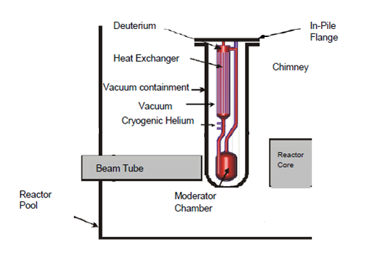

- Cold Neutron Source (CNS)

For some research reactor, the regulator requires an analysis on the effect of hypothetic explosion of a Deuterium-air mixture, independently of how may be the mechanism leading to such situation. Then, a fracture-mechanical analysis under emergency conditions load case, level C according to ASME III classification is analyzed [1].

2.1. Component description

The vacuum containment (VC) analyzed comprises a main cylindrical body, a torispherical bottom head, and a flange at the top end. The construction material is Zircaloy-4, Figure 2 shows VC geometry and main dimension.

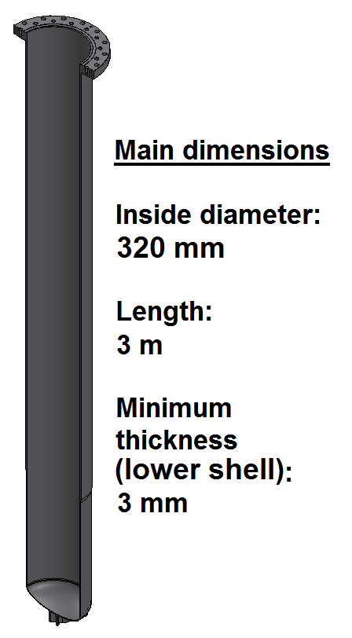

- Vacuum Containment (VC)

3. Fracture-Mechanical Analysis

Fracture analysis was performed following the ASME III- Appendix G [4] guidelines. The main steps are stated below:

- Identification of Critical Stress Intensity Factor (K_{IC}), obtained from the lower bound available tenacity experimental values.
- Identification of load case
- Very large defect postulation
- Estimation of applied K_{I}
- A safety factor of 2 is applied over the tenacity intensity factor (K_{I}), therefore 2K_{I}+K_{1t}<K_{IC}. The variable K_{1t} represents the intensity factor that corresponds to stresses from temperature differentials in the vessel thickness.

3.1. Fracture toughness and mechanical properties

The elected alloy of VC is Zircaloy-4. This Zirconium alloy is widely used in nuclear industry and mechanical properties and fracture toughness is well characterized under irradiation conditions.
In TABLE 1 mechanical properties of Zry-4 are shown. Lower bound fracture toughness (K_{IC}) in no-irradiated and irradiated conditions is presented [5,6].

- Mechanical properties of Zircaloy-4
Property | No irradiated Condition
Elasticity Modulus (E) | 99,3 GPa
Poisson Coefficient () | 0,37
Tensile Stress ( | 415 MPa
Ultimate Stress ( | 240 MPa
K_{IC} | 38 MPa
K_{IC} (irradiated condition) [3] | 27 MPa

3.2. Load cases definition

Fracture-mechanical analysis under emergency conditions load case, level C according to ASME III classification is analyzed [1]. This case consists on equivalent internal pressure of 1600 kPa due to a deuterium-air reaction.
First verification performed is that vessel stresses under accidental internal pressure are below admissible service limit.
The values for σ_{adm} should be extracted from ASME Section II Table 1-B Nonferrous materials [7]. Although 705 and 702 alloys from Zirconium family alloys are considered in Table 1-B, Zry-4 is not contemplated. Then, Table 1-100 from reference [8], which specifies the rules to determine the admissible values of table 1-B, was taken as base to define the service limit for Zry-4. Therefore, the admissible stress was obtained from:

For Zircaloy-4 the σ_{adm} value is 118 MPa. TABLE 2 shows the service limit criteria for Level C of service according to ASME III [1] and the values for Zry-4.

- Admissibility criteria for Level C according to ASME III
Service Level | Service Limit |  | Zry-4 Values [MPa]
Level C | Membrane | σm ≤ 1.5 σadm | ≤ 177
Level C | Membrane+ Bending | σm + σb ≤ 2.25 σadm | ≤ 212

In FIG. 3 and FIG. 4 stresses produced by internal pressure in the VC are presented.

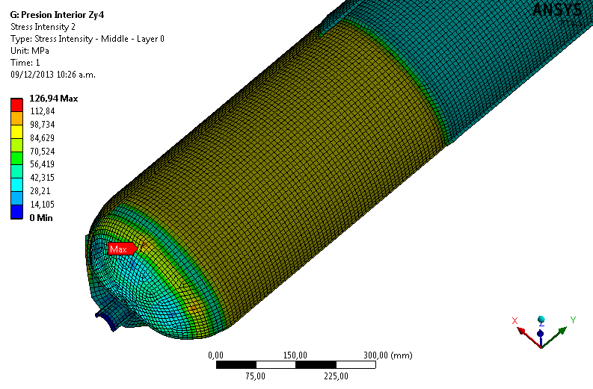
- Detailed view of membrane stresses. Deformation is enlarged 50 times.

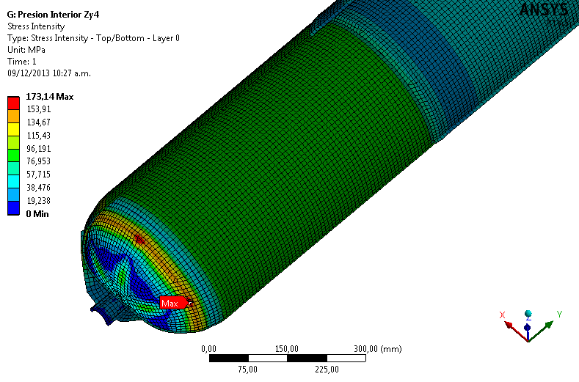
- Detailed view of membrane + bending stresses. Deformation is enlarged 50 times.

FIG. 7 indicates that membrane stress in the lower shell is around 100 MPa, and FIG. 6 indicates that the Membrane + Bending stresses in the head and cylindrical part welding is around 150 MPa. TABLE 3 summarizes the results and it can see that stress admissibility criteria are fulfilled for level C load case.
- Stresses in thinner shell of VC
Stress | Value | Criterion | Fulfill
Membrane | 100 MPa | ≤ 177MPa | Yes
Bending | 50 MPa | No Apply | No Applay
Membrane + Bending | 150 MPa | ≤ 212 MPa | Yes

Then, it is assumed that the defect is located in the most unfavorable zone where the thinner cylindrical shell is welded to the bottom head and where maximum stresses are generated.

3.3. Postulated defect

Article G-2120 of ASME III Appendix G [4] establishes the characteristic defect to be postulated. The defect orientation is axial for plates welded axially and orientated circumferentially for circumferential welds. Defect is assumed to be semi-elliptic with sharp points, see FIG. 5.
- Elliptical flaw model, figure taken from reference[4]
The adopted flaw characteristics taken from references correspond to pressure vessels made of thick walls of ferritic steels. The G-2120 article state that: a) for section thicknesses of 4 in. to 12 in. (102 mm to 305 mm), the postulated defects have a depth of one-fourth of the section thickness and a length of 1,5 times the section thickness, b) for sections less than 4 in. (102 mm) thick, the 1 in. (25 mm) deep defect is conservatively postulated.
The wall thickness of VC is 3mm, well below 4 inch (102mm) and the recommended postulated defect depth (25 mm) lacks of physical sense. The article G-2120 article also indicates that smaller defect sizes may be used on an individual case basis if a smaller size of maximum postulated defect can be ensured.
Therefore, a validation analysis of postulated defect is needed for the present study case. As first step, a reference postulated defect following the indications of article G-2120 is established. The postulated flaw has a length of 1,5 thickness and a depth of ¼ thickness. For a wall thickness of t = 3 mm, flaw dimensions are:

  - Length: l = 1,5 x t = 4,5 mm
  - Depth: a = 0,25 x t = 0,75 mm
Then, in order to evaluate the influence of geometry on K_{I} other geometrical proportions a/l were considered (see FIG. 6).

- (reference defect)
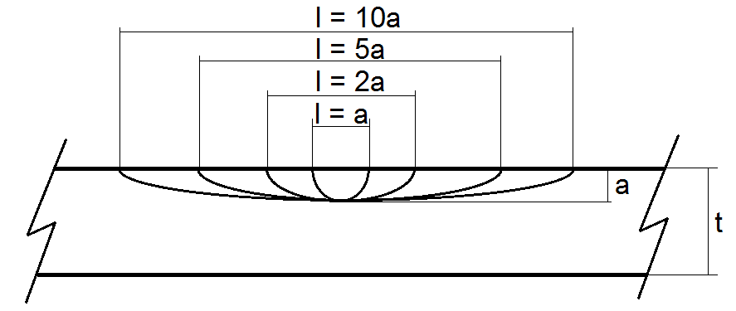
- Geometries of analysed flaws

3.4 Estimation of applied K_{I} method

For calculation of K_{I}, Appendix G take in consideration only wall thickness vessel higher than 1 inch (102mm). Then, methodology from ASME XI Appendix A Article-3000 Method for K_{I} determination [9] was taken as guideline. Article 3320 describes the elliptic flaw characteristics and the equations to estimate the stress intensity factor:

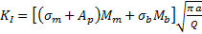 | (1)

Where and are membrane and bending stresses, and are shape factors, is a coefficient that applies in interior faces of pressure vessels, is the flaw depth and a falw´s shape factor calculated according to equations 2 and 3:
 | (2)
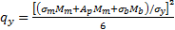 | (3)

Previous equations consider stress linealization along the thickness next to the flaw. In real stress distribution is not lineal, but as a conservative hypothesis a linear equivalent distribution is assumed.
and shape factors depend on coefficients and that correspond to surface defects and are obtained from Table A-3320-1 in reference [9].
(6)
(7)

3.5 Admissibility criterion

In Appendix G article G-2215 [4] the admissibility criterion is stated as:
(1)
Where resulting from general primary membrane stress due to pressure, and corresponds to thermal stresses.
In this analysis no thermal gradients effects in the load case will be considered given the thin wall thickness and good thermal conductivity of Zry-4. Then, the admissibility criterion is:
(2)
A safety factor of 2 over the applied K_{I} is imposed.

3.6 Results and discussion

In TABLE 4 it is shown the results for reference postulated flaw following Article G-2120 of ASME III Appendix G [4] and FIG. 7 shows the parametric analysis of the evolution of K_{I} with crack depth (a) for different aspect ratio (a/l).

- Results of stress intensity factors
Material condition | K_{I} | 2 K_{I} | K_{IC} | Fulfill
Irradiated | 7,72 MPa | 15,44 MPa | 27 MPa | YES

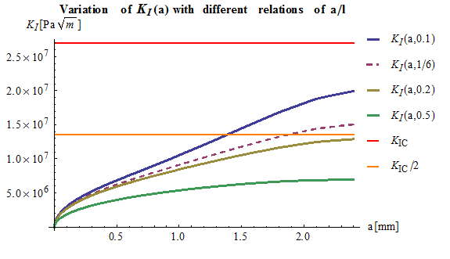
a = 1.85 mm
a = ¼ t = 0.75 mm
- Variations of K_{I} with flaw geometry
Variations of flaws depth is extended up to 80% of thickness (2,4 mm) using geometrical factors G₀ and G₁ from Table A-3320-1 in reference [9]. The red horizontal line shown in FIG. 7 indicates the admissible value of K_{IC} of Zircaloy-4, the orange horizontal line indicates the value given by admissible criterion indicated in article G-2215 of Appendix G [4] code: , or the equivalent .
All analyzed flaw geometries shown in FIG. 7 are stable since any of them exceeded the critical value of stress intensity factor K_{IC}. Semicircular flaws, a/l=0.5, are more stables than semielliptical flaws and applied K_{I} increase when a/l diminish or the length of the crack increse.
The maximum crack depth is given by the intersection of curves K_{I} (a,a/l) and K_{IC}/2. According to the admissibility criterion the maximum admitted depth for a “long” flaw with a/l = 0,1 (l = 10 a) is 1,4 mm whereas for a semicircular flaw any of the crack depth considered, a, reach the admissible limit. For the reference flaw shape with a/l = 1/6 the maximum admissible depth is 1,85 mm given by the intersection of curves K_{I}(a,1/6) and K_{IC}/2.
On other hand for reference flaw depth, the assumption of a longer flaw no implies an important change in the applied K_{I} value. However the variation depth has more influence on the applied K_{I} value. This analysis can help to establish the admissible defect for non destructive inspection according to the ability of the different non destructive method to detect the defect.
From the analysis it can be seen that the reference postulated defect following the guidelines of Appendix G from ASME III code has enough conservatism degree and the component analyzed preserves its structural integrity when subjected to the design basis accident of air-deuterium accident with the postulated defect. Therefore in the most severe load case corresponding to the accidental air-deuterium reaction, VC structural integrity is guaranteed considering the reference postulated defect.

4. Summary and conclusions

The study has presented two examples where the mechanical design in RR was made under ASME III code guidelines but some particular considerations were taken.
First case was the determination of stress intensity values (σadm) for Zry-4 due to this alloy was not considered among materials in ASME Section II Table 1-B Nonferrous materials. Then, Table 1-100 from ASME II, Part D - Properties, Appendix 1, which specifies the rules to determine the admissible values of table 1-B, was taken as base to define the service limit for Zry-4 at service temperature.
The second one was the application of the fracture mechanics analysis given in ASME III and ASME XI, Appendix G for pressure vessel. Main deviation from Article G-2000 were:
- Construction material is not Ferritic alloy
- Wall thickness of pressure vessel (3mm) is well below 1 inch (102 mm)
- Minimum postulated defect depth 1/4 inch (25 mm) lacks physical sense
However the concepts behind the methodology, K_{IC} obtained from the lower bound available from experimental values, to postulate very large defect and a safety factor of 2, still valid and each deviation was overcome:
- Fracture toughness characteristics for Zry-4 in irradiated condition is known
- ASME XI Appendix A Article-3000 Method for K_{I} determination was used for calculus of applied K_{I}
- A parametric analysis was made in order to validate the geometry and size of postulated defect, length of 1,5 thickness and a depth of ¼ thickness.
Therefore, from the analysis it was proven that Appendix G from ASME III code as guideline has enough conservatism degree and the component analyzed preserves its structural integrity when is subjected to the design basis accident.

5. References

- ASME Section III - Division 1 - Rules for Construction of Nuclear Facility Components
- KTA 3201- Components of the Reactor Coolant Pressure Boundary of Light Water Reactors
- CSA-N285- General Requirements for Pressure-Retaining Systems and Components in CANDU Nuclear Power Plants
- ASME Section III - Division 1 - Rules for Construction of Nuclear Facility Components – Appendices - APPENDIX G PROTECTION AGAINST NONDUCTILE FAILURE
- L.D Blackburn, D.G Farwick, S.R Fields, L.A James, R.A Moen, “Maximum allowable temperature for storage of spent nuclear reactor fuel” HEDL-TME 78-37/UC-70.
- Metals Handbook, Vol.2 - Properties and Selection: Nonferrous Alloys and Special-Purpose Materials, ASM International 10th Ed. 1990.
- ASME Section II - Part D - Properties – Materials- Subpart 1- Stress Tables
- ASME Section II- Part D - Properties, Appendix 1, Table 1-100
- ASME Section XI - Division 1 - Rules for Inspection and Testing of Components of Light-Water Cooled Plants- APPENDIX A- Article-3000 Method for KI determination

