IRRADIATION CAPSULE DESIGN TO SUPPORT DOE RESUMPTION OF US ⁶⁰Co ISOTOPE PRODUCTION
¹R. Howard, ¹B. Schnitzler, ²M. Sprenger, ²L. Soderquist

1) Oak Ridge National Laboratory, Oak Ridge, TN 37831, USA
2) Idaho National Laboratory, Idaho Falls, ID 83402, USA

Corresponding author: howardrh@ornl.gov

The project was funded by the United States Department of Energy Office of Science by the Isotope Program in the Office of Nuclear Physics.

Abstract:

The ⁶⁰Co isotope is a powerful gamma source with many common uses, such as radiotherapy in hospitals, sterilization of foods, and industrial leveling devices and thickness gauges. Until recently, US production of this valuable isotope occurred at the Advanced Test Reactor located at the Idaho National Laboratory (INL). However, a capsule rupture event in June 2012 led the Department of Energy (DOE) to suspend ⁶⁰Co production and develop a new, more robust irradiation vehicle design. This joint effort between the Oak Ridge National Laboratory and INL has produced a capsule design that addresses DOE’s corrective action requirements in order to resume production of ⁶⁰Co sources with a nominal specific activity of 300 Ci/gm. This paper describes the new capsule design (i.e., the “neutronic and thermal performance”) and it elaborates upon the innovative features and fabrication/assembly techniques that increase safety and improve post-irradiation management.

1. Introduction

A capsule rupture event at the Advanced Test Reactor (ATR) at Idaho National Laboratory (INL) in June 2012 led the US Department of Energy (DOE) to suspend high-specific-activity (HSA) ⁶⁰Co production. To date, the ATR is the sole provider of ⁶⁰Co in the US. This suspension is problematic, given the importance of this valuable isotope and its wide range of uses that include radiotherapy, food sterilization, and industrial leveling devices and thickness gauges. The original “annular” target was fabricated by sliding a thin-walled aluminum (Al) tube over a thick-walled tube with machined features to capture the ⁵⁹Co feedstock material. Both ends of the target were manually gas tungsten arc welded (GTAW). It was deduced that the failure of this design was due to coolant leakage through the weld area. This design vulnerability to inleakage of coolant pressurized the capsule (as a result of steam generation) and led to a target rupture. The DOE commissioned Oak Ridge National Laboratory (ORNL) and INL to collaborate in a joint effort to design and develop a new, more robust irradiation vehicle. Design considerations for this capsule include wall corrosion mitigation, prohibition of water intrusion, and a robust weld joint geometry. This discussion covers the capsule design and the “bounding” in situ ATR thermal and neutronic analysis.

2. Capsule Design Details and Requirements

2.1. The Advanced Test Reactor

The ATR is the highest-power US research reactor (250 MW_{th} max) and is located at the ATR Complex at INL. The ATR was originally commissioned in 1967 with the primary mission of materials and fuels testing for the United States Naval Reactors Program. In addition to Naval Reactors experiments, nuclear material experiments are performed for DOE; and in 2007 the ATR was designated as a National Scientific User Facility; the designation changed the reactor’s role to include research led by universities in collaboration with other laboratories and industry. It employs a unique serpentine fuel arrangement that provides 9 high-intensity neutron flux traps and 68 additional irradiation positions inside the reactor core reflector tank, each of which can contain multiple experiments. Figure 1 shows the ATR core configuration, center flux trap, Group H, and Group A positions. The ⁶⁰Co capsules are designed to fit in the A and H positions.

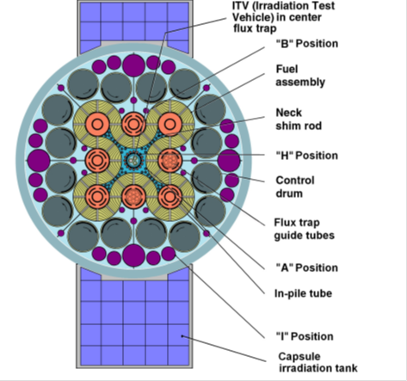
FIG. 1. ATR core cross-section.

2.2. Capsule Description

The capsule assembly is shown in Figure 2. The capsule has an active length (for cobalt [Co] pellets) of 37.5 cm. and is fitted with a top and bottom end cap. The end caps are made from Al 4047 and the capsule body from Al 6061-T6. Centering standoff features are located 50.8 mm from the weld zones to center the capsule within the A and H position baskets and to provide sacrificial material to be abraded from the housing during basket loading. This sacrificial material ensures that the capsule housing is not thinned as a result of handling.

Weld Zone
Weld Zone
Centering Standoffs

Centering Standoffs
Weld Zone
Weld Zone
Centering Standoffs
Weld Zone
Weld Zone
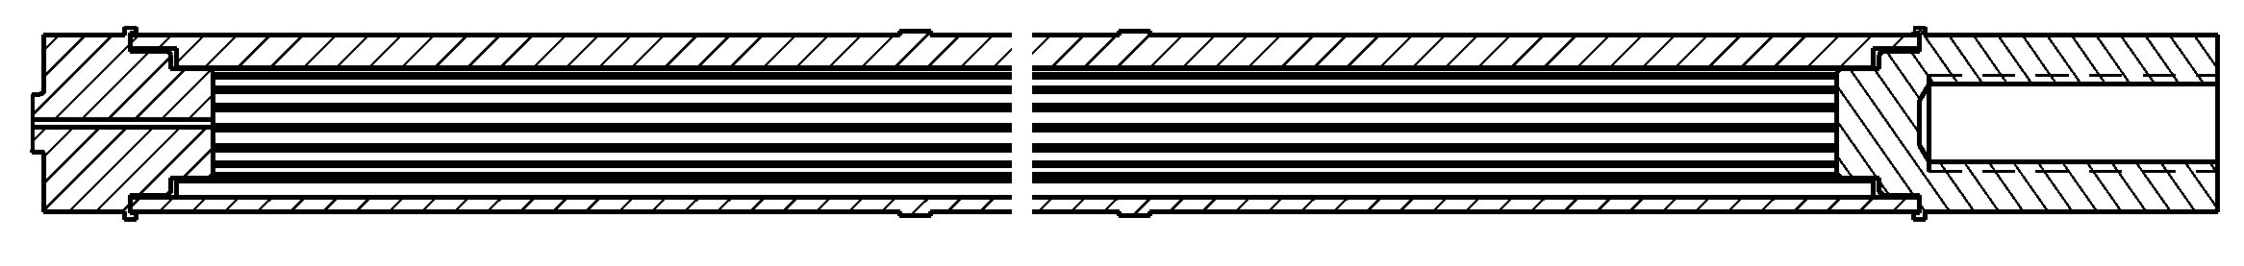
Capsule Housing
Top Cap
Bottom Cap
(w/ backfill hole)

FIG. 2. HSA ⁶⁰CO capsule (axial cross-section).
Bottom Cap
(w/ backfill hole)
Bottom Cap
(w/ backfill hole)
Top Cap
Capsule Housing
Bottom Cap
(w/ backfill hole)
Top Cap
Capsule Housing
A radial cross-section view of the capsule body detailing the pellet channel configuration can be seen in Figure 3. The center of the capsule housing contains 17 equispaced channels that run the active length of the body. These channels are nominally 1.10 mm in diameter and are oriented on an 8.76 mm bolt circle. The required wall thickness between the pellet channel and the outer diameter of the housing was calculated to be 0.91 mm (minimum) based on section VIII of the American Society of Mechanical Engineers (ASME) Boiler and Pressure Vessel Code [1]. Assuming an artificially high maximum allowable internal pressure of 17 MPa, a minimum wall thickness calculation yielded the value of 0.86 mm. The corrosion rate of Al 6061 at the High Flux Isotope Reactor (HFIR) was determined to be 0.005 mm/year (0.0002 in./year) [2]. Given that HFIR has a similar water chemistry to the ATR and operates at a higher neutron flux, pressure, and coolant temperature, HFIR corrosion conditions are considered to be bounding to those in the ATR. Therefore, the wall thickness is conservative, given the high internal pressure limit and an upper irradiation time limit of 6 years.

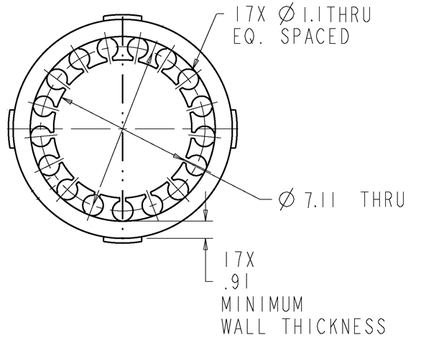
FIG. 3. HSA ⁶⁰CO capsule (radial cross-section).

2.3. Design Improvements

The primary issues with the original target welds stem from the weld joint geometry and the nondestructive test mechanism. The original (GTAW) fillet geometry was prone to create large pores, and welds were not consistently leak-checked. Furthermore, the annular target was welded in air, eliminating the standard helium leak-check as a reliable nondestructive examination technique. Given the difficulty of welding thin-wall Al tubes, this lack of quality assurance made the previous annular target weld protocol extremely unreliable. Figure 4 shows a cross-sectional view of an annular target fillet weld. Note the relatively large penetration depth and porosity found in this weld. These factors can lead to inconsistent capsules that are vulnerable to water inleakage.

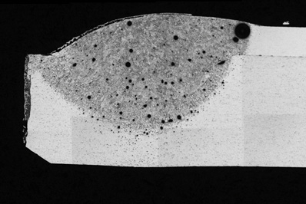
FIG. 4. Annular target weld cross-section.

The newly designed HSA capsule joint geometry employs compatible materials to create an autogenous electron-beam socket weld joint. Electron-beam welding techniques are highly repeatable and require less power to create the weld, making the weld area and heat-affected zone much smaller (which reduces the likelihood of pore formation). The capsule is backfilled with helium gas to improve heat transfer and allow for more consistent, high-fidelity leak checking.

The capsule is fabricated entirely from Al alloys because of their excellent heat transfer characteristics, transparency to neutrons, compatibility with the ATR, relative robustness and corrosion resistance, and inexpensive material stock. Note that Al 4047 was selected for the end cap material because of its weld compatibility with the 6000 series alloys. Also, the solid end caps provide a robust location to engrave unique capsule identifiers (the June 2012 target failed in the engraving on the thin-walled outer tube).

Choosing Al 6061 as the capsule body material also limits irradiation-induced swelling. This capsule is expected to experience large fluences during the irradiation/⁶⁰Co production period. Irradiation-induced swelling in the Al 6061-T6 holders must not diminish the capsule performance. Early work at the HFIR to quantify swelling in Al 6061-T6 showed that 1.1% swelling occurred after exposure to 9.2 × 10²² n/cm² (E>0.1 MeV). Moreover, 0.7% of this swelling was produced by void formation in the material. It is important to mention that no voids were observed at fast fluences (E>0.1 MeV) below 2.8 × 10²² n/cm² [3]. This implies that the Al swells at most by 0.4% under fast fluences below 2.8 × 10²² n/cm². The measured swelling at a fast fluence of 2.8 × 10²² n/cm² was 0.15%. Therefore, an upper bound of 0.4% swelling is a conservative estimate for swelling at a fast fluence of 2.8 × 10²² n/cm².

For the highest-flux positions (Group A positions [A-9 through A-1]), with a fast flux (E>0.1 MeV) of 2.3 × 10¹⁴ n/cm²•s, the capsule must be irradiated continuously for more than 1400 days to reach a fast fluence of 2.8 × 10²² n/cm². This amount of time is much greater than the expected irradiation time in the ATR. The upper bound of 0.4% swelling changes the capsule outer diameter from 0.460 to 0.462 in. This change in geometry has little effect on the system convective heat transfer coefficient (roughly a 3% reduction), which is well below the uncertainty of the methods used to calculate the value (Dittus-Boelter correlation) [4]. Finally, the swelling of the centering tabs would increase the outer diameter from 0.480 to 0.482 in., which is below the minimum 0.490 in. inner diameter of the ATR basket. Therefore, irradiation-induced swelling would not reduce the capsule performance.

TABLE I: Design parameter comparison between the annular target and HSA capsule

Design parameter | Annular target | HSA capsule
Construction material | Al 6061 with Al 4043 weld rod | Al 6061 with Al 4047 monolithic end caps
Weld joint geometry | Thin wall fillet | Autogenous socket
Welding technique | Manual GTAW | Automatic electron beam welding
Fill gas | Air | Helium
Fill gas delivery | N/A | Vacuum/backfill in weld box
Identifier application | Pneumatic engraving on thin-walled housing tube | Pneumatic engraving on solid end cap

The 17-channel design simplifies pellet loading and increases the capsule payload by almost 60%. A general comparison of the annular target and the HSA capsule design parameters are found in Table I. Axial cross-sections of the target and capsule are found in Figure 5.

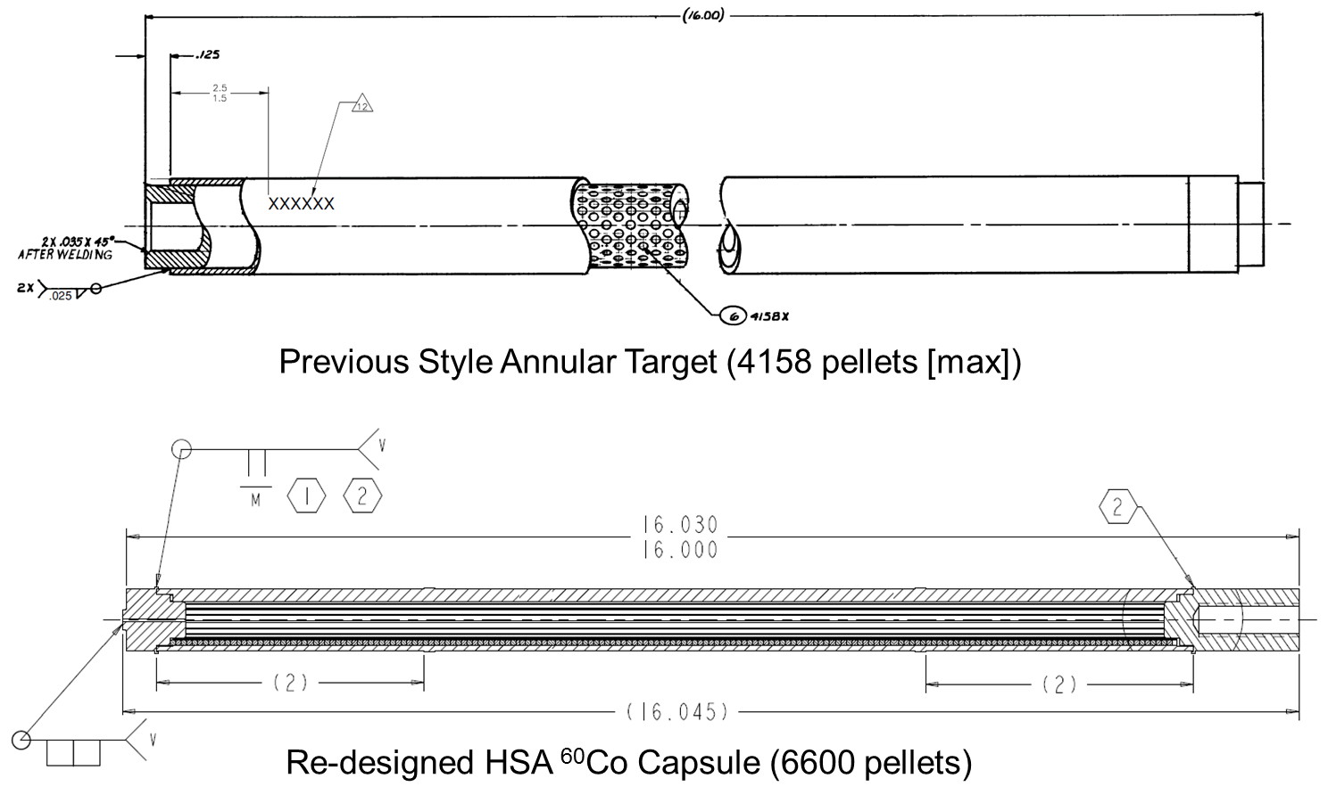
FIG. 5. Axial cross-sections of the annular target and HSA capsule.

3. Capsule Analysis

A thermal-hydraulic and neutronic analysis was performed to gain understanding of the performance of the HSA capsule. This report describes results from a “bounding” case in-pile scenario in the ATR, i.e., a 300 MW_{th} power excursion. Given that the end use of the capsule is for isotope production, there is no design temperature for the capsule; however, the lowest achievable temperature is favored. The assumptions for both the thermal-hydraulic and neutronics models are as follows:

Thermal Analysis Assumptions –
- The centering tabs do not account for any thermal path to the Group A or H position baskets, making the heat transfer in the capsule subject to the annular flow channel between the capsule and the basket.
- Axial heat transfer is neglected.
- The helium fill gas is assumed to be stagnant and conduction is assumed to be the sole method of heat transfer (i.e., radiation is also neglected).
- Thermal expansion is neglected to impose the largest gas gaps around the internal part of the capsule (i.e., maximize temperature).
- The capsule is placed at the ATR vertical midplane to simulate the highest heat generation conditions.

Neutronics Assumptions –
- There is no fission product buildup in the MCNP model of the ATR.
- The total energy deposition rate is formulated by combining the calculated prompt neutron energy deposition rate, with 1.2 times the calculated prompt gamma energy deposition rate.
- An average recoverable energy per fission of 194.02 MeV is assumed.
- The ATR experiences 60 MW_{th} lobe power, which imposes a multiplication factor of 2.83 to the calculated heat rates.
- Thermal analyses at INL have traditionally employed an additional safety factor of 10%; this additional conservatism is used.

3.1 Thermal-hydraulic Model

Initially, a design drawing for this capsule was created in the Pro-E computer-aided drawing (CAD) software. An Initial Graphics Exchange Specification file detailing the CAD model was produced to supply geometry data for ANSYS Workbench. A simplified 2-dimensional radial model exploiting a 10.6° symmetry angle was produced to describe the thermal performance of the capsule. Figure 6 shows the radial cross-section of the model with the simplified section highlighted in yellow. The final meshed geometry of the model can be seen in Figure 7.

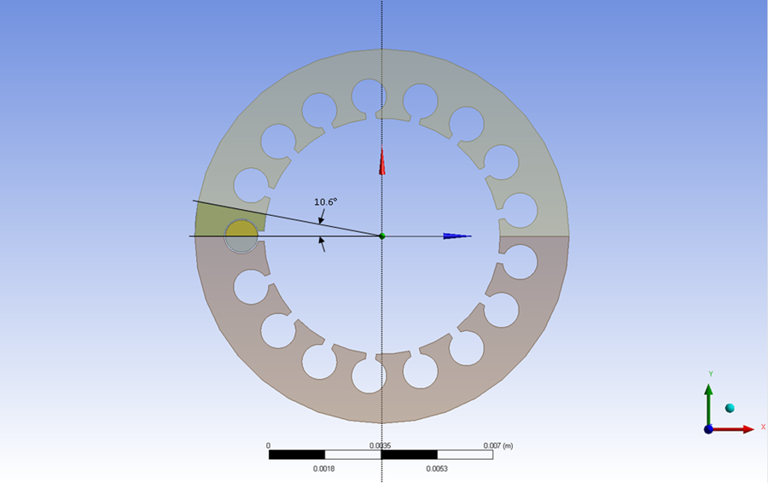
FIG. 6. Radial cross-section showing the simplified geometry and symmetry planes.

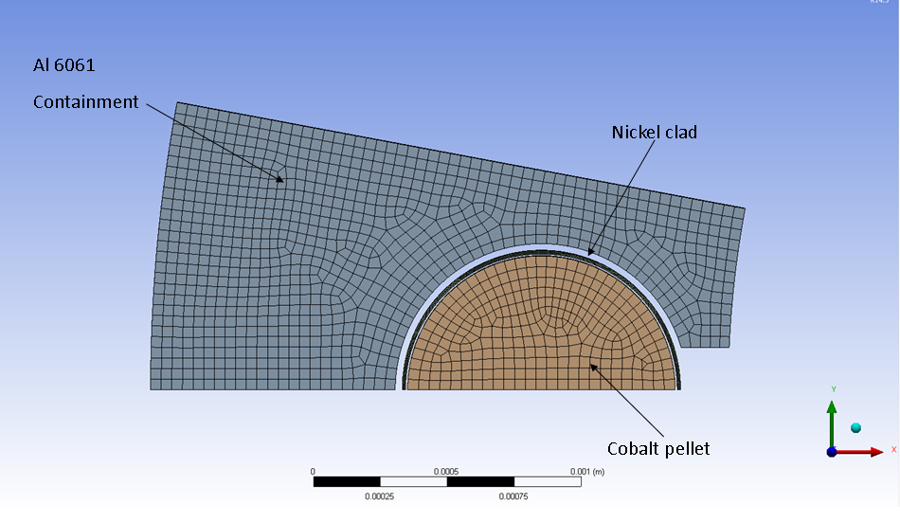
FIG. 7. Finite element analysis mesh for the HSA capsule assembly.

The heat generation rates for all materials were taken from the neutronics calculation (see Section 3.2). The input values are summarized in Table II. The convection parameters (heat transfer coefficient and bulk temperature) were calculated using reactor parameters gathered from the ATR Handbook [5].

TABLE II: Thermal boundary conditions for HSA capsule

Item | Value
Heat transfer coefficient (capsule) | 22.5 kW/m²•°C
Bulk fluid temperature (inlet) | 51.7°C
Peak heat generation rate for Al 6061 | 28.5 W/g
Peak heat generation rate for nickel clad | 42.4 W/g
Peak heat generation rate for cobalt pellet | 39.8 W/g

3.2 Neutronics Model

The neutronics analysis was performed with an MCNP model of the ATR supplied by INL [6]. This model accurately depicts the ATR and has been used for recent evaluations by the INL staff. It is a fixed source model that represents typical ATR cycles. The driver core and control element positions are representative of a middle-of-cycle condition for the ATR. See Table III for a summary of the analysis results.

TABLE III: Summary of heating rate results from the neutronics analysis

Component | Estimated total heating  (W/g) / (source neutron/s) | Total heating At 106 MW ATR power plus axial peaking factor (W/g) | Total heating At 300 MW plus 10% safety factor (W/g)
Cobalt | 1.512 × 10⁻¹⁸ | 12.77 | 39.77
Nickel clad | 1.613 × 10⁻¹⁸ | 13.62 | 42.41
Helium gap | 1.497 × 10⁻¹⁸ | 12.64 | 39.36
Interior water | 2.307 × 10⁻¹⁸ | 19.49 | 60.67
Housing | 1.085 × 10⁻¹⁸ | 9.17 | 28.54

To support the production schedule, optimized specific activity rates were calculated. These “best case” rates assume the capsules are in an optimal (highest-flux) position for a series of 49 day ATR cycles with the reactor operating at 106 MW_{th}. Three capsules may be loaded in the A or H positon in the ATR (one at the vertical midplane and one above and below the vertical midplane). These calculations estimate production rates for all three available positions. The calculated production rates are shown in Figure 8. It can be seen that capsules can reach the required specific activity (of 300 Ci/g) in 12 optimized ATR cycles or less.

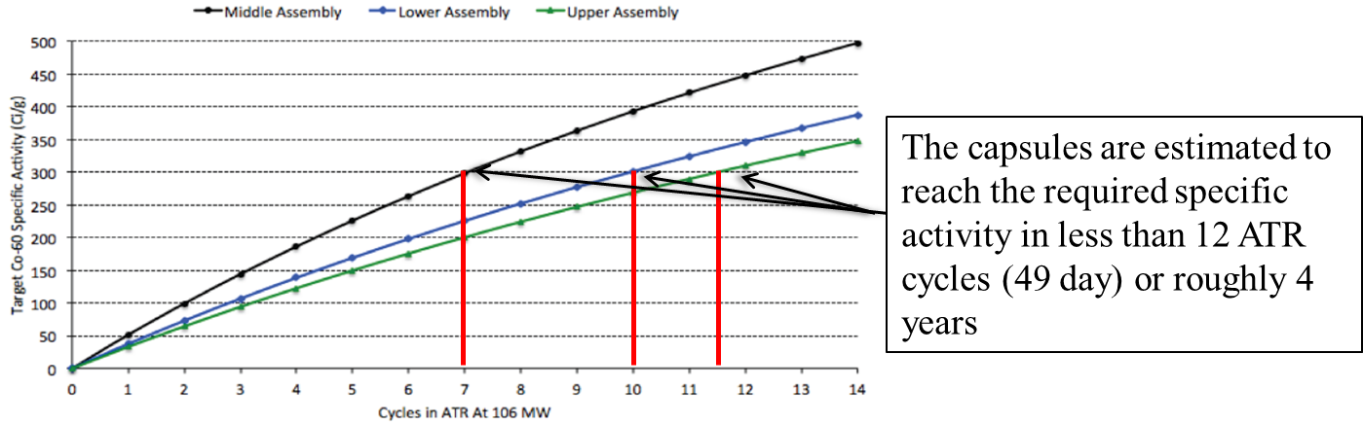
Below
Above
Midplane

FIG. 8. ⁶⁰Co production rate as a function of ATR cycle.

4. Analysis of Results

4.1 Results of Thermal Analysis

The thermal model of the capsule was based on conservative material heat generation rates, heat transfer mechanisms, and structural behaviours. Under these conditions, none of the capsule constituent parts approaches its respective melting point. Moreover, the maximum temperatures of these parts are below the boiling point of water at reactor operating conditions. Tables IV and V describe the heat load and temperature results for the capsule, respectively. Temperature contour plots of the capsule can be seen in Figures 9 and 10.

TABLE IV: Heat load details for HSA capsule

Item | Material | Heat generation (W/kg) | Linear heat load (W/m)
Containment | AL 6061 | 28,500 | 3678.8
Nickel clad | Nickel | 42,400 | 259.1
Cobalt capsule | Cobalt | 39,800 | 4676.3

TABLE V: Temperature details for HSA capsule

Item | Material | Avg. temp. (°C) | Min. temp. (°C) | Max. temp. (°C) | Melting temp. (°C)
Containment | AL 6061 | 63 | 62 | 65 | 582
Nickel clad | Nickel | 82 | 81 | 84 | 1455
Cobalt capsule | Cobalt | 88 | 88 | 88 | 1493

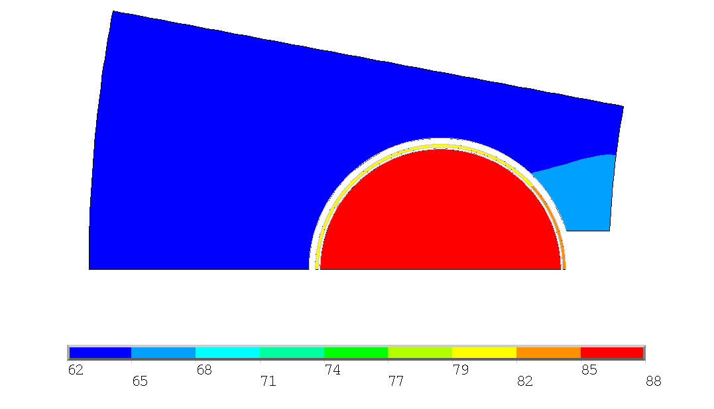

FIG. 9. Temperature contour plot (°C) for the cobalt capsule (with nickel clad).

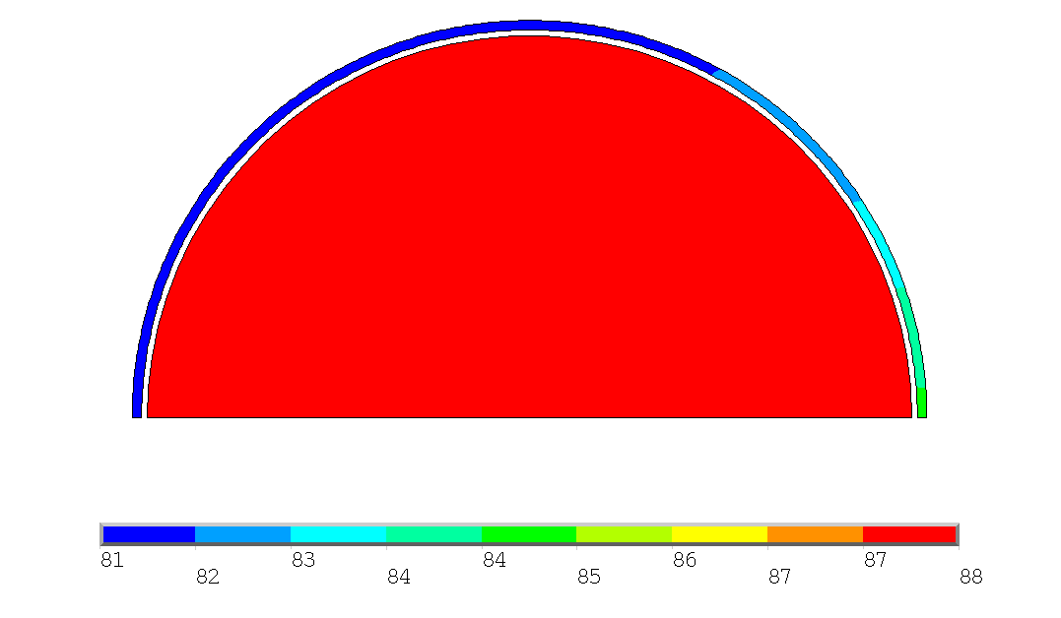
FIG. 10. Temperature contour plot (°C) for a cobalt pellet (with nickel clad).

4.2 Quality Assurance Guidelines

Quality assurance and control is an integral part of the HSA capsule production program. The design and fabrication teams at ORNL must strictly adhere to the ASME Nuclear Quality Assurance-1 (NQA-1) protocol, which dictates the appropriate methods of documenting material chain of custody, dimensional inspection, and so on. Moreover, ORNL must tightly control any design features and parameters that receive credit in the safety basis calculations that support reactor insertion at the ATR. These include

- Minimum wall thickness is 0.91 mm to provide adequate structural integrity and corrosion resistance.
- All welds provide hermetic seals to prohibit water intrusion and sustain the capsule internal helium atmosphere for necessary heat transfer.
- The maximum capsule diameter is ≤ 12.19 mm to ensure proper ATR loading and handling.
- Pin stamp markings remain legible for the “in pool” and disassembly life of the capsule without compromising the housing integrity.

Other parameters that are designated as non–safety-critical but that are essential to the capsule and isotope production program include the following:

- All welding procedures adhere to (US) nationally recognized standards (ASME Boiler and Pressure Vessel Code, American Welding Society B2.1)
- Certified materials held to ASTM or AMS International standards, state-of-the-art fabrication, and dimensional inspection are used to ensure the best and most reliable components.
- Nondestructive testing is performed on all capsules (helium leak rate testing and external hydrostatic compression testing) to ensure the capsules are hermetically sealed and structurally sound.
- A procedure-controlled assembly process is performed at ORNL to ensure a pristine and repeatable product is produced.
- Most assembly processes are automated to reduce the human error component.

Finally, an assay system is being developed at the ATR to survey the capsules to ensure the proper specific activity is obtained.

5. Conclusions

This paper describes the HSA ⁶⁰Co production capsule design and outlines the calculated performance of the irradiation vehicle. The capsule is designed to irradiate cobalt pellets in the Group A and H positions of the ATR and to reach a nominal specific activity of 300 Ci/g. The pellets are contained within Al 6061-T6 holders. Helium is used as the fill gas inside the capsule. The specimen temperature is dictated by the axial location. This analysis determined the peak specimen temperature at the ATR midplane at 60 MW_{th} lobe power. Under these conditions, with conservative constraints (e.g., limiting heat transfer, irradiation swelling effects), none of the capsule’s constituent parts approaches its respective melting points.

6. References

- American Society of Mechanical Engineers, Boiler and Pressure Vessel Code, Section VIII, (2013).
- Griess, J.C., The Corrosion of Aluminum Clad Fuel Elements in Storage Pools, DCM HFIR-169M , Oak Ridge National Laboratory, Oak Ridge, Tennessee (1993).
- Farrell, K., et al., Examination of the Irradiated 6061 Aluminum HFIR Target Holders, ORNL TM/4139, Oak Ridge National Laboratory, Oak Ridge, Tennessee (1973).
- Incropera F. P., DeWitt D. P., Bergman T. L., Lavine A. S., Fundamentals of Heat and Mass Transfer, Sixth Edition, John Wiley & Sons, Davers, MA (2007)
- Idaho National Laboratory, Users Handbook for the Advanced Test Reactor, INEEL/EXT-02-01064 02-GA50880, Idaho Falls, Idaho (2014).
- Perry, J., MCNP Advanced Test Reactor Model for Cobalt Modeling, Idaho National Laboratory (2013).

Notice: This manuscript has been authored by UT-Battelle, LLC, under contract DE-AC05-00OR22725 with the U.S. Department of Energy. The United States Government retains and the publisher, by accepting the article for publication, acknowledges that the United States Government retains a non-exclusive, paid-up, irrevocable, world-wide license to publish or reproduce the published form of this manuscript, or allow others to do so, for United States Government purposes.

