Density determination of pyrotechnical devices using neutron imaging techniques on the RA-6 reactor

N. Chiaraviglio¹, J.M. Marín¹, F.A. Sanchez¹

1) Departamento de Reactores y Radiaciones, Comisión Nacional de Energía Atómica, Bustillo 9500, Bariloche, Argentina

Corresponding author: chiaraviglio@cab.cnea.gov.ar

Abstract. The RA-6 is an experimental reactor operating since 1982, and its main purpose is to be a school reactor for the Nuclear Engineering career of the Instituto Balseiro. It was designed and built by the Argentinian National Atomic Energy Commission (CNEA) and placed in the Bariloche Atomic Center. The design power was 0.5MWth, which was increased to 3MWth after a nucleus redesign. Nowadays it is licensed to work at 1MWth. Several experimental facilities are in use in this reactor: Prompt Gamma Activation Analysis (PGAA), Boron Neutron Capture Therapy (BNCT) and Neutron imaging are some of them.
The Neutron imaging facility was built in 2011 and since then it has been used for qualitative analysis such as antiques inspections, hydrogen container materials, shielding material analysis, etc. The thermal flux in the facility is 2x10⁶n/cm²s in a 20x20cm area with a L/D relation around 100. Nowadays we are conducting studies for the National Spatial Activities Commission (CONAE) to determine the homogeneity of pyrotechnical devices called RDX which are used to detonate explosives in outer space. Absence of point defects and uniformity in density (in a range from 0.9 to 1.1 gr/cm³) must be guaranteed.
This work is being conducted using neutron imaging techniques. For that purpose we built a set of pattern samples from a material with similar nuclear properties. Those samples were analyzed using different combinations of exposure times and f/numbers to find the lowest data dispersion in the densities obtained. The resulting images were processed using Octave scripts written for this purpose, in order to have higher processing capacity than can be achieved by using standard image processing software (such as ImageJ).

1. Introduction

Neutron imaging has a great potential as a non-destructive test for materials or devices that cannot be studied using other techniques such as X-Rays. This technique is mainly used for qualitative analyses such as crack detection, heterogeneities, corrosion, etc. but quantitative information is hard to obtain.
Cyclonite, also known as RDX, is an explosive nitroamine widely used in aerospace applications. To work properly this explosive must have a density among 0.9 and 1.1 gr/cm³.
In this work we use neutron imaging techniques to develop procedures that allows us to determine density variation of 10% in RDX. For this we built reference sample and develop image processing scripts in OCTAVE.

2. Basic principle
In FIG. 1 a scheme of the neutron imaging facility is shown. A neutron source is collimated and interacts with a sample that attenuates the neutron beam. Transmitted neutrons reach a scintillator screen and the image is taken using a CCD-based digital camera.
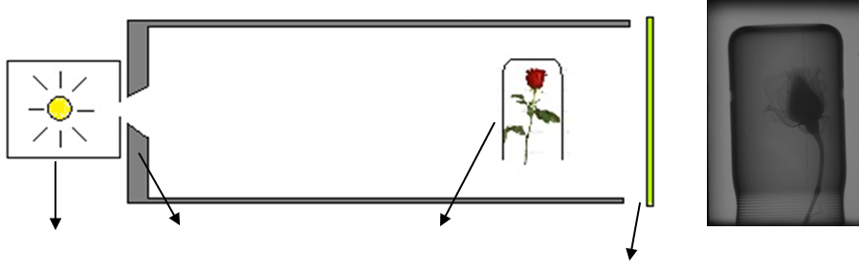
Neutron Source
Colimator
Sample
Scintillator screen
Resulting Image
FIG. 1 Simplified scheme of a neutron imaging facility.

The intensity of the beam after interacting with the sample is:

$$I\left(Σ_{T},x\right)=I_{0}e^{-Σ_{T}x}=I_{0}e^{-\frac{ρN_{A}}{M_{M}}σ_{T}x}$$ | (1)
Here: I₀ is the beam intensity before interacting with the simple,$Σ_{T}$ is the macroscopic total cross section, $σ_{T}$ is the microscopic cross section, $ρ$ is the sample density, N_{A} is Avogadro’s number, M_{M} the molar mass of the molecules in the sample and $x$ the sample thick.
A useful quantity to work with is the transmission, defined as:
$$T=\frac{I\left(Σ_{T},x\right)}{I_{0}}=e^{-\frac{ρN_{A}}{M_{M}}σ_{T}x}$$ | (2)

3. RDX attenuation

RDX attenuation is produced mainly due to dispersion in hydrogen and can be estimated from its total cross section (which takes a value of 0.63 cm⁻¹). In FIG. 2 the transmission as a function of the density can be observed for a sample of 5 mm thick. In the same image it is also shown the transmission for RDX with 1% and 3% of gadolinium which can be used to increment contrast. For the case without gadolinium variations of 20% in density (around 1gr/cm³) only produce variations of 5% in transmission. In the curves with gadolinium the relation is amplified. This can be used to detect density variations.
FIG. 3 shows the transmission as a function of the thickness for a sample of density 0.6 gr/cm³. Then, if we use RDX with a density ρ*=0.6 ρ (ρ = mean density of RDX), there will be a thickness that produces the same transmission as the base case. This is:
$$T=\frac{I}{I_{0}}=e^{-\frac{ρN_{A}}{M_{M}}σ_{T}x}=e^{-ρ^{*}\frac{N_{A}}{M_{M}}σ_{T}\frac{x}{0.6}}$$ | (3)
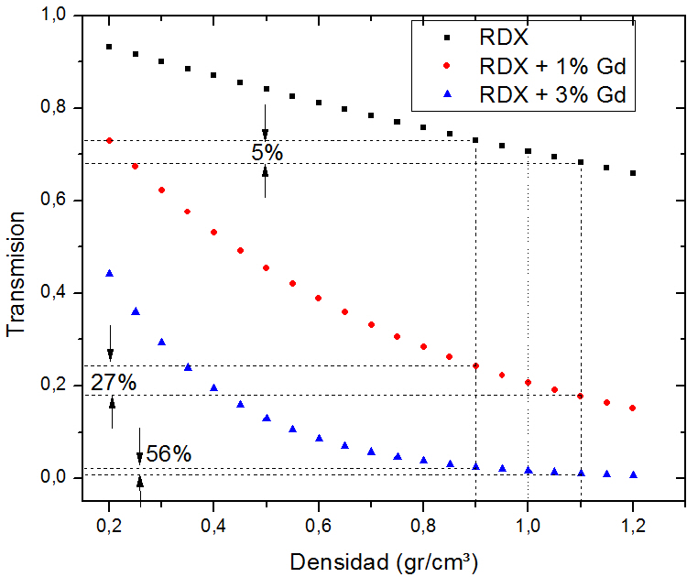
Density [gr/cm³]
Transmission
FIG. 2 RDX transmission as a function of the density.
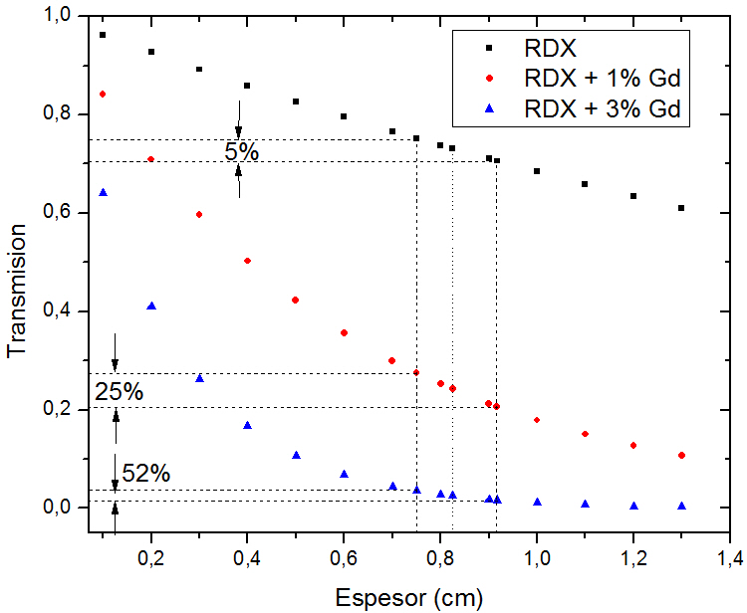
Thickness [cm]
Transmission
FIG. 3 RDX transmission as a function of the thickness.
3.1 Standard Samples
Since it’s difficult to obtain RDX samples of a known density we generate standard samples of corn starch which has a similar chemical composition but a density (0.6 gr/cm³ instead of 1.0 gr/cm³). We also generate samples of pure corn starch and with 1% and 3% of gadolinium.
We use two different approaches: first we compact the corn starch to reach the desired density using aluminum cylinders and huge amount of pressure (FIG. 4); second we use the natural density of the cornstarch but with higher thickness (that can be done due to eq. 3).

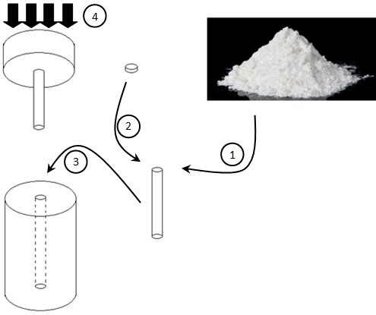
FIG. 4 Fabrication scheme of samples produced by compaction.

For the later samples we use an aluminum matrix (that we will call sample holder) with drilled holes (sample thickness) in order to produce the equivalent transmission. This has an added issue: the attenuation due to the sample holder. Then we consider two components to the attenuation:
$$I=I_{0}e^{-\left(ρ^{s}\frac{N_{A}}{M_{M}^{s}}σ_{T}^{s}x^{s}\right)-(ρ^{sh}\frac{N_{A}}{M_{M}^{sh}}σ_{T}^{sh}x^{sh})}$$
Here the superscript s refers to the sample and sh to the sample holder. Then we can re-write the eq. 3 as:
$$\frac{I}{I_{0}e^{-(ρ^{sh}\frac{N_{A}}{M_{M}^{sh}}σ_{T}^{sh}x^{sh})}}=e^{-\left(ρ^{s}\frac{N_{A}}{M_{M}^{s}}σ_{T}^{s}x^{s}\right)}$$ | (4)
In order to compute the quantity of eq (4) we need to take a neutron image of the sample holder.

4 Image processing

Image processing was done using OCTAVE scripts. In this section we describe the applied algorithms.

4.1 Normalization

To compute the transmission (eq. (3)) we take 3 images: an image of the sample (here we call it Image), a flat field image (FF which is an image taken without sample) and a dark field (DF image without neutrons). Then, the resultant image is:

$$T=Img=\frac{I}{I_{0}}=\frac{Image-DF}{FF-DF}$$ | (5)
4.2 Denoising

Image denoising is made using Gaussian filters [1] as:

$$p\left(x,y\right)=\frac{1}{2πσ^{2}}e^{-\frac{x^{2}+y^{2}}{2σ^{2}} }$$
Here σ represents the weight of the filter and x and y are pixels coordinates.

4.3 Edge recognition

Edge recognition is made using Sobel filters [2]. The convolution of the image with the Sobel operator produces an image with all the X edges. The application of the transpose of the operator gives Y edges. These results can be combined to produce all edges in the image, this is:
$$XEdges=Img\left(x,y\right)*Sobel$$
$$YEdges=Img\left(x,y\right)*Sobel^{T}$$
$$Edges=\sqrt{ {XEdges}^{2}+ {YEdges}^{2}}$$

4.4 Spatial transformations

Rotations and translation are two commonly used transformations. Translations are done by adding or subtracting pixels on the edge of the image.
Rotations are done by the multiplication of each pixel of the image to the rotation matrix:
$$\left[\begin{matrix}\cos{α} & -\sin{α} \\ \sin{α} & \cos{α}\end{matrix}\right]$$

Since pixels have integer coordinates a bilinear interpolation is used after the rotation is applied [3].

4.5 Image registration

For the computation of the eq (4) we need to overlap two images with the sample holder coinciding with the image of the samples. This is done maximizing the correlation coefficient of the images [4]. This coefficient can be calculated as:
$$r_{xy}=\frac{\sum_{i=1}^{n}{\left(x_{i}-\overline{x}\right)(y_{i}-\overline{y})}}{\sqrt{\sum_{i=1}^{n}{{\left(x_{i}-\overline{x}\right)}^{2}}\sum_{i=1}^{n}{{\left(y_{i}-\overline{y}\right)}^{2}}}}$$

5 Results

5.1 Compaction samples

On FIG. 5 the image produced by the compaction samples is shown. In the same figure the transmission along a horizontal line is also shown. There are 3 groups of samples, for each set the central sample has a density of 1 gr/cm³ while the others represent variations of ±10%. In this case only samples without gadolinium were used.
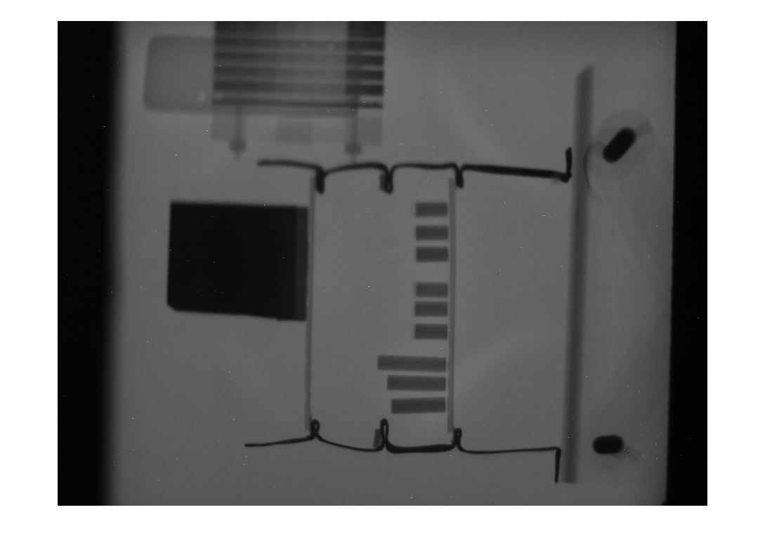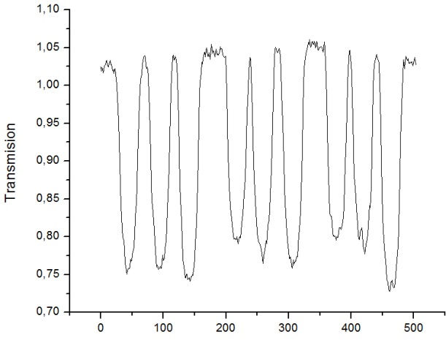

1

2

3

FIG. 5 On the left: Image produced by compaction samples. On the rigth the transmission in the yellow horizontal line showed on the left.
TABLE 1 shows the difference in transmission for each sample of the set and also the relative variation from the middle sample. It’s easy to see that the transmission differences are less than the error we have on the transmission value itself. Also there exist variations from samples of the same density. This is due to a bad compaction of the corn starch.
TABLE 1 Variations in transmission for different samples
Density [gr/cm³] | Set 1 |  | Set 2 |  | Set 3
Density [gr/cm³] | Transmission | Variation [%] | Transmission | Variation [%] | Transmission | Variation [%]
0.9 | 0.55 (±0.02) | -0.8 | 0.60 (±0.01) | 2.3 | 0.61 (±0.03) | 4.0
1 | 0.56 (±0.02) | - | 0.59 (±0.02) | - | 0.59 (±0.02) | -
1.1 | 0.52 (±0.02) | -6.3 | 0.57 (±0.02) | -2.8 | 0.52 (±0.02) | -12.0

5.1 Variable thickness
FIG. 6 shows an image of the variable thickness samples. It’s easy to see that there are three different kinds of samples (different colours due to different transmissions). The first group has corn starch with 3% of gadolinium; the second has 1% of gadolinium and the third has only corn starch.
The middle sample of each group has a thickness which would produce a transmission equivalent to a density of 1 gr/cm³ (eq. (3)). The other samples have a thickness which produces an increment (or decrement) of 10% from the middle one, this is equivalent to densities of 0.9 gr/cm³ and 1.1 gr/cm³.

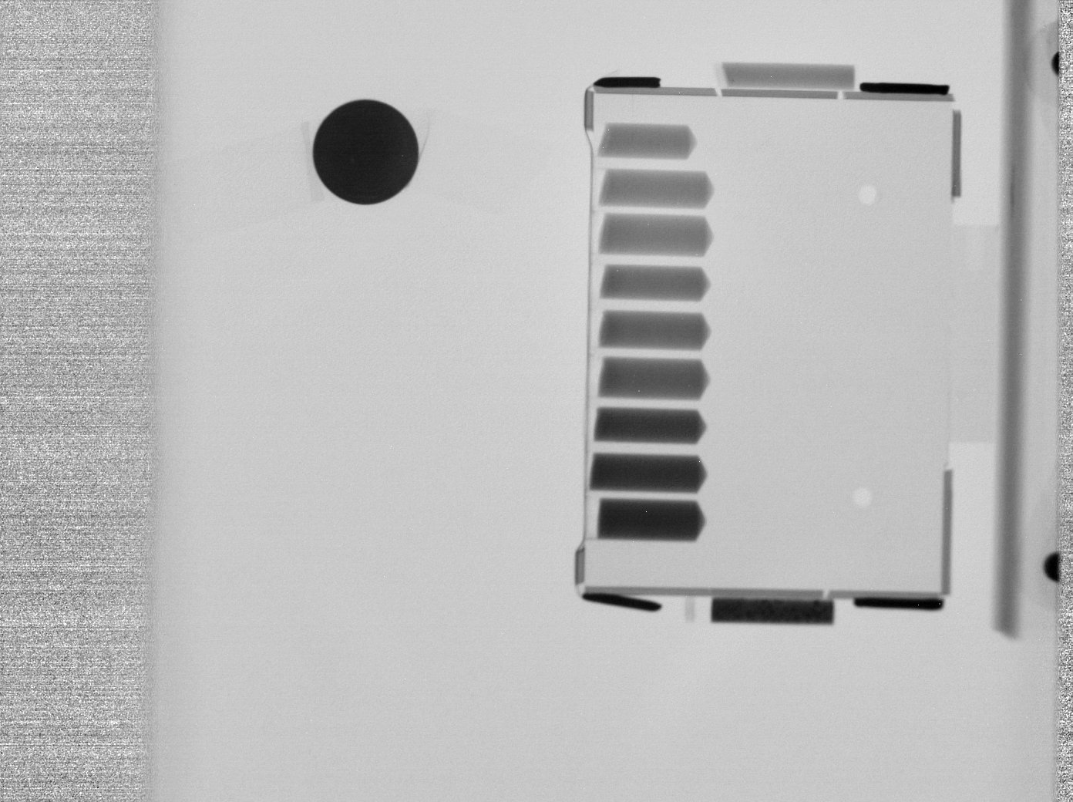

3% Gd
1% Gd
0% Gd
FIG. 6 Neutron image of the variable thickness samples

The sample holder consists in a matrix of aluminium with drilled holes. Aluminium is almost transparent to neutrons but for a correct quantification over the image the attenuation due to this material must be considered (since each hole has a different aluminium thickness). This is represented in eq. (4).
To achieve this we apply the process shown in FIG. 7. First, two images are taken: one of the empty sample holder and the other one of the sample holder with the samples in it (Steps 1 and 2). Then we have to register the two images to compute the quantity on eq. (4). For this we apply Sobel filter to the first image (Step 3) and invert the colours; then we apply rotations and translation until we reach a maximum for the correlation coefficient (Step 4). This is done without any optimization method, applying the transformations according to visual inspection of the superposed images. After this we apply the same transformations to the image taken in the Step 1. When the two images are in the same coordinate system we divide them (which is equivalent to compute eq. (4)) and obtain the final image (Step 5).
The final image represents only the differences between the two images taken. This is easy to see in the Step 5 of FIG. 7.

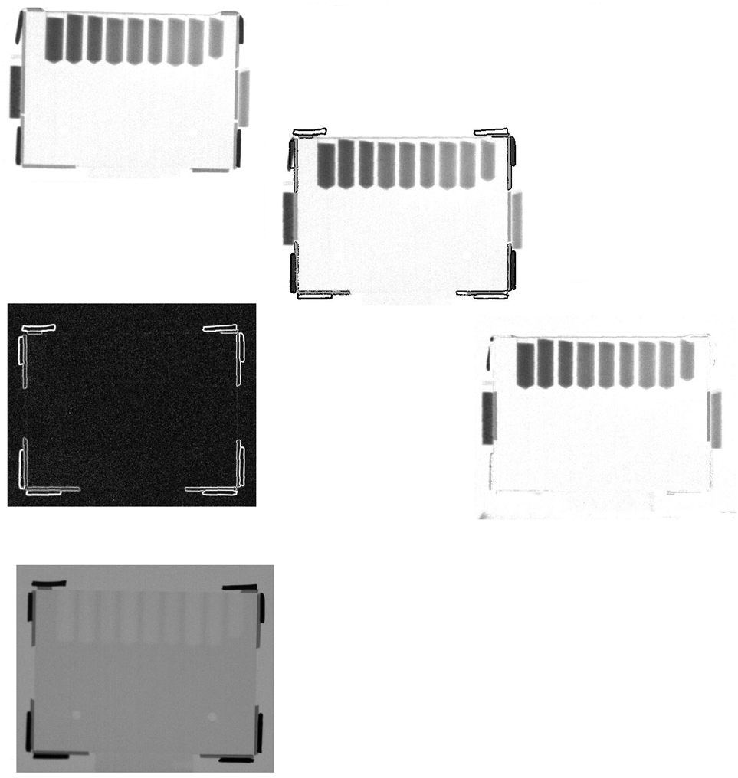
1
2
3
5
Sobel Filters
Image registration
(rotations + translations)
Final Image
4
FIG. 7 Image processing for the variable thickness sample: Step 1: we take an image of the sample holder without any sample; Step 2: we take an image of the sample holder with the samples in it; Step 3: we detect edges on the first image; this will give as a frame to apply rotations and translations. Step 4: we apply translations and rotations until we find a maximum on the correlation coefficient; Step 5: we apply the same transformation that we need to overlap the images to the image taken in step 1 and divide them to compute the quantity of eq. (4).
TABLE 2 shows the transmission observed for each sample after applying the described procedure. The variations from the sample with transmission equivalent to 1 gr/cm³ are also shown.

TABLE 2 Transmissions and variations for the samples analysed.
%Gd | 7.5 mm (ρ=0.9 gr/cm³) |  | 8.25 mm (ρ=1.0 gr/cm³) |  | 9 mm (ρ=1.1 gr/cm³)
%Gd | Transmission | Variation [%] | Transmission | Variation [%] | Transmission | Variation [%]
0 | 0.63 (±3%) | 2.6 (±0.2) | 0.64 (±2.5%) | - | 0.63 (±3%) | 2.7 (±0.2)
1 | 0.57 (±3.5%) | -7.8 (±0.4) | 0.53 (±4%) | - | 0.48 (±3.5%) | 9.1 (±0.4)
3 | 0.37 (±5%) | -8.8 (±0.6) | 0.34 (±5%) | - | 0.31 (±5.5%) | 7.9 (±0.6)
From TABLE 2 we can conclude that:
- Without doping the samples with gadolinium variations of 10% cannot be detected. This was predicted in FIG. 2 and FIG. 3.
- Doping corn starch with 1% of gadolinium produces an almost linear relation between density (or thickness) variations and the resultant transmission. This is, for a ±10% variation in the thickness an 8-9% variation in transmission is observed.
- Doping the samples with 3% of gadolinium also produces an almost linear transmission between densities (or thickness) variations and the resultant transmission but with a higher relative error. This is because the attenuation of the neutrons due to a 3% of gadolinium is much higher than in the other cases and the transmission is much lower.

5. Final Remarks - Conclusions

Two kind of standard samples were generated to predict results over RDX using neutron imaging techniques. As a replacement of the RDX corn starch was used because its chemical composition similarity with the explosive. Since the density this material is approximately half of the RDX density two approaches were followed: compaction of corn starch to RDX densities and the study using an equivalent thickness and natural density of the replacement material.
Compaction samples were difficult to produce due to the high variability of the resulting densities.
Variable thickness samples were useful to study the problem since similar transmissions could be obtained by changing the thickness instead of the density. In this manner is possible to control the variations in a more precise way.
Three kinds of samples were used for the variable thickness case. These samples had a contrast material for some of the cases. The material used was gadolinium in small concentration. We used samples with 0%, 1% and 3% of it.
For the samples without gadolinium no difference in transmission was observed (neither for the variable density or variable thickness samples). Then if we want to detect variations of 10% (or less) we need to use a contrast material.
For both doped samples (1% and 3% of gadolinium) the difference in transmission due to a change in thickness could be quantified. We found a direct proportionality between the transmission and the increment in thickness.
If we use these results to predict what would happened with RDX we can assume that doping the explosive material with gadolinium is a must if we want to detect density variations using neutron imaging techniques.
The main result of this work is the feasibility of performing densitometric analysis using neutron imaging techniques.

6. References

- B.K., SHREYAMSA KUMAR, “Image denoising based on Gaussian/bilateral filter and its method noise thresholding”, SIGNAL, IMAGE AND VIDEO PROCESSING, London, England (2013).
- I., SOBEL, “History and definition of the Sobel operator”, Unpublished (2014).
- NUMERICAL RECIPES IN FORTRAN 77: THE ART OF SCIENTIFIC COMPUTING, Cambridge University Press (1992).
- M., Sonka et al, HANDBOOK OF MEDICAL IMAGING, VOL 2 MEDICAL IMAGING PROCESING AND ANALISYS, International society of optical engineering, Washington, USA (2004).
- N. CHIARAVIGLIO, “Estudio preliminar de análisis densitométricos con radiografía de neutrones aplicados al estudio de dispositivos pirotécnicos de uso aeroespacial.”, CNEA technical report 4301-017-2014, Bariloche (2014).
- J.W. EATON et al, “GNU-OCTAVE A high-level interactive language for numerical computations”, (2011).

