Irradiation Loop Facility in RA-10 Reactor

A. Caillet-Bois¹, E. Chiacchiarini¹, J. Longhino², L. Vázquez¹

1) Constituyentes Atomic Center (CNEA), 1499 Gral. Paz Av., Buenos Aires, Argentina
2) Bariloche Atomic Center, Km 9 Bustillo, Bariloche, Argentina

Corresponding author: lvazquez@cnea.gov.ar

Abstract. Within the framework of the RA-10 reactor project the basic engineer of the high pressure and temperature Irradiation Loop is being developed. The projected facility objective is to carry out experiments on NPPs fuel rods, in order to study its behavior at constant power (burn up accumulation) and at power ramps. The installation consists of three main parts: the Irradiation Module (IM) inside reactor pool that contains the experimental targets (fuel rods), the Process Systems located in services room outside the pool and the Interface which is the connection between both parts. A through tunnel allows the passage of tubing, piping & instrumentation from reactor pool to the loop services room. Besides, the interface includes a Passive Residual Heat Removal system located in the interface connection inside the pool immediately above of IM. The IM is at fixed position with respect to the reactor core, so that irradiation power is determined by reactor power and the liquid neutron absorber concentration. Irradiation shutdown is achieved by means of reactor shutdown. Loop operation and control is achieved by means of the Loop Supervision and Control System. Operation and test conditions are controlled by the LOOP operator from reactor main control room. The core of the facility allows to place a maximum of three fuel rods and the maximum operating conditions are 15MPa, 350°C and 60 KW. The Burn-up accumulation tests is being designed up to 500 W/cm power linear and the mass flow range between 1-2 kg/s. In relation to Power Ramping: only one (1) fuel rod up to 600 W/cm power linear with power ramps velocities range: 4 to 100 W/cm/min. For operations involving unloading of the test fuel, the IM is disconnected from the primary circuit, transported to a LOOP rest station inside reactor service pool and transported (after some time of radioactive decay) to the hot cell to disassembly.

1. Introduction

Within the framework of the RA-10 reactor project the basic engineer of the high pressure and temperature Irradiation Loop is being developed. The projected facility objective is to carry out experiments on NPPs fuel rods, in order to study its behavior at constant power (burn up accumulation) and at power ramps.
The installation includes a part inside of reactor pool that contains the fuel rods to irradiate and a part outside of the reactor pool that includes all the process systems needed to maintain the thermalhydraulics, chemical and neutron flux conditions.
It is planned to make the power ramp test modifying the neutron absorbent element (¹⁰B) concentration in an external jacket surrounding the active fuel rods length.
The Irradiation Targets are at fixed position with respect to the reactor core, so that irradiation power is determined by reactor power and the liquid neutron absorber concentration. Irradiation shutdown is achieved by means of reactor shutdown.
The LOOP occupies a 106 mm diameter irradiation position in the reflector tank of the reactor and it is vertically placed to the reactor core . in order to maximize the neutron flux.
For operations involving Unloading of the test fuel, the part inside the pool must be disconnected from the primary circuit, transported to a LOOP rest station inside reactor service pool and transported (after some time of radioactive decay) to the hot cell to disassemble.
The loop include a Passive Shut Down Cooling System located inside the pool immediately above the Irradiation Module

Facility operation and control is achieved by means of the Supervision and Control System. Operation and test conditions are controlled by the LOOP operator from reactor main control room.
The facility is protected against postulated initiating events by Loop Protection System (LPS). It acts by detecting the occurrence of initiating events and demanding Reactor Shut-Down.

3. General Characteristics

2.1. Requirements

The main requirements for each test types are:
- Burn-up accumulation - Steady States
  - PWRs & PHWRs fuel rods
  - Up to three fuel rods
  - 200 - 500 W/cm linear power
  - 1 < mass flow [kg/s] < 2
  - Fuel Rods Initial Condition: Fresh
- Power ramping
  - PWRs & PHWRs fuel rod
  - One (1) fuel rod
  - 100 - 600 W/cm linear power
  - Power ramps velocities range: 4 to 100 W/cm/min.
  - Fuel Rods Initial Condition: Fresh or with accumulated burn up
- Specials: Coolant chemical changes, cladding tests, etc
  - PWRs & PHWRs fuel rod
  - One (1) fuel rod
  - 100 - 600 W/cm linear power.
  - Power ramps velocities range: 4 to 100 W/cm/min.
  - Fuel Rods Initial Condition: Fresh or with accumulated burn up
2.2. Facility Technical Features

- Closed light water loop.
- NPP operation conditions (approximately 15 MPa & 340°C)
- Up to 3 fuel rods vertically installed.
- Test Channel diameter: 0.038 m
- Fuel rods length: 0.4 m
- In pile instrumentations: thermocouples and self powered neutron detectors.
- Coolant flow: 1-2 kg/s (10-20 m³/h)
- Several coolant velocities (up to 10 m/sec).
- Maximum lineal power: 600 W/cm
- Total Power generated in the targets: 60 Kw
- Fuel enrichment: 5 - 10 %
- Different coolant chemistry
3. Safety Features

Safety characteristics of LOOP design rely on the application of defence in depth concept. Safety objectives are intended to ensure radiation exposure is kept below as low as reasonably achievable and mitigation of radiological consequences of events, and to take all reasonably practicable measures to prevent accidents.

3.1. Safety design principles and goals: Design goals are determined to fulfill national regulation. Safety principles and goals include the following:
- Operation within conservative margins
- Selection of adequate materials
- Provide several levels of protection and multiple barriers to prevent release of radioactive material
- Use of appropriate national and international design codes and standards
- Use of proven or qualified technologies
- Application of single-fault criteria, inherent safety features and simplicity in design of SSC important to safety
- High reliability on SSC’s important to safety and application of redundancy, diversity and independence principles
- Implement a quality assurance program
- Limited amount, to the extent of possible, of radioactive waste and ensuring their later management under the same standards and systems used for the reactor
- Consideration of all Reactor operational states and conditions (Stat-Up, Shut-Douwn, unscheduled shut down and immediate restart, Low Power Operation, refueling and core modifications, and others) and LOOP operation and SSC’s load conditions

3.2. Technical safety features: Technical safety features provided in design include the following:
- Additional pressure tube in Irradiation Module to protect against and compensate primary pressure tube failure.
- Penetrations to Reactor block placed above Reactor natural convection valves.
- Reactor shut-down request by LOOP Protection System to protect against initiating events
- Airtight Bunker to contain resulting ambient on events with potential release of radioactive materials
- Passive decay heat removal system

4. Facility Description

For its description the LOOP shall be divided into:
- Irradiation module (IM): is the zone containing the fuel rods to be irradiated, which shall be placed in the Reactor reflector tank (fig. 1 & 2).
- Process & Services Systems: heat transport, purification, pressure control, liquid neutron poison, off gases, compressed air, demineralized water, etc.) that generate and maintain the operational conditions considered as well as the shutdown cooling. Process Systems & Services equipment are placed outside the reactor pool excepting the shutdown cooling system that which is placed inside the reactor pool and belongs to de Interface.
- Interface: pipes, shielding, instrumentation, etc. that will connect the IM inside the reactor pool with the loops service room outside the pool. Part of this interface is submerged in the reactor pool and the other part is outside the pool.
A general lateral view of the IM and the Interphase can be observed in Fig. 3.

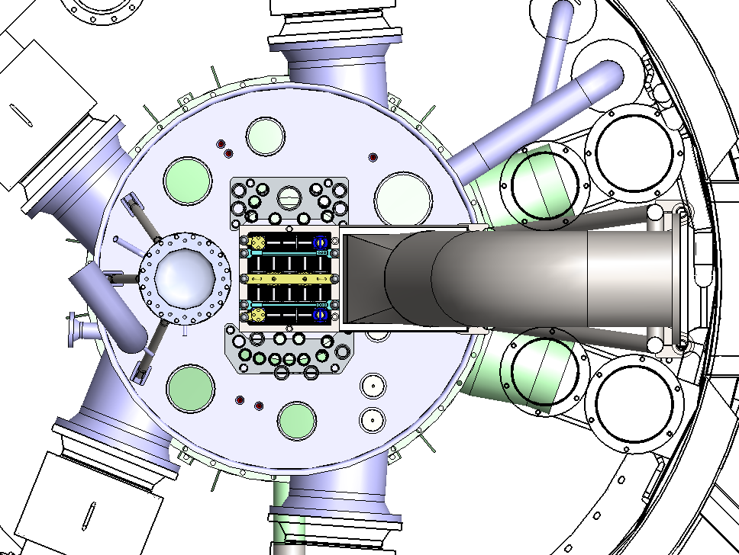
Reflector tank
Cold neutron source
loop Irradition Channel
Reactor primary coolant oulet
reACTOR Core

FIG. 1. Loop Channel Location

Transfer channel
Through Tunnel to LOOP services room
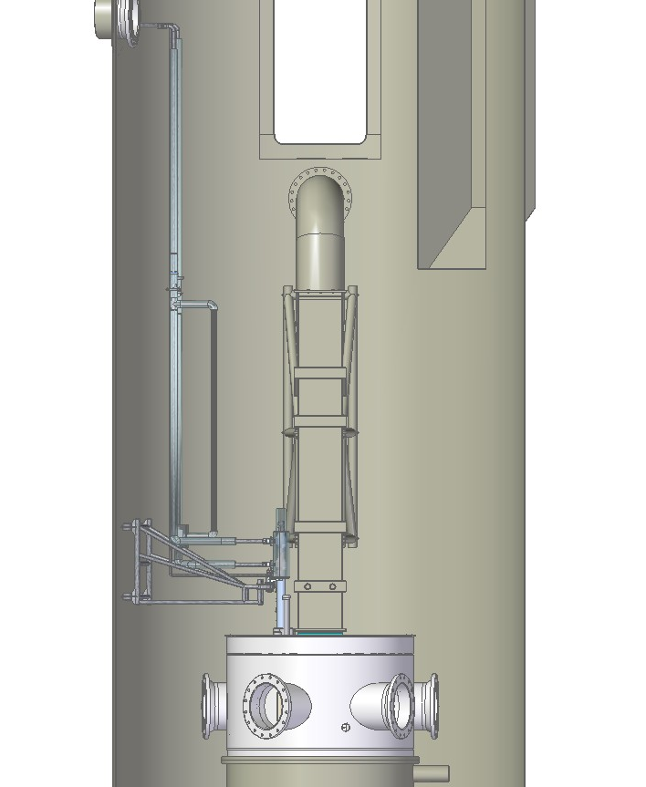
LOOP
Support
Reflector
tank
MI in irradiation place
reactor pool
primary coolant chimney
Passive Shut down coling system
INTERFAce
FIG.2. MI & Interface Location inside de Reactor Pool
4.1. Irradiation Module

The IM is mainly composed of: main body & internals assembly lance, head thermal insulation (Fig. 3).
The Main Body is formed basically by two concentric tubes (approximately 2 m long) with a head (0.5 m long). The tubes are named, from inside to outside, pressure and security tubes, the head includes the pass-through instrumentation, coolant inlet/outlet connections and the female connection to assembly/disassembly the internals assembly lance. (Fig. 3)
The internal tube acts as pressure confinement and as a second barrier against fission products release, and the external security tube to protect against pressure tube failures.
The security tube, has two main functions:
- Normal operation. To form, together with the pressure tube, an annulus where the gas that will act as thermal barrier between the water of the reactor pool (approximately at 40ºC) and the water flowing through the IM (approximately at 310ºC) shall be placed.
- Pressure tube failure: it will act as the last pressure limit.
Each one of these tubes is closed at the lower end with torispheric caps (Fig. 3). In the upper part, above the core both tubes are welded to the head, where the pressure boundary becomes only one.
The Internals Assembly Lance is composed of: instrumentation pass-through, male connection to assembly/disassembly internals lance, fuel rods assembly supporting and instrumentation guide tube, fuel rods, support structure and spacers for fuel rod.
In the bottom part (approximately 1 m long): an annular zone is formed between the external liner and the security tube to allocate the liquid neutron absorber, an annular zone between the pressure & security tubes forms a gas jacket acting as thermal insulator to the reactor pool. Inside the pressure tube a flow split tube forms two coaxial paths for primary coolant flow: the down comer, an annular cross section between the tube and the divisor that directs flow downwards, and the raiser, the internal section of the divisor that directs the flow upwards through the fuel rods zone and internals (Fig.3 y 5).

4.2. Interface

The interface laid out underwater and connects the in-pile and out-of-pool parts, it means between IM to the Process Systems. The underwater connections running in pressurized metallic lines are broken sown as follows:
- Mechanical connections, thermally insulated, linking the IM to the leak-tight tunnel flange pool penetration at -4 m below the free level of the water and terminating in the bunker.
- Electrical connections linking the in pile instrumentation to junction boxes (also positioned in the leak-tight tunnel flange), terminating in the bunker connected to the monitoring and control racks.
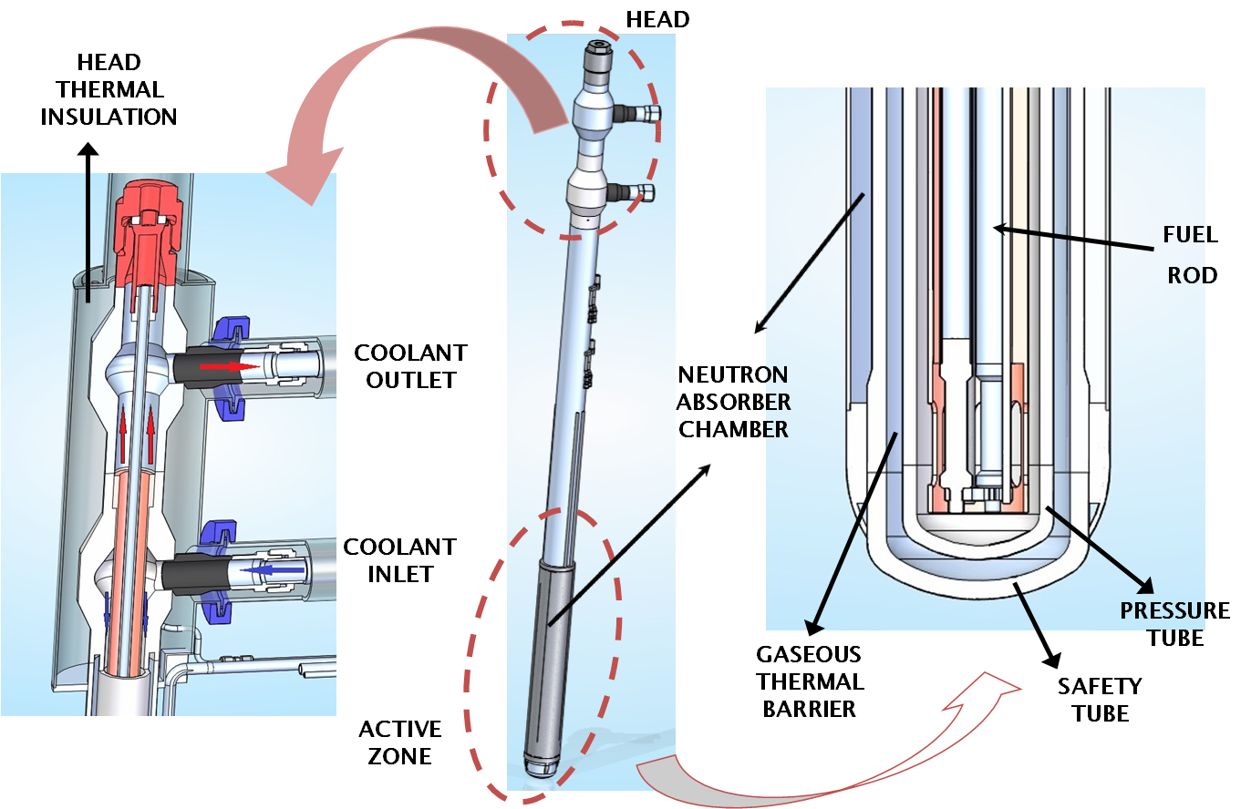

FIG.3. General & Details views.

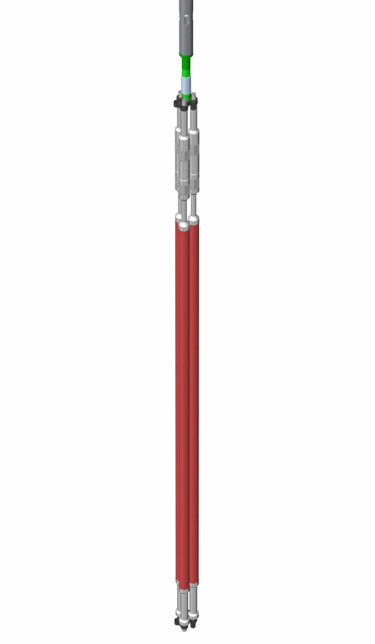
Fuel Rods
fuel rods Spacers
Fuel rods assembly support and instrumentation guide tube
FIG.4. Internals Assembly Lance: Lower Part views.

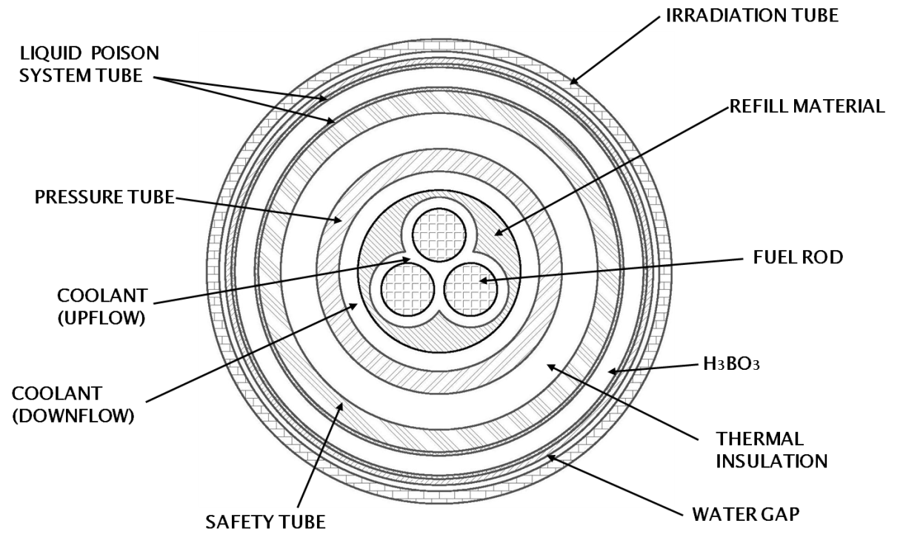

FIG.5. Fuel rods zone cross section.

4.3. Process & Services Systems

Primary Heat Transport System (PHTS) removes irradiation power from test fuel rods while maintaining required process operation conditions. The Purification and Volume Control System (PVCS) maintains primary coolant quality and chemical parameters as required by irradiation test. PHTS is cooled by the Intermediate Heat Transport System (IHTS). Irradiation power and process heat are evacuated to ambient in Reactor Secondary Cooling System by mean of Final Heat Transport System (FHTS). An airtight room inside the LOOP Services Room is provided to contain high energy and potentially radioactive release from process systems. This Bunker, not accessible in operation, acts as a dynamic confinement in response to events potentially leading to such conditions. PHTS and PVCS process equipment is placed inside the Bunker in LOOP Process and Service Room.

PHTS is a pressurized light water loop. Primary coolant flow is maintained by the main pump. A decay tank is provided to reduce activity fields in surrounding areas. System pressure is controlled by means of pressurizer cover gas pressure. Temperature control is carried out by control over IHTS cooling capacity and electrical heaters. Process conditions and parameters are listed in Table I.

TABLE I: PHTS Process conditions and parameters

Condition / Parameter | Value
Power | 80 Kw
Mass Flow | 1-2 kg/sec
Pre-Heaters | 10 Kw
Pressure | 150 bar
Temperature | 330 °C

A fraction of primary coolant flow is derived to PVCS and re-injected continuously. Purification and chemical control are implemented at reduced pressure and temperature. Purification involves ion exchange in resin beds. Coolant pH and dissolved O₂ concentration are controlled by chemical addition; dissolved H₂ is also controlled.

FIG.6. Process Systems Block Diagram.

Ventilation of Bunker and Services Room is provided by Reactor Ventilation Systems and the LOOP Ventilation Interface. This interface comprises components for the Bunker isolation, Process and Services Room ventilation, process off-gas management and discharge to Reactor Ventilation Systems.

The shutdown cooling system consists basically of a pipe connected to the inlet and outlet of the coolant to the irradiation device completely submerged in the reactor pool. Through a check valve, it is maintained isolated from the normal operation loop. In normal shutdown or in case of loss of flow accident (LOFA), this valve shall open passively (due to the disappearance of the differential pressure between the inlet-outlet IM) and will enable the passive removal of radioactive decay heat towards the reactor pool (natural convection). The heat removal capacity of this system is approximately 30% of the LOOP nominal power.

Other LOOP Process Auxiliary Systems, including process air, process effluents, electrical supply and others, are designed as adequate interfaces to Reactor services equipment and systems.

5. Irradiation Power Control

LOOP power, developed in test fuel elements under irradiation, can be varied or modified by action of Liquid Neutron Absorber System (LNAS). This system effectively acts as a neutron absorbent shade (screen) that varies the irradiation neutron flux. The shade is made up of a hydraulic chamber, surrounding the active length of IM, and the dissolved neutron absorbent element compound. The absorber is ¹⁰B in the form of boric acid. Irradiation neutron flux variation is actually achieved by variation of the concentration of the solution in the chamber. Fluid circulates from/to the LOOP Process and Services Room. Heat generated in the capture reaction and deposited in process flow is transferred to FHTS.

Process system is designed to implement different concentration variation schemes and rates intended to cover user requirements and operational constrains. Process equipment includes a circulation pump, a heat exchanger with Reactor Secondary System, 3 operation tanks, a diluted solution storage tank and various services and auxiliary components.

Irradiation power control operation is involved in developing of following functions:
- Reactor Start-Up power transient accommodation
- Power ramp tests
- Power adjustment in base irradiation tests (cumulative burn-up)
- Screening for LOOP Stand-By

Reactor Start-Up power transient accommodation is intended to minimize the effects of power increase rate over test fuel elements that could lead to spurious effects and erroneous results interpretation.

Power ramp tests involve creating controlled power transients as required for a certain irradiation test. Generation of a controlled irradiation history under known conditions previous to developing the ramp test and repeated or sequencing of various ramps are considered in design.

Power adjustment in base irradiation tests is required mostly when constant power profile is required in a long term irradiation test. Typically this type of tests has an initial power generation that exceeds requirements. In this case power adjustment is intended to provide a means of maintaining irradiation power in the required band along this type of tests.

Screening for LOOP Stand-By is required to diminish irradiation power to appropriate levels for LOOP Passive Cooling System. This function is not intended as operational and not as a safety action or LOOP shut-down ability and the goal is to reduce Reactor shut-down time due to LOOP non availability.

6. Neutronics Aspects

TABLE II: Neutronics parameters

 | Burn-up Accumulation Tests |  | Ramp Tests
 | 0 ppm ¹⁰B | 7500 ppm ¹⁰B | 0 ppm ¹⁰B | 7500 ppm ¹⁰B
Rods Total Power [W] | 53018 | 15013 | 22080 | 5834
Max Linear Power [W/m] | 512 | 148 | 600 | 161
Thermal Neutronic Flux in rods [n/cm²s] | 3.14E+13 | 1.19E+13 | 3.8E+13 | 1.35E+13
Epi-Thermal Neutron Flux in rods [n/cm²s] | 3.69E+13 | 2.21E+13 | 3.18E+13 | 2.21E+13
Fast Neutron Flux in rods [n/cm²s] | 3.07E+13 | 1.08E+13 | 2.79E+13 | 9.6E+12
Total Neutronic Flux in rods [n/cm²s] | 9.90E+13 | 4.47E+13 | 9.77E+13 | 4.43E+13
Reactivity Change due to LPS [pcm] | -126 |  | -117
First cycle burn-up [MWd/TonU] | 1384 | 384 | 1748 | 453
Total Power to be evacuated by HTPS [W] | 58874 | 17803 | 28449r | 12203
Total Power deposited out of HTPS [W] | 8040 | 14483 | 7790 | 14403

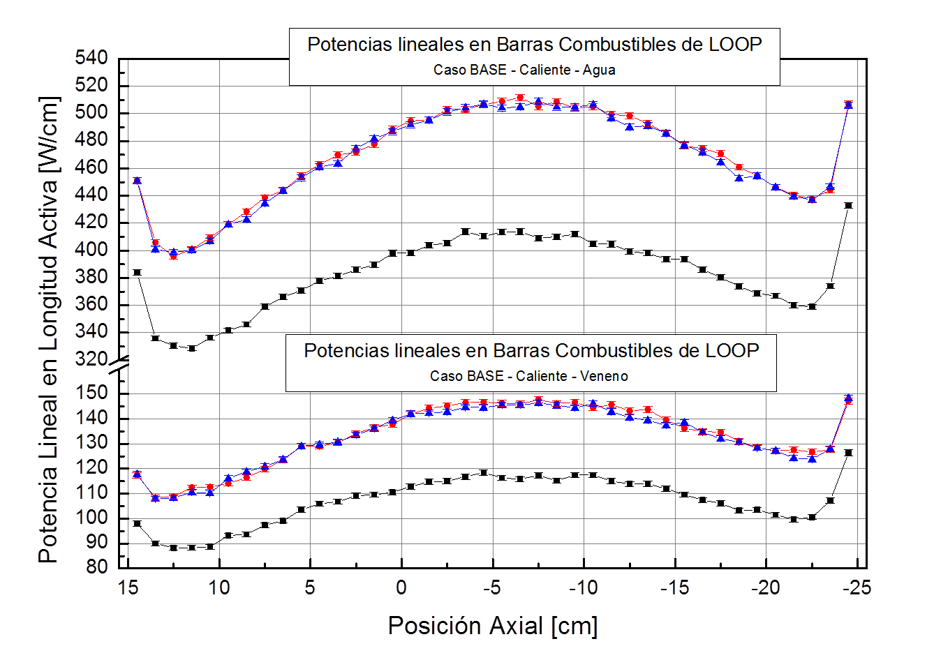
Linear Power [W/cm
Fuel rods Linear Power (0 ppm ¹⁰B)
Axial Position [cm]
Fuel rods Linear Power (7500 ppm ¹⁰B)

FIG.7. Linear Power Axial Distribution- Accumulation Burn-up Test.
7. Thermal-Hydraulics Aspects

Burn-up accumulation Tests

TABLE II: Thermalhydraulics parameters

Linear Power : | 500 W/cm
Heat Flux | 146 W/cm²
Total Power | 72 KW
Mass Flow Rate | 2 kg/seg
Coolant velocity | 8,8 m/seg
Coolant ΔT | 6,3 °C
Clad Temperature | 321 °C
RDNB | 2.95

8. Instrumented Systems

Instrumentation and instrumented systems are provided to cover safety, operational and experimental aspects.

LOOP Protection System (LPS) is a safety system designed to protect against LOOP postulated initiating events, terminating them safely thus limiting the potential of hazard to the experiment, the Reactor and the personnel. LPS is an automatic and independent system interconnected to Reactor Protection System (RPS). The LPS is designed so that this interconnection does not alter quality ad effectiveness of RPS, following the same specific safety principles and requirements as the RPS. LPS acts by detecting the occurrence of initiating events and demanding Reactor Shut-Down Systems through RPS. LOOP dedicated annunciators and commands are provided in the Reactor Main Control Room for operator notifications and actions over LOOP safety actions.

LOOP Supervisory and Control System (LSCS) is provided to control LOOP process systems in order to maintain experiment operating conditions within required and safety limits. LSCS is an independent system that collects LOOP systems and equipment information and makes it available to operators. LSCS interconnects with LPS and acquires safety variables and system status information. It is also interconnected with Reactor Supervisory and Control System to make information available for plant supervision and to receive Reactor status and conditions for LOOP operation. Operator interface in Reactor Main Control Room is provided to cover operation, process variables visualization and alarm annunciation.

LOOP Experiment Monitoring System (LEMS) is provided for experiment specific instrumentation, variables and information acquisition and storage. It makes acquired information properly available to experimenters. Flexibility on information acquired by the system is on the basis of design since diverse experiments may require different instrumentation and information. LOOP specific irradiation conditions and Reactor neutronic variables, LOOP process variables and other plant information are collected and registered by this system. LEMS is interconnected with LSCS. LOOP in core experiment specific instrumentation includes the following:
- Thermocouples for test fuel rods cladding temperature
- Thermocouples for test fuel rods pellet temperature
- SPND for LOOP irradiation neutron flux

8. Loop Operacional States

- IRRADIATION
  - Irradiation Module is in Reflector Tank, Loop cooling and safety systems are operative
  - REACTOR full power
- STANDBY
  - Irradiation Module in Reflector Tank and poisoned. Passive cooling systems activated
  - Reactor start-up allowed
- SHUTDOWN
  - Irradiation Module in Reflector Tank, Loop cooling and safety systems are NOT operative
  - REACTOR start-up inhibited
- TEST
  - Irradiation Module in Reflector Tank, Loop cooling and safety systems in mode TEST.
  - REACTOR start up inhibited
- REPOSE
  - Irradiation Module in Service Pool.
  - Reactor start-up allowed

