Description and Applications of the Neutron Imaging Facility at RA-6

J. Marín¹, A. Baruj^{1,2,3}, G. O. Meyer^{1,2,3}, F. Cantargi^{1,2}, F. A. Sánchez^{1,2}

1) Centro Atómico Bariloche, CNEA, Av. Ezequiel Bustillo 9500, Bariloche, Argentina.
2) Instituto Balseiro, Universidad Nacional de Cuyo-CNEA, Argentina.
3) Consejo Nacional de Investigaciones Científicas y Técnicas, Argentina.

Corresponding author: jhmarin@cab.cnea.gov.ar

Abstract. In 2012, the new neutron imaging facility of the RA-6 research reactor became functional. The neutron beam of this facility uses a radial extraction tube which has a double cone collimator with L/D=100. The beam is shaped by a delimitating collimator made of lead and borated polyethylene, being its size 20 cm x 20 cm at the sample position. The sample is placed in a shielded space of 40 cm x 40 cm x 40 cm. The back wall of this space is an aluminium sheet that supports a 20 cm x 20 cm ⁶LiF scintillation screen. The resulting image is reflected by two front-surface mirrors placed at 45 degrees into the axis of a Peltier-refrigerated CCD camera. This camera records images with a resolution of 2776 pixel x 2074 pixel and 65536 grey levels. The mirrors and camera are all located inside a light-tight box. Finally, a heavy concrete beam-catcher stops the remaining neutrons. After the description of the facility, in this work it is shown the application of neutron imaging to objects belonging to the cultural heritage and to the study of hydrogen-storage devices.

1. Introduction

Argentinian nuclear activities began in 1950 when the Comisión Nacional de Energía Atómica (CNEA) was created. In 1957 Argentina had it first research reactor locally developed, the RA-1. One of its successors is the RA-6, built in 1982. This reactor is placed in Bariloche (part of the Argentinian Patagonia), and it is a materials testing, open pool type, nuclear research reactor. Apart from research applications, its main purpose is to help forming new physicists, engineers and other related professionals. Although the RA-6 was originally designed to operate up to 500 kW of thermal power, in 2009 its core was changed so now it can achieve a maximum thermal power of 3 MW. Up to date, due to licensing issues, it is allowed to operate up to 1 MW. Many facilities of the reactor had to be redesigned since this power improvement, being the neutron imaging facility among them [1, 2]. In this paper details of the new facility are given and examples of neutron images are also presented.

2. Neutron imaging system

2.1. General setup

The Bariloche’s neutron imaging facility (NIF) uses the extraction tube number 1 of the RA-6. This tube points radially to the nuclear core, penetrates the reactor biological shielding and ends at the graphite reflector. FIG. 1 schematically shows the location of the NIF in the hall of the RA-6. The NIF is placed between the Boron Neutron Capture Therapy (BNCT) and the Prompt Gamma Neutron Activation Analysis (PGNAA) facilities.

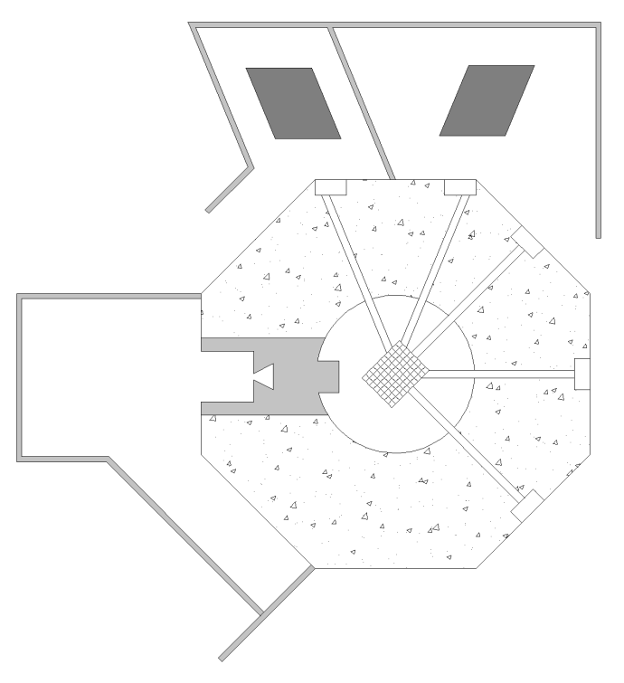
BNCT
NIF
PGNAA
#1
#2
#3
#4
#5

FIG. 1. Schematic layout of the facilities of the RA-6.

2.2. Collimation

An aluminum tube allows properly placing a collimator and filter into the extraction tube. The middle section of this tube is floodable, while the remaining parts are watertight (see FIG. 2). Following the beam direction, the first part of the tube hosts the collimator. The collimator is a 40.2 cm long cylinder, placed at 85 cm from the source and consists of three parts. The first one is a convergent cone made of borated polyethylene and it mainly acts on thermal and epithermal neutrons. This part hosts three sapphire filters, each of 5 cm in longitude, which reduce the fast and epithermal components of the beam, while affecting as little as possible the thermal component. The filter is followed by a cadmium disc for precisely collimating the thermal component of the neutron beam. The final part of the collimator is a divergent cone made of lead which is necessary for reducing the gamma component without affecting the neutron beam.

After the collimator, the aluminum tube has a floodable middle section and a final beam shaping section. The desired beam shape is a square of 20 cm side, at the sample position. To achieve this shape, the final section contains a combination of several pieces of borated polyethylene and lead. The resulting cylinder has the inner form of a truncated pyramid. The interior surface of the shaping section has a cadmium lining.

By design, the ratio between the source to sample longitude (L) and beam aperture (D) is fixed to 100 (L/D = 100).

The thermal neutron flux at the sample position is 5.08x10⁶ n/cm²s.

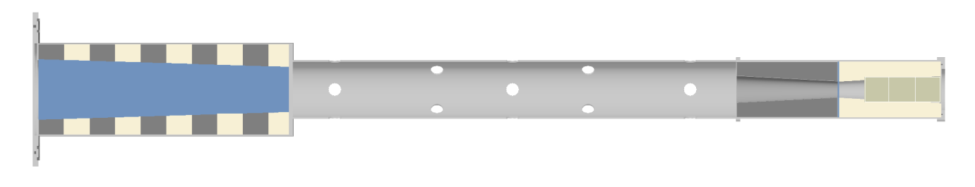
Cd lining
Lead
Borated polyethylene
Lead
Borated polyethylene
Cd disc
Beam direction
Shaping section
(watertight)
Middle section
(floodable)
Collimator
(watertight)
Sapphire
filter
FIG. 2. Cross section of the aluminum tube that hosts the collimator.

2.3. Imaging equipment

The detection system uses a scintillation screen made of ⁶LiF/ZnS doped with Ag, it is 20 cm x 20 cm and was made by Applied Scintillation Technologies [3]. Its scintillation light peak is at 450 nm. The light is reflected out of the beam path by a set of two front surface mirrors [4] in order to protect the CCD camera from radiation. A condensing lens focuses the image onto the camera. The lens is a Schneider Kreuznach Xenon [5] and is operated at its lowest available f-number (f = 0.95). The installed camera is a Penguin 600 CLM from Pixera Corporation [6]. It has a maximum resolution of 2776 pixels x 2074 pixels and provides digital depth of 16 bits. The CCD dark current is reduced by a four stage thermoelectric Peltier cooling device. The camera with the lens is placed on a light tight box.

2.4. Shielding and sample chamber

In order to protect the users from radiation and to extend the lifespan of the camera, a shielding has been incorporated. Surrounding the path of the beam, the shielding consists of 30 cm thick walls of wax loaded with boron, followed by 2.5 cm thick lead walls, all these embedded in steel housing. For ending the beam, a heavy concrete cylinder of 130 cm length by 90 cm in diameter is used. The sample chamber allows placing objects of 40 cm x 40 cm x 40 cm (see FIG. 3). A shielded door gives access to the sample chamber. To allow the possibility of imaging long objects, portions of the roof and floor of the chamber may be removed.

3. Applications

3.1. Cultural Heritage

Neutron imaging techniques can contribute to understand the process of manufacturing, the application and origin of unique objects that belong to the cultural heritage. For that reason we have invited people from local museums to collaborate on a first stage of application of neutron imaging to this kind of objects.

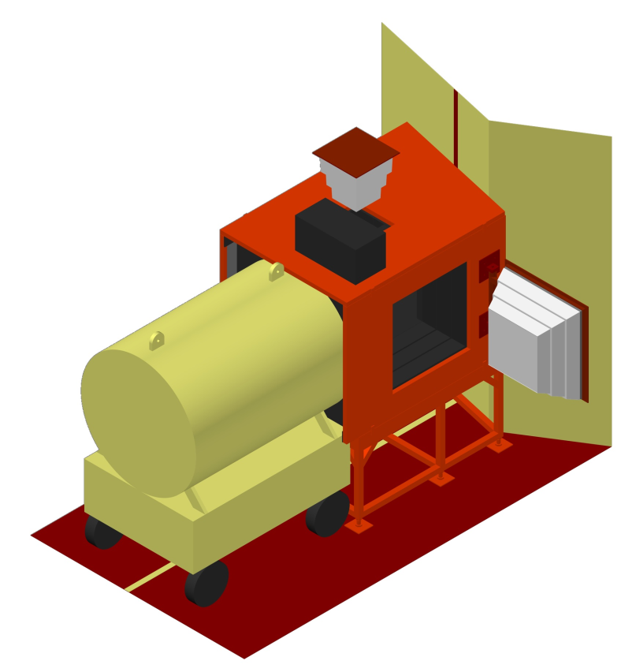
Beam-catcher
Light tight box
Upper removable
portion
Reactor’s face
Access door

FIG. 3. Schematic model of the neutron imaging facility.

At this stage we wanted to identify the capabilities and limitations of our facility, to settle agreements with local researchers of cultural heritage and to find the proper way of transporting and handling the objects.

A successful agreement has been established with a research center (Patrimonio e Instituto Histórico de la Ciudad de Buenos Aires) that, among other things, performs excavations on backyards and dumps of historical houses of the city of Buenos Aires. We have received and analyzed beads from necklaces, an iron, a door handle, a metal pitcher and bones with different degrees of mineralization, some of these objects are shown in FIG. 4.

3.2. Hydrogen storage

The Materials Physical-Chemistry Group of Centro Atómico Bariloche is developing hydrogen-storage devices for applications that require hydrogen as an energy vector. These devices are based on the absorption and desorption of hydrogen by LaNi₅, a hydride forming material [7]. The absorption/desorption reactions are controlled by temperature or by pressure. Since the devices are in a prototype phase, it is required to validate the theoretical models that describe their dynamics and functioning.

The device studied uses 198.8 g of LaNi₅ as hydride forming material, which allows the device to act as a source or sink of hydrogen according to the temperature settings. During hydrogen absorption, LaNi₅ transforms to LaNi₅H₆ at room temperature with a hydrogen pressure higher than 300 kPa. On the other hand, by controlling the temperature of a central heater, the hydrogen is desorbed by the material. The outlet H₂ pressure can be set in the range between 400 kPa and 2000 kPa by controlling the heat power.
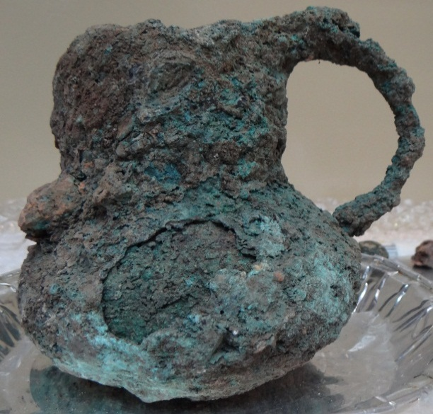
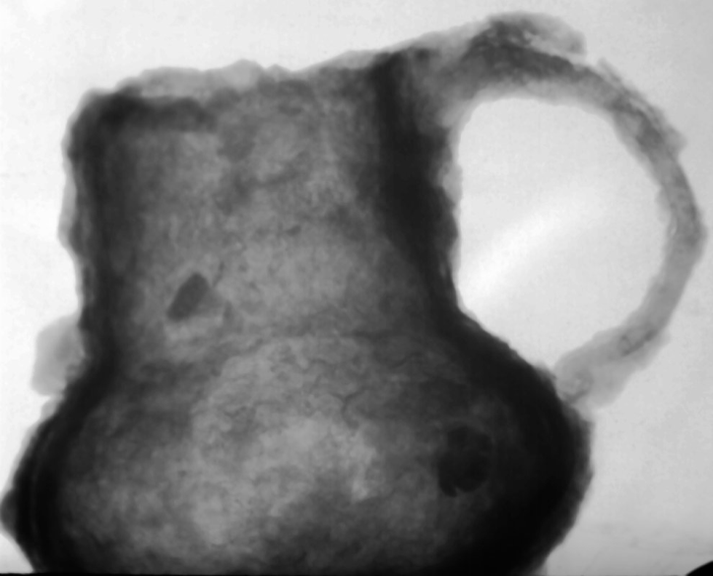
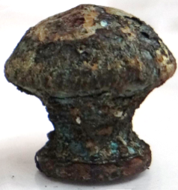
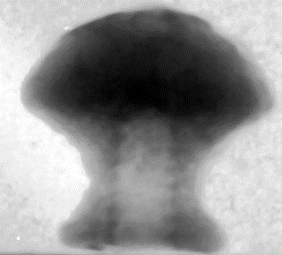
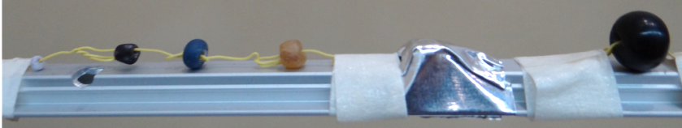
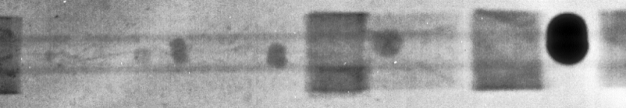
FIG. 4. A. Metal pitcher and its neutron image. The last one allows to identify inclusions covered by the rust. B. Beads from necklaces of various materials and sizes. The neutron image shows that the bigger bead is made of a highly attenuating material. C. Door handle. In the neutron image it can be seen the turns of the thread.
A
B
C

The device studied (see FIG. 5) is a cylindrical chamber with an external diameter of 12 cm and an inner volume of 65 cm³. The body is made of stainless steel 304L and it is 18 mm thick. The chamber has two thin covers of stainless steel, one is removable and it is sealed by an O-ring. The inner pressure is supported by two external aluminium covers of 6.8 mm and 8.9 mm. All the covers are kept attached by eight Allen screws. A cupper tube reaches the center of the device; this tube allows placing a resistive heater. A stainless steel tube penetrates the upper part of the device and allows the charge/discharge of hydrogen.

A set of neutron images was obtained for the device fully charged with hydrogen while temperature was applied by the central heater. The images were taken every minute, for a total period of 83 minutes. A montage of some of these images is shown in FIG. 6.

In the neutron images, it can clearly be seen the interior of the device, the Allen screws, the gas extraction tube, the central heater with its wires and the hydride powder. As the temperature increases, the powder liberates hydrogen. This is seen as a light grey circle that grows radially from the center. The contrast between this growing circle and the rest of the powder gradually reduces over time. This is because heat transport by the metal walls accelerates the reaction of the material in contact with them.

These results show that neutron imaging is a useful tool for dynamics studies of this kind of devices. By evaluating the rate of hydrogen liberation, models can be validated and this may help finding an optimal geometry for the device.
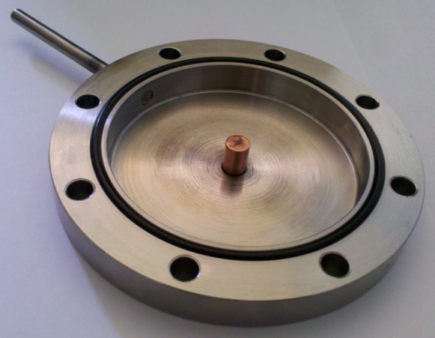
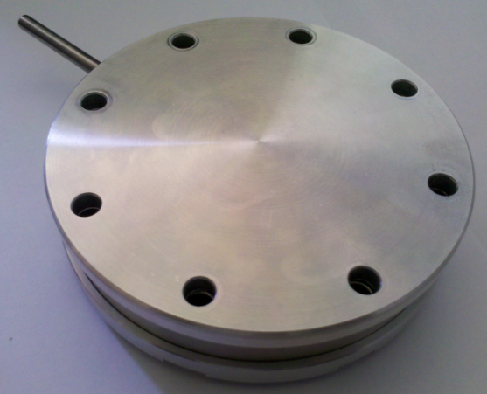

FIG. 5. Photographs of the device studied, with and without its aluminium cover.

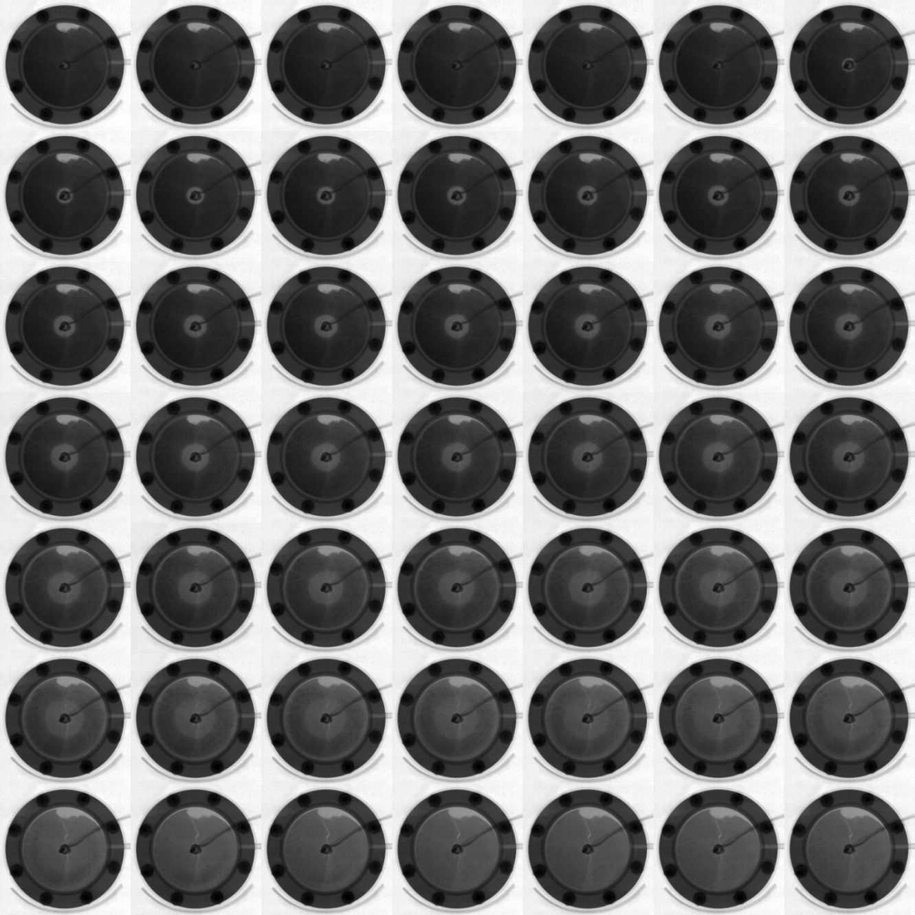
FIG. 6. Montage of the neutron images obtained for the hydrogen storage device. The steady state is seen at the top, extreme left. By applying heat to the hydride, the reaction liberates hydrogen, this is seen as a grey circle that grows radially from the center. At a certain time, the heat is also conducted by the aluminum walls, so the reaction loses preference.

4. Conclusions

A thermal neutron imaging facility has been set up at RA-6 research reactor in Centro Atómico Bariloche, Argentina. At the sample position, the thermal neutron flux is of 5.08 x 10⁶ n/cm²s. The facility allows taking good quality neutron images with exposure times below one minute.

After two years of activity, its utility has been proven in many areas of interest. Some of these results have been included in this report. In particular, this technique seems to be promising for studying hydrogen storage devices.

Further work is being performed in order to improve the quality of the images. Some attempts to obtain neutron tomographies also have been done.

5. References

- MEZIO, F., “Caracterización y optimización de la facilidad de radiografía con neutrones on-line del reactor RA-6”, Final project for achieving the Nuclear Engineering degree at Instituto Balseiro, 2007. Available in Spanish at http://ricabib.cab.cnea.gov.ar/
- PIECK, D., “Rediseño de la facilidad de neutrografía del RA-6 y su aplicación a la tecnología del hidrógeno”, Final project for achieving the Nuclear Engineering degree at Instituto Balseiro, 2009. Available in Spanish at http://ricabib.cab.cnea.gov.ar/
- http://www.appscintech.com/
- http://www.firstsurfacemirror.com/
- https://www.schneideroptics.com/
- http://www.pixera.com/
- MANGIAROTTI, F., “Desarrollo de una fuente de hidrógeno de media presión basada en materiales formadores de hidruros”, Final project for achieving the Nuclear Engineering degree at Instituto Balseiro, 2009. Available in Spanish at http://ricabib.cab.cnea.gov.ar/

