Neutronic Design of the RA10 Research Reactor´s Core

J.M.Tuñón¹, E.A.Villarino¹, D. Ferraro¹, P. Camusso¹, G. Sarabia¹, F.Sánchez²

1) INVAP S.E, Nuclear Engineering Division, Av. Cmte. Luis Piedrabuena 4950, S.C. de Bariloche (R8403CPV), Argentina
2) CAB-CNEA (National Atomic Energy Commission)

Corresponding author: jtunon@invap.com.ar

Abstract. The RA-10 Research reactor is a multi-purpose open-pool type reactor, currently being designed jointly between INVAP and CNEA, and owned by this last institution. It has a nominal fission power of 30 MW, with the capability of producing several radioisotopes, while providing suitable conditions for many types of irradiation tests.
The reactor core is located inside a chimney, surrounded by heavy water contained in the Reflector Vessel, filled with Heavy Water. The whole assembly is at the bottom of the Reactor Pool, which is full of de-mineralized light water acting as coolant, moderator and biological shielding. The Fuel compound is LEU- U₃Si₂.
Reactor shut down can be achieved by two different means, which are the insertion of six Control Rods into the core, or the partial drainage of the heavy water from the Reflector Vessel.
Two types of neutron sources are foreseen: a cold neutron source with two tangential beams, and thermal neutron source with two beams; both with several neutron guides.
The current neutronic design of the Reactor´s Core and the verification of the design criteria, as well as the testing capabilities are also fully described.

1. Introduction

The RA10 Research Reactor is a multi-purpose open-pool type facility, which design is a result of the technical collaboration between INVAP and CNEA [1]. It is currently at the Detail Engineering stage, and its first criticality is foreseen by 2018.
The nominal fission power is 30 MW. The reactor’s core is located inside the Chimney, surrounded by heavy water contained in the Reflector Vessel. The whole assembly is at the bottom of the Reactor Pool, which is full of de-mineralized light water acting as coolant, moderator and biological shielding. The coolant flows upwards.
The reactor core is composed by 4 main components:
- 19 plate-type Fuel Assemblies (FAs).
- 6 Absorber Plates (AP) which are driven through Guide Boxes.
- 4 in- core Thermal flux Irradiation Facilities.
- 2 in-core Fast flux Irradiation Facilities.

The FAs are square shaped, each of them containing 21 fuel plates and using Cd wires as burnable poison.
Reactor shut down can be achieved by two independent means, which are the insertion of the six APs into the core, or the partial drainage of the heavy water from the Reflector Vessel.
The reactor is designed for the accomplishment of two main purposes:

- The continuous production of several radioisotopes, such as ⁹⁹Molybdenum, and ¹⁹²Iridium, among others; and Neutron Transmutation Doping in Silicon ingots.
- Perform several types of experiments, for what features thermal and fast neutrons in-core Irradiation Facilities, Pneumatic Rigs with a wide range of neutron fluxes, two Cold Neutron Beams provided by a Cold Neutron Source, two Thermal Neutron Beams, one particular Beam for a underwater Neutron radiography facility, one Power Reactor FAs testing Loop and a MTR FAs testing position.

Both of these purposes are compatible, minimizing the perturbations produced by one another.
The reactor will be provided with a particularly designed Cold Neutron Source to produce neutrons in specific spectral ranges. Specially designed neutron beam guides featuring high technology super-mirrors will extract these neutrons from the Reflector Vessel up to the positions where the experiments will be located.

2. General Description of the Capabilities of the RA-10

2.1 Reflector Vessel

Figure 1 shows a scheme of the current design of RA-10 Reflector Tank and Core.

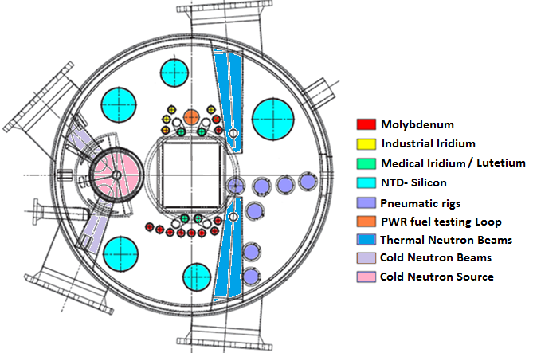
Figure 1: Scheme of the RA-10 Reflector Vessel and Irradiation Facilities Layout

The layout of the Out-Of-Core Irradiation Facilities responds mainly to the Thermal flux levels, in order to accomplish the performance requirements. For each of them, the heat load deposition is estimated in order to ensure a proper cooling.

The Molybdenum, NTD-Silicon and Pneumatic rigs are non-fixed positions, which means that can be loaded or unloaded while operating the reactor.
Two neutron beams transport very low energy neutrons (namely, cold neutrons, with energies below 10 meV) - which are moderated in the Cold Neutron Source- outside the Reflector Vessel. From there, neutron guides transport neutrons from one beam to the Reactor Face; and to the Guide buildings from the other.
Two neutron beams transport thermal neutrons (E < 0.1 eV) -which are originated in a Thermal Peak zone- outside the Reflector Vessel. From there, neutron guides transport neutrons from one beam to the Reactor Face; and to the Guide buildings from the other.
A fifth beam transports Thermal neutron to an under-water Neutron radiography facility.

The partial dumping of the Heavy Water in the Reflector Vessel works as the Second Shutdown System.

2.2 Core

Figure 2 shows a scheme of the RA-10 reactor core, limited by the Chimney. Four main components can be observed: Fuel Assemblies, Absorber Plates that slide inside the Guide Boxes, two Fast Neutron Flux Irradiation Facilities, and four Thermal Neutron Flux Irradiation Facilities, located in the corners.

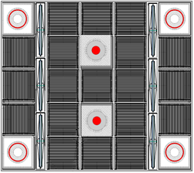
Figure 2: RA-10 reactor core.

The Standard Fuel Assemblies use U₃Si₂ with a Uranium density of 4.8 g U/ cm³. The fuel management strategy has an operating cycle of around 30 Full Power Days, and around 2 days for maintenance and refueling. Each cycle, four FAs are to be refueled.

The Absorber Plates are used to control the reactivity, and also works as the First Shutdown System, and are moved separately. The inner Plates are smaller than the outer ones, to even their reactivity worth.
The Fast Flux Irradiation Facilities models are composed mainly by Aluminum, to preserve the Fast component of the spectra, and to avoid Power Peaks around them.
The Thermal Flux Irradiation Facilities models are composed mainly by Light Water (same as the coolant circuit) to increase the Thermal flux peaks.

The Core main characteristics are analyzed in the Equilibrium Core, since it is representative of most of the reactor lifetime. This configuration is reached after around 5 cycles, after about 300 Full Power Days of operation.
The First and intermediate cores (Beginning of Life) have some particularities, which led to the design of diverse Fuel Assemblies. The design of the first core is carried out to have an smooth transition to the Equilibrium core.

3. Neutronic Design Requirements

The Neutronic Design requirements can be divided in two main groups: Safety Requirements and Performance Requirements.

3.1. Safety Requirements

These requirements are based on the Argentinean Regulatory Normative (ARN [2] and [3]) and IAEA’s safety standards [4], and are focused to ensure the safe operation of the reactor. This section gives a summary of the nuclear safety neutronic design criteria:

- Reactivity Design Criteria: negative feedback coefficients, enough shutdown margins for both shutdown systems, including single failure criteria. Actuation time of the shutdown systems, reactivity worth of irradiation facilities, reactivity insertion rate of the non-fixed irradiation facilities, reactivity insertion rate of the control system, and more.
- Thermal-hydraulics related criteria: the number of FAs shall be 19 and the Power Peaking Factor lower than 3.3.

3.2 Performance requirements

These requirements are based on the optimization of the usage of the reactor, both in FAs and Irradiation Facilities. This section gives a summary of the Performance neutronic design criteria:
- Flux level: Several irradiation facilities require a minimum value for the neutron flux; but there are other irradiation facilities requiring a minimum and maximum neutron flux value.
- Flux spectra: Different flux levels according to the energy range of neutrons are required in some facilities, for example, in the Cold Neutron Source and Thermal or Neutron radiography Beams.
- Flux Homogeneity: There are requirements on the flux homogeneity in some irradiation facilities, for example the axial homogeneity on Silicon doping facilities.
- Flux Perturbation: The flux in the Irradiation Facilities should be perturbed as less as possible during normal operation.
- Burnup: A minimum discharge burnup of the FAs is required.
- Reactivity Excess: Strongly related to the reactor operation and the burnup of the FAs, a criterion is established to allow the facilities operation through all the cycle while assessing the shutdown margins at the same time.

4. Neutronic Design Process

Figure 3 shows the design flowchart, which covers all the neutronic design aspects. It shows how the Neutronic Design is guided by the following topics:
- Neutronic Design criteria
- Documented calculation model and data.
- Usage of validated calculation codes
- The usage of experimental measurements to verify a proposed design, etc.
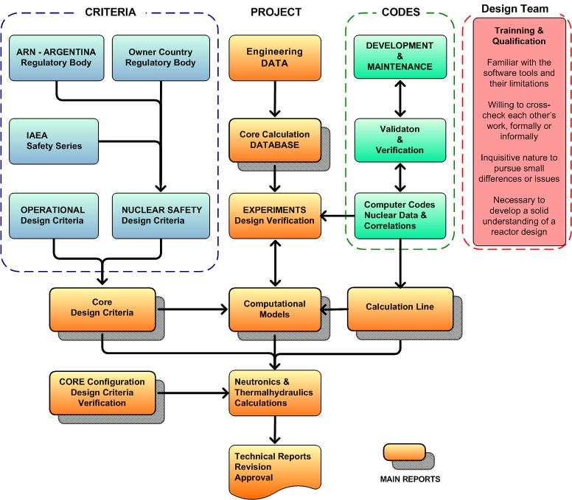

Figure 3: Neutronic Design Flowchart

5. Neutronic Calculation Line

The calculation of the RA-10 is carried out with different validated codes. The calculation line comprises one Deterministic Line [5], and one Stochastic Line.
The Deterministic Line is formed by several codes, described below:

- ESINLM: (EScuela Ingeniería Nuclear Library Manager). This program is used for the maintenance of the nuclear microscopic multigroup XS library. It has for example, the capability to add isotopes from ENDF/B files after NJOY processing. It is based on the WIMS and HELIOS XS libraries.
- ESINPLOT: This is a graphical post processor to plot XS available in the nuclear library.
- CONDOR [6]: This is the cell code performing the neutronic calculation of the fuel assembly (FA) or any component of the reactor core. CONDOR calculates homogenized and condensed macroscopic XS to be used by the core code. It can be also used for the analysis of the FA, or to generate additional data to be used by other codes.
- HXS (Hand XS): Macroscopic XS library manager. This program is the interface between Cell code and Core code. It has the capability to import XS from different cell codes, and export them to different core codes.
- POSLIB: This program is used to generate CITATION microscopic XS libraries from the CONDOR outputs.
- HGEO (Hand GEOmetries): This program is a visual pre processor to generate the geometrical input for CITVAP. It also has the capability to generate PUMA geometrical input.
- CITVAP: This is the core code performing burnup-dependent calculation of nuclear reactor cores, calculating the nuclear parameters associated with several states of the reactor taking into account the feedback of many thermal-hydraulic parameters.
- NDDUMP (Numerical Densities DUMP): This utility is capable to generate burnup dependent numerical densities to be used by MonteCarlo codes such as MCNP or SERPENT codes.
- ARCANE (Advance Reactor Core ANalysis Environment:): This tool allows performing numerical calculations and verifications with the core or cell code calculated parameters.
- POS_CON: This is a graphical post processor of the CONDOR code.
- FLUX: This is a graphical post processor of the CITVAP code.

The Deterministic Line is used for two purposes mainly:

- Calculation using Macroscopic cross sections: This methodology is used for almost all the neutronic parameters. The equilibrium core burn-up distribution is the most important calculated parameter.
- Calculation using Microscopic cross sections: This methodology is used for the calculation of the kinetic parameters and time dependent calculation.

These deterministic calculations are performed following three main steps: XS library generation, Cell calculations and Core calculations

The Stochastic Line comprises the well-known 3-D Montecarlo transport code MCNP [7], in an up-to-date version. For neutron and gamma calculations, ENDF/B-VI and ENDF/B-VII cross sections are available (among others). This code is mainly used to verify some neutronic parameters by means of an independent calculation method.

Both Calculation Lines are coupled by the NDDUMP code, which exports compositions from the Deterministic Line to the MCNP format. It is used mainly for exporting the FAs burnup compositions, as well as the depleted composition of some components of interest.
These methodologies and their interfaces are shown in Figure 4, where many utilitarian codes are included.

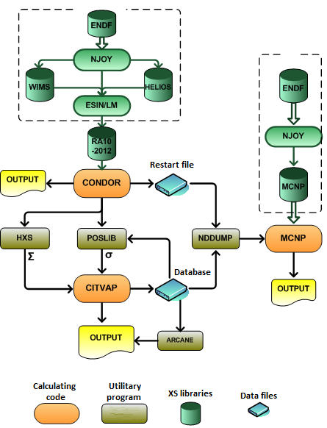
Figure 4: Neutronic Calculation Line

6. RA-10 Reactor Estimated Neutronic Parameters

6.1. Core Reactivity Excess in the main Operational Conditions

Table I shows the reactivity excess of the Equilibrium Core, in the main operational conditions, the Xenon reactivity worth, and the Cold-Hot reactivity swing.
Several refueling strategies had been analyzed in order to indentify the one which optimizes the reactor performance.

TABLE I: Main reactivity values
Operational Condition | BOC | EOC
Cold Shutdown | 7400 pcm | 5100 pcm | Xenon reactivity worth | ~ 3800 pcm
Hot Shutdown | 7100 pcm | 4800 pcm | Cold-Hot reactivity swing | 300 pcm
Full Power | 3400 pcm | 1000 pcm

The EOC reactivity is an indicator of the usage of the Fuel, allowing at the same time enough margins to allow an easy operation of reactor facilities, for what the design is focused on obtaining a Reactivity Excess as close as possible to the 1000 pcm.

6.2. Safety Design Criteria verification

Table II shows the verification of the main safety design criteria parameters.

TABLE II: Verification of the Safety Design Criteria
Design Criteria | Limit | Estimated
Shutdown margin (SM) of the First Shutdown System (FSS) | ³ 3000 pcm | 5000 pcm
SM with single failure of the FSS | ³ 1000 pcm | 2410 pcm
Second Shutdown System (SSS) Shutdown margin | ³ 4000 pcm | 5000 pcm
Power Peaking Factor | ≤ 3.0 | < 2.5
Actuation of FSS at 0.5 sec | ³ 4000 pcm/s | 7500 pcm/s

6.3. Performance Design Criteria verification

Table III shows the design objectives for the different In-Core Irradiation Facilities. All values are accomplished by the design.

TABLE III: Performance requirements
In- Core Irradiation Facilities | Value | Comments
Fast neutrons flux irradiation facility  (E > 0.1 MeV) | > 3.0 10¹⁴ n/ cm² s
Thermal neutrons Flux Irradiation facility  (E > 0.625 eV) | > 1.0 10¹⁴ n/ cm² s | May be used for MTR FAs testing
Discharge burnup | ≥ 45 % | Calculated: 45 %
Absorber Plates lifetime | ≥ 5 years | About 10 years

A representative map of the Thermal Neutrons Flux is provided in Figure 5, while a map of the Fast Neutrons Flux is provided in Figure 6. Both maps correspond to the axial middle plane of the core.
Maps also show the geometrical modeling in the diffusion code.

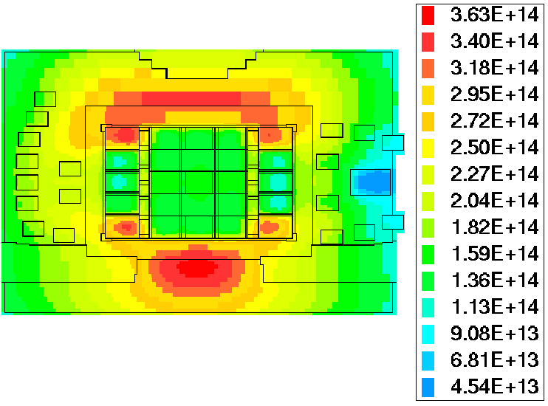
Figure 5: Thermal Neutron Flux map in the core and surroundings (n/ cm² s)

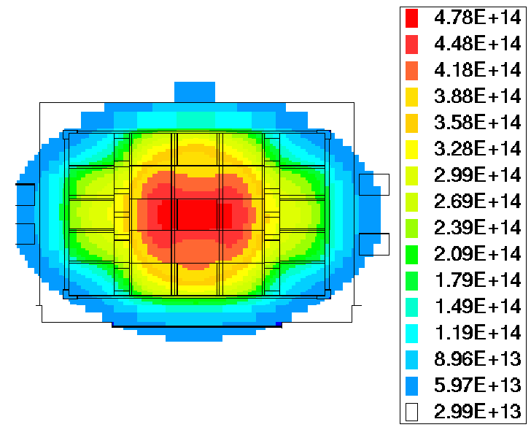
Figure 6: Fast Neutron Flux map in the core and surroundings (n/ cm² s)

6.4. Remarks on the First Core and Transition Cores

If the First core is to be loaded with Standard Fuel Assemblies, the reactivity excess would be too high. For this reason, different FAs are designed specifically for these cores, keeping the geometrical measures while changing the Uranium mass. The main concept is to obtain the same behavior than the Equilibrium core, to make the transition between these cores smoother.
So on, the Uranium mass and Cadmium wires in the First Cores FAs is selected to emulate the burn up distribution of the Equilibrium core.
As an example, the Uranium Masses and the amount of Cadmium wires for the different FAs estimated in Preliminary Engineering are shown in Table IV. These designs are being revised in Detail Engineering.

TABLE IV: Uranium mass and amount of Cadmium wires in First and Transition Cores FAs, in Preliminary Engineering
Fuel Assembly | Uranium 235 mass (g) | Amount of Cadmium wires
Standard Fuel Assembly | 565 | 20
First Core FA - Type1 | 450 | 0
First Core FA – Type2 | 220 | 20

Figure 7 shows the comparison between the Burnup distribution in the Equilibrium Core and the FAs positioning in the First Core.

Figure 7: Burnup distribution in the Equilibrium Core (left and FAs distribution in the First Core (right)

7. Conclusions

At the present, the RA-10 neutronic design is in its last stages, and it is strongly consolidated.
Several design aspects for this reactor, along with the main calculation tools used and the Design process have been presented and discussed.
The current consolidated design accomplishes all the safety requirements imposed by the Argentinean Regulatory Authority, as well as the IAEA´s safety Standards.
The main neutronic characteristics of the Reactor Cores during most of its lifetime have been fully described.
Regarding the overall operation performance, the usage of the Uranium in the Fuel Assemblies has been optimized, allowing enough margins to allow an easy operation of facilities and satisfying all shutdown criteria at the same time.

8. References

[1] Most of the information presented in this paper is obtained from the RA-10 project documentation, which is confidential, and property of the CNEA, with their permission.
[2] Autoridad Regulatoria Nuclear, AR 4-2-2, “Diseño de Reactores de Investigación”, Revisión 1.
[3] Autoridad Regulatoria Nuclear, Guía AR 4, “Diseño de Reactores Nucleares de Investigación”, Revisión 0.
[4] IAEA Safety Standards, NS-R-4 Safety of Research Reactors UR DS476.
[5] Villarino, E; Mochi, I; Sartorio, P; “INVAP Neutronic Calculation Line”, Mecánica Computacional Vol. XXXIII, pages from 3217 to 3226; Asociación Argentina de Mecánica Computacional.
[6] CONDOR Calculation Package Physor 2002, "International Conference on the New Frontiers of Nuclear Technology: Reactor Physics, Safety and High-Performance Computing. Author: E. Villarino.
[7] Forrest Brown, Brian Kiedrowski, Jeffrey Bull, "MCNP5-1.60 Release Notes", LA-UR-10-06235.

