Development of Equipment for Simulating Coolant Flow in a Test Rig

J. T. Hong¹, J. B. Kim¹, S. H. Heo¹, C. Y. Joung¹, S. H. Ahn¹

1) Dept. of HANARO Utilization & Research, KAERI, 989-111 Daedeok-daero Yuseong-gu, Daejeon, Korea

Corresponding author: jthong@kaeri.re.kr

Abstract. Irradiation tests are carried out in the test loop of a research reactor to evaluate the characteristics of nuclear fuels and materials. High temperature and pressurized coolant is circulated through the test rig to remove heat generated during the irradiation test, and it is necessary to verify the soundness of the sensors under the operating conditions. In this study, a coolant flow simulator has been developed to check the behavior of the sensors and calibrate their signals prior to installing the test rig in the test reactor. The coolant flow simulator is designed to circulate the coolant according to the designated flow rate, and test rigs can be assembled to test their components or sensors installed on them. To analyze the heat generation during the burn up test of the fuels, it is necessary to measure the central temperature of nuclear fuels, deviation of coolant temperature, pressure of the coolant, the coolant flow rate, etc. In particular, it is very difficult to measure the flow rate of the coolant when it passes by the fuel rod. In this study, a noise analysis technique is adapted to measure the flow rate of the coolant using k-type thermocouples installed at the inlet and outlet of the coolant according to the information from IFE. Signal acquisition and processing is implemented using NI modules and Labview 2013 software. Then, the calibration process has been carried out with an electronic flow meter, an analogue flow meter, and the bypass line, which is installed in the coolant flow simulator.

1. Introduction

One of the most important things in a nuclear power plant is to effectively remove the heat generated from the nuclear fuel owing to nuclear fission. If the generated heat is not completely removed, the excessive heat can melt down the claddings, leading to an explosion of the reactor system. Therefore, it is necessary to investigate adequate coolant conditions while developing a nuclear fuel. To develop a new nuclear fuel, several kinds of irradiation test should be carried out in a research reactor. In particular, an independent test loop that can circulate coolant under the same conditions as a nuclear power plant should be established to carry out a burn up test of the nuclear fuel. The main activities during the irradiation test of nuclear fuel are measuring the central temperature of the nuclear fuel, internal pressure of the fuel rod, coolant temperature, flow rate of the coolant, and the neutron dose. Among them, measuring the flow rate in the test rig is very important to calculate the heat generation rate of nuclear fuels. IFE in Norway is one of the most advanced institutes in the nuclear field, and has implemented several flow measurement techniques.[1-3] IFE developed flow measurement techniques using a turbine flow meter and thermocouples. Because HANARO at KAERI is an open-pool type reactor, an independent test loop, FTL, is established with a complicated structure. Therefore, it is difficult to apply a turbine flow meter in the in-pile test section. In this study, a flow measurement technique using noise signals obtained from the thermocouples has been developed, and a small-scaled coolant flow simulator has been developed to verify the precision of the flow measurement.

2. Development of Coolant Flow Simulator

A coolant flow simulator that circulates coolant at a controlled speed has been developed to check the characteristics of the components under a high flowrate of the coolant, and to calibrate the flowrate obtained by noise analysis with the flowrate obtained by the calibrated flow meter.

2.1. Design Coolant Circulation System

To develop a coolant circulation system at the laboratory scale, a compact design is necessary including a drain system for optional processes. FIG. 1 shows a piping and instrumentation diagram for the coolant circulation system. As shown in FIG. 1, sensors to check the coolant temperature, pressure, and flow meters in the pipeline will be instrumented. In addition, to pump out stagnant water in the system, drain valves are instrumented at several places in the pipeline, such as the inlet and outlet of the water pump, the bending part, and outlet of the coolant in the test rig.

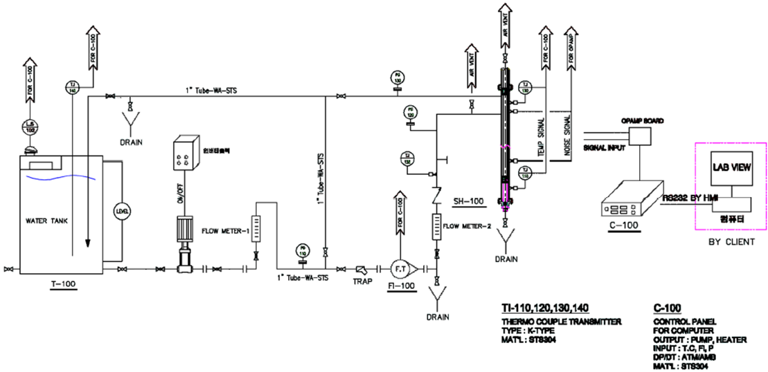
FIG. 1. P&ID for coolant circulation system

2.2. Design Test Rig Mockup and Turbine Flow Meter for Flow Measurement

Because the coolant circulation system is equipped in a laboratory, the test rig with a full length is difficult to be installed in the system. Therefore, the design of the test rig mockup is modified by removing the supporting components, as shown in FIG. 2(a). Because the flow measurement in the test rig is focused on the position of the fuel rods, and the supporting parts do not affect the coolant flow, the supporting parts do not need to be considered in the test rig mockup. To apply a noise analysis technique to measure the flowrate of the coolant, a cross section between the two sensing points should be uniform. Therefore, a duel cooled fuel test rig is considered, and the thermocouples are instrumented at both ends of the fuel rod assembly, as shown in FIG. 2(b).
Then, the design of the pressure vessel, which seals out the highly pressurized coolant and turns the direction of the coolant flow, is modified according to the length of the test rig mockup. In addition, a turbine flow meter is also designed at the bottom of the pressure vessel to calibrate the flowrate, as shown in FIG. 3. Because the fuel rod assembly is located at the bottom of the test rig, the coolant passes the turbine flow meter just before it passes the fuel rod assembly.

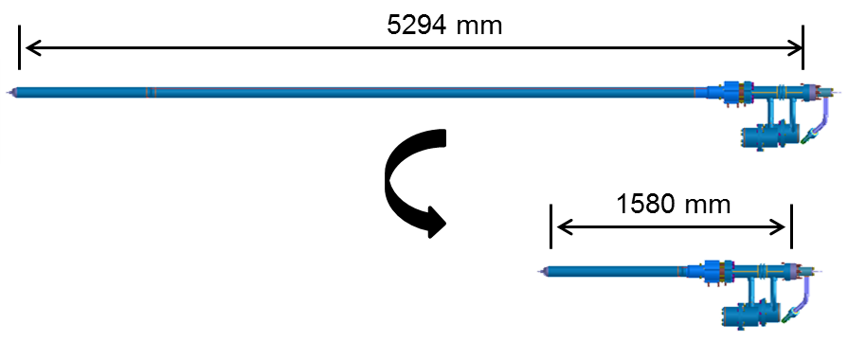
(a) Design modification of the test rig

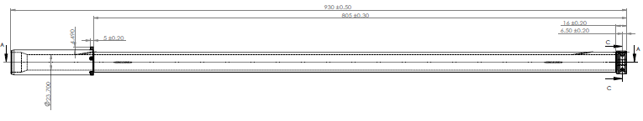
(b) Design modification of a duel cooled fuel rod assembly
FIG. 2. Design modification of the in-pile test section

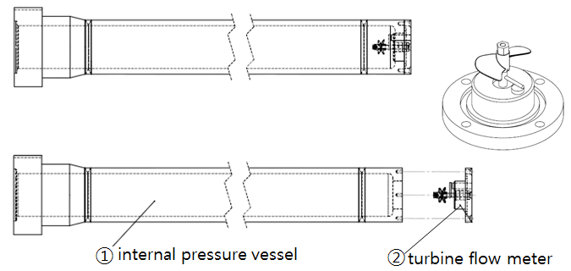
FIG. 3. Design modification of pressure vessel by adding turbine flow meter

2.3. Fabrication of Equipment and Test Rig Mockup

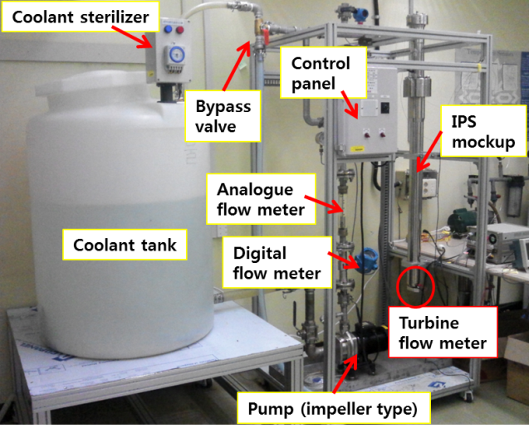
FIG. 4. The coolant flow simulator for flow measurement

Based on the P&I diagram shown in FIG. 1, the coolant flow simulator was fabricated, as shown in FIG. 4. The equipment uses stainless steel pipes a one inch diameter, which is the same with that of the pipes used in the FTL. Coolant is circulated by an impeller typed water pump whose capability is 140 liter/min. In addition, several sensors are installed in the pipe of the equipment to check the coolant temperature, pressure, and flow rate in a timely manner. In particular, there is a bypass line used to enable a calibration of the flow meters installed in the pipeline by comparing the amount of bypassed coolant.
A test rig mockup was fabricated, as shown in FIG. 5. Two k-type thermocouples were installed, as shown in FIG. 5(a), to measure the flowrate of coolant by noise analysis. FIG. 5(b) shows the sequence of fabricating the IPS mockup including the test rig mockup. Before the IPS mockup is installed in the coolant flow simulator, the soundness tests for flow meters and sensors including thermocouples need to be passed.

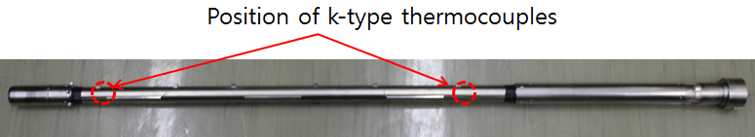
(a) Mockup of the duel cooled fuel test rig

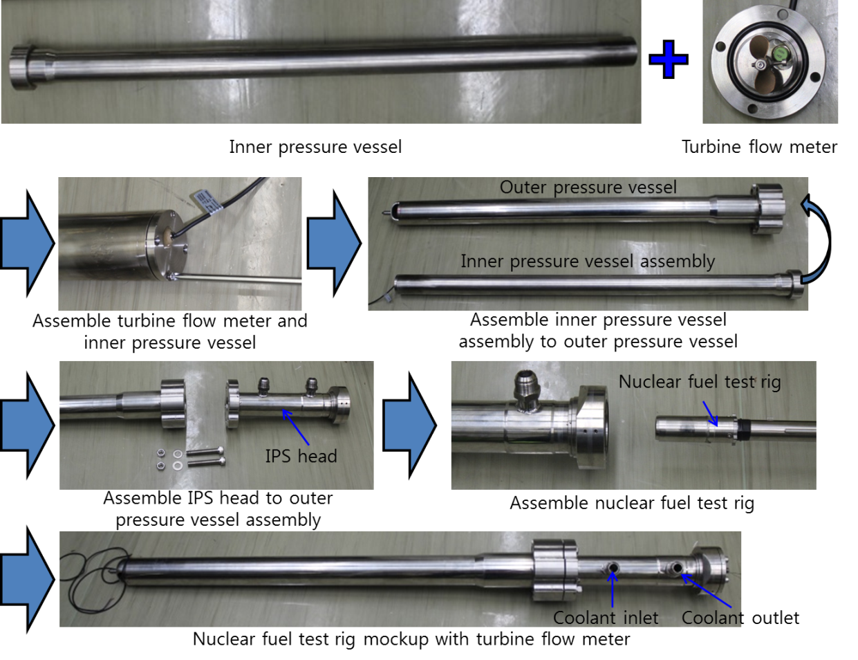
(b) Fabrication of the IPS assembly
FIG. 5. Test rig and the IPS mockup

3. Experiment for Flow Measurement

3.1. Calibration of flow meters

Before the coolant flow simulator is utilized in the experiments, the flow meters installed in the pipeline of the coolant flow simulator need to be calibrated. The processes of calibration of the flow meters are as below (Fig. 6(a)):

a) Set the pump to circulate coolant with a uniform flowrate following the digital flow meter
b) Turn the bypass valve to let the coolant poured out to the subsidiary tank
c) After one minute, return the bypass valve
d) Check the amount of coolant with a scale
e) Empty the coolant in the subsidiary tank and repeat from a)

According to the above calibration processes, the digital flow meter is precisely calibrated with less than 1.0% error.
The turbine flow meter installed at the bottom of the pressure vessel then needs to be calibrated. Because the signals of the digital flow meter and the turbine flow meter are delivered to the control panel, the signals can be easily analyzed. As shown in Fig. 6(b), the turbine flow meter indicates a flowrate of 30% less than the digital flow meter. After compensating the signal of the turbine flow meter, the two flow meters indicate the same flowrate. In particular, the stepwise curve of the digital flow meter is owing to the dilatation of the signal processing.

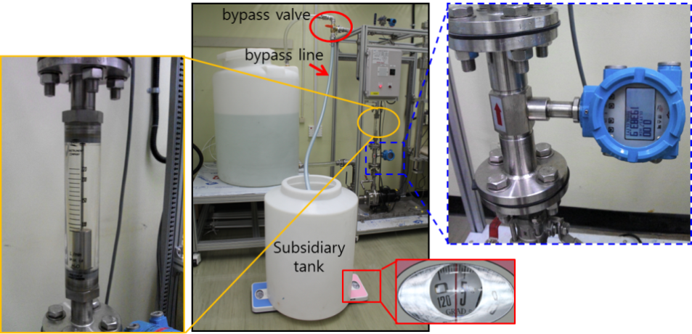
(a) Calibration of flow meters in the pipe with bypassed coolant

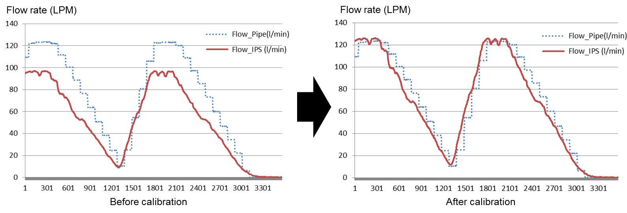
(b) Calibration of turbine flow meter with digital flow meter
FIG. 6. Test rig and the IPS mockup

3.2. Flow Measurement using Noise Analysis

Heat flux generated by nuclear fuels can be calculated with the function of the flowrate of the coolant, and deviation of the coolant temperature between the inlet and outlet of the fuel rod, as shown in equation (1) and Fig. 7(a).

${\dot{Q}}_{fuel}={ρ_{coolant}∙C}_{p}∙V_{coolant}∙A∙(T_{2}-T_{1})$ (1)

where ${\dot{Q}}_{fuel}$, $ρ_{coolant}$, $C_{p}$, $V_{coolant}$, $A$, $T_{1}$, and $T_{2}$ are specified as the heat flux of the nuclear fuel, density of the coolant, specific heat of the coolant, the flow velocity, the cross section area of the flow channel, the inlet temperature, and the outlet temperature, respectively.
In particular, while carrying out irradiation test of nuclear fuels in HANARO, it is difficult to install a flow meter near the fuel rod owing to the spatial restrictions. Therefore, the flow velocity needs to be measured by using a noise analysis through the signals of the thermocouples installed at both end parts of the fuel rod. From the noise data obtained by adjusting signals with amplifiers and band pass filters, a cross correlation is carried out using equation (2) (Fig. 7(b)).

$∅_{s_{1}s_{2}}\left(τ\right)=E\left[s_{1}\left(t-τ\right)s_{2}(t)\right]$ (2)
$Q_{flow}=V_{coolant}×A=\frac{L}{t}×\frac{π}{4}(D^{2}-d^{2})$ (3)

where $Q_{flow}$, $L$, $D$, and $d$ are the flowrate of the coolant, the distance between the two thermocouples installed at both end parts of the fuel rod, the outer diameter of the flow channel, and the inner diameter of the flow channel, respectively. In the experiment, because L, D, and d are set to 380 mm, 48 mm, and 30 mm, respectively, the flowrate can be easily calculated by adding t, which is obtained through the noise analysis in equation (3).

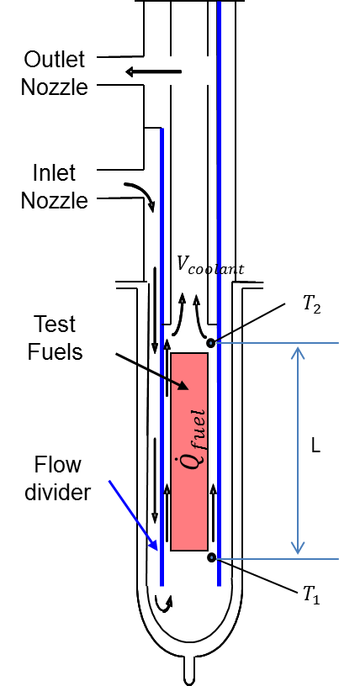 | 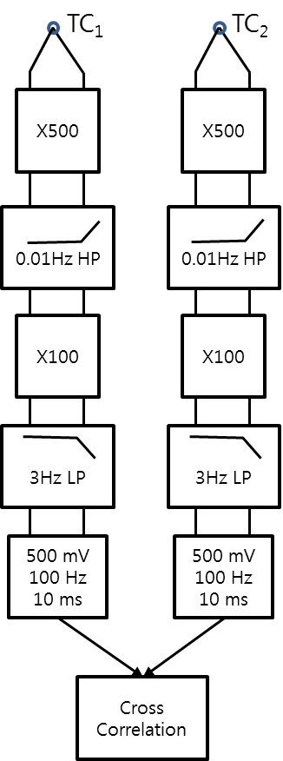
(a) Coolant flow in the IPS | (b) Sequence of cross correlation of noise signals
FIG. 7. Concept of noise analysis from temperature signals

The data acquisition system for a noise analysis consists of a PXIE-4353, which has a multi-channel thermocouple input module mounted on a NI-PXIE express chassis, as shown in Fig. 8(a). The data analysis program was implemented using NI-LabVIEW2013. In the data analysis program, the two time series temperature signals from two thermocouples were analyzed using a cross-correlation technique. If two signals have a similar pattern with each other with a time interval, the time interval can be calculated by a cross-correlation technique. In this system, flow induced signals between two adjacent thermocouples show a similar pattern with the time interval. Fig. 8(b) shows the cross-correlation routine as programmed by NI-LabVIEW2013.

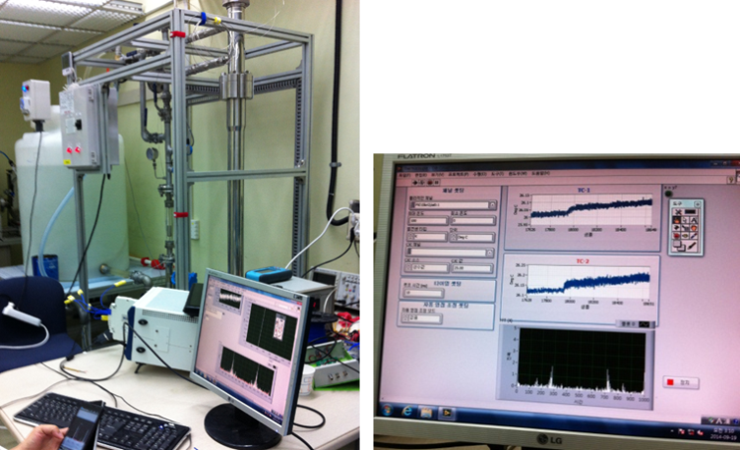
(a) NI equipment for noise analysis

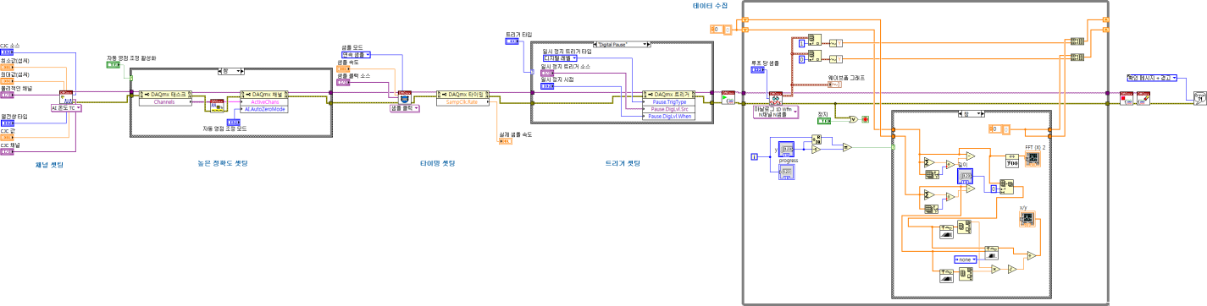
(b) Programming for noise analysis
FIG. 8. Data acquisition system and cross-correlation routine for noise analysis

For a cross correlation analysis, the time series signals should be properly conditioned using amplifier and filters. As a pre-processing step, a Fast Fourier Transform (FFT) can be used to analyze the band frequency for the correlation signals. Fig. 9 shows the FFT results for a temperature fluctuation signal at a flowrate of 80 liter/min, 100 liter/min, and 120 liter/min, respectively. The FFT data show that the pattern of the temperature signal is correlated with the flowrate of the coolant. The data then need to be used as the input of the cross-correlation by removing unnecessary noise signals. The author is now implementing a band pass filter based on the results of the FFT.

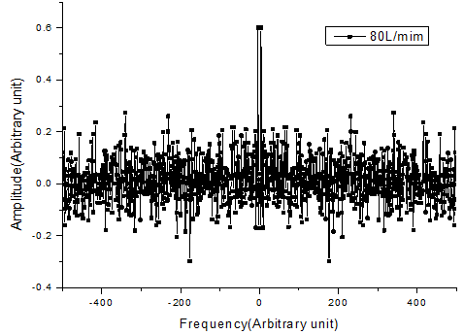 | 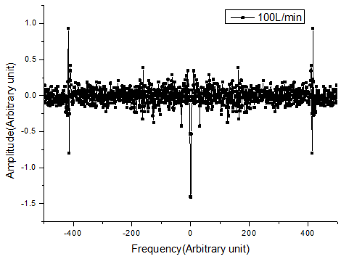 | 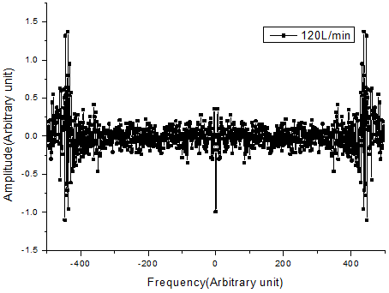
(a) 80 liter/min | (b) 100 liter/min | (c) 120 liter/min
FIG. 9. Fast Fourier Transform of time series signal from thermocouple at different flow-rate

4. Conclusion

In this research, a coolant flow simulator that can circulate the coolant through the nuclear fuel test rig was developed. Several sensors such as a digital flow meter, a turbine flow meter, and manometers are installed in the equipment and calibrated through repeated experiments. A system for flow measurement by a noise analysis has then been established. According to the basic analysis using the FFT technique, the temperature fluctuation signals are correlated with the flowrate of the coolant. As future work, a band pass filter needs to be implemented, and the data need to be used as an input of the cross-correlation to measure the flowrate of the coolant.

5. Acknowledgement

This work was supported by the National Research Foundation of Korea(NRF) grant funded by the Korea government(MSIP) (2012M2A8A5010535)

6. References

- Valerio, T., “A new method to measure rig coolant flowrate,” F-Note 222, OECD Halden Reactor Project(1992).
- Valerio, T., “Flow-rate measurements in IFA-596/597 via cross correlation technique,” F-Note 644, OECD Halden Reactor Project(1993).
- Hartmann, C., Liverud, J. K., Volkov, B., and Eriksen K. W., “Volume flow measurements from temperature noise measurements,” FC-Note-2751, OECD Halden Reactor Project(2012).
- Cho, M. S., “Utilization of the Capsule Out-pile Test Facilities (2000 ~ 2003),” KAERI/TR-02406/2003.
- Lim, K. W., Choi, J. O., and Lee W. K., “A study on the Uncertainty Estimation of Flowmeter Calibrator with Two Master Flowmeters,” Trans. Korean Soc. Mech. Eng. B(2004), Vol. 28, No. 10, pp. 1219 – 1230.
- Miller, R. W., “Flow measurement engineering handbook,” McGraw-Hill(1989).
- Spitzer, D. W., “Industrial flow measurement,” Instrument Society of America(1990).
- Lee, J., Seo, J. K., Park, C. T., Ryu, S. Y., Yoon, J. H., and Zee, S. Q., “A Flow-rate Measurement Method by Using the Motor Powers of the Axial Flow Pumps with Higher Specific-speeds,” Proc. of the 2006 International Congress on Advances in Nuclear Power Plants.
- D. Lubbesmeyer, “On the Physical Meaning of the Fluid Velocity Measured in BWRs by Noise Analysis,” Ann. Nucl. Energy(1983), Vol.10, No.5, pp. 233 – 241.
- Kim, K. R., Park, Y. C., and Choung, Y. H., “The flow measurement in the core channel of the HANARO flow simulated test facility,” 2004 Korean Nuclear Society Autumn Meeting.

