OPAL Reactor Full 3-D Calculations using the MonteCarlo Code Serpent 2

Diego Ferraro¹ and Eduardo Villarino ²
1) Nuclear Engineering Department, INVAP S.E., Esmeralda 356, Buenos Aires, Argentina - dferraro@invap.com.ar
2) Nuclear Engineering Department, INVAP S.E., Av. Cmte Luis Piedrabuena 4950, Bariloche, Río Negro, Argentina - men@invap.com.ar
Corresponding author: dferraro@invap.com.ar

Abstract. Monte Carlo neutron transport codes are widely used to perform criticality calculations and to solve shielding problems due to their capability to model complex systems without major approximations. However, as far as these codes usually demand very high computational resources, some applications, such as full core burnup calculations or cell level modeling have been prohibitive in the past decades. In spite of this, with the advance in computer performance and the massive parallelization schemes, the use of Monte Carlo neutron codes to perform complex calculations including burnup arise as a promising near-future application.
In this work the Monte Carlo Serpent 2 code developed by VTT Technical Research Centre of Finland is used [1]. This code is the second version of a brand-new Monte Carlo code designed to perform burn dependent cell-level and full 3-D core calculations using optimized schemes that enhance the capabilities and reduce the computational effort compared with other Monte Carlo Codes [1]. Serpent 2 also allows the user to obtain relevant information for reactor design and analysis such as few group constants, neutron fluxes, kinetic parameters and burned compositions. Despite Serpent code was originally oriented to pin-type cell calculations, its newly enhanced geometrical capabilities allows the user develop general 3-D models without major approximations.
In past works [2], Serpent code was tested as a cell-code for the modeling of the MTR-type fuel assemblies from OPAL 20MW Research Reactor. Accordingly, Serpent was used as to obtain few-group constants (namely macroscopic Cross Sections – XS) with burnup dependence. Afterwards, those XS were used in the already developed 3-D diffusion core models of the INVAP´s deterministic Calculation line [3] for the OPAL reactor (i.e. CITVAP 3-D finite differences diffusion code, which is well-known reactor-level code based on CITATION) and fairly acceptable results were obtained.
In the present work, a full 3-D model for OPAL Research Reactor [4] is developed using Serpent 2 v1.21, including simplified models for most relevant experimental facilities. Results for these models are presented and compared both with experimental data from Reactor Commissioning and from INVAP´s calculation line results during this Commissioning ([5] and [6]), showing a good agreement. Additionally, several aspects of the computational issues related with this modeling such as memory usage and CPU demands are presented in order to evaluate the Serpent 2 code actual capabilities and potential ones.

1. Introduction

Monte Carlo neutron transport codes are widely used to perform criticality calculations and to solve shielding problems due to their capability to model complex systems without major approximations. However, as far as these codes usually demand high computational resources, other natural applications such as full core burnup and cell calculations have been prohibitive in the past decades.
Nevertheless, due to the advances in computer performance in the last years, the utilization of MonteCarlo methods both to perform cell level calculations including branch and burnup calculations or to perform full core calculations including burnup for small research reactors are now feasible. In this work the Monte Carlo Serpent 2 v1.21 code [1] developed by VTT Technical Research Centre of Finland is used. This code is the second version of a brand-new Monte Carlo code designed to perform cell-level burnup calculations and full 3-D core calculations, using optimized schemes that enhance the calculation capabilities and reduce the computational effort compared with other Monte Carlo Codes. Serpent 2 also allows the user to obtain relevant information for reactor level calculations, reactor design and general analysis such as few group constants, neutron fluxes, kinetic parameters and burned compositions.
The capabilities of Serpent code to be used as a cell-level code to model MTR-type Fuel Assemblies (FA) to obtain few group constants to be used in core calculations have been already tested for the OPAL Research Reactor, showing a good performance [3]. Additionally, the capabilities of Serpent Code to model small Research Reactors including burnup have been also tested and compared to other Codes [7].
Encouraged by the past results, a full 3-D Serpent 2 model for the OPAL Research Reactor is developed in the present work. Using this model, the main neutronic parameters measured during reactor Commissioning are compared with experimental data and reported calculations ([5] and [6]).

2. OPAL Research Reactor

The OPAL Research reactor [4] is a state of art 20MWth multi-purpose open-pool type Research Reactor located at Lucas Heights, Australia. It was designed and built by INVAP between 2000 and 2006 and it is owned and operated by ANSTO.
The reactor consists of a compact core of 16 LEU MTR-type fuels, cooled and moderated by light water and reflected by heavy water contained in a Reflector Vessel. Several irradiation facilities are located in the Reflector Vessel, including a cold neutron source with two beams, a thermal neutron source with two beams, a region reserved for a future hot neutron source, 17 vertical irradiation tubes with place for 5 targets each for bulk radioisotope production (such as ¹⁹²Ir, ⁹⁹Mo and ¹³¹I), 19 pneumatic rigs with 57 target positions for different purposes and 6 neutron transmutation doping (NTD) facilities.
The reactor was commissioned during the second half of the year 2006. During the Commissioning, several nuclear safety related design criteria were experimentally verified and compared with INVAP´s neutronic calculation line results ([3], [5] and [6]), showing a good agreement with measured values.
As far several neutronic parameters were measured during OPAL reactor commissioning and other parameters regarding the Contract Performance Tests of the main irradiation facilities are also available, the OPAL Reactor represents an interesting case to perform experimental benchmark of calculation codes, allowing the comparison of a wide range of measured parameters.

3. Serpent 2 full 3-D Model for OPAL Research Reactor

A full core 3-D model for OPAL reactor has been developed for the first cycle of the reactor [4]. Simplified models for the most relevant facilities in the reflector Tank were included in order to be able to model the main parameters obtained during Reactor Commissioning. Accordingly the following facilities were included in the model, as it is shown in Figure 1:
- 17 vertical irradiation tubes.
- A simplified model for the Cold Neutron Source (CNS), including main aspects such as the Vacuum Containment.
- The Cold neutron beams.
- The Thermal neutron beams.
- The Hot neutron beam.
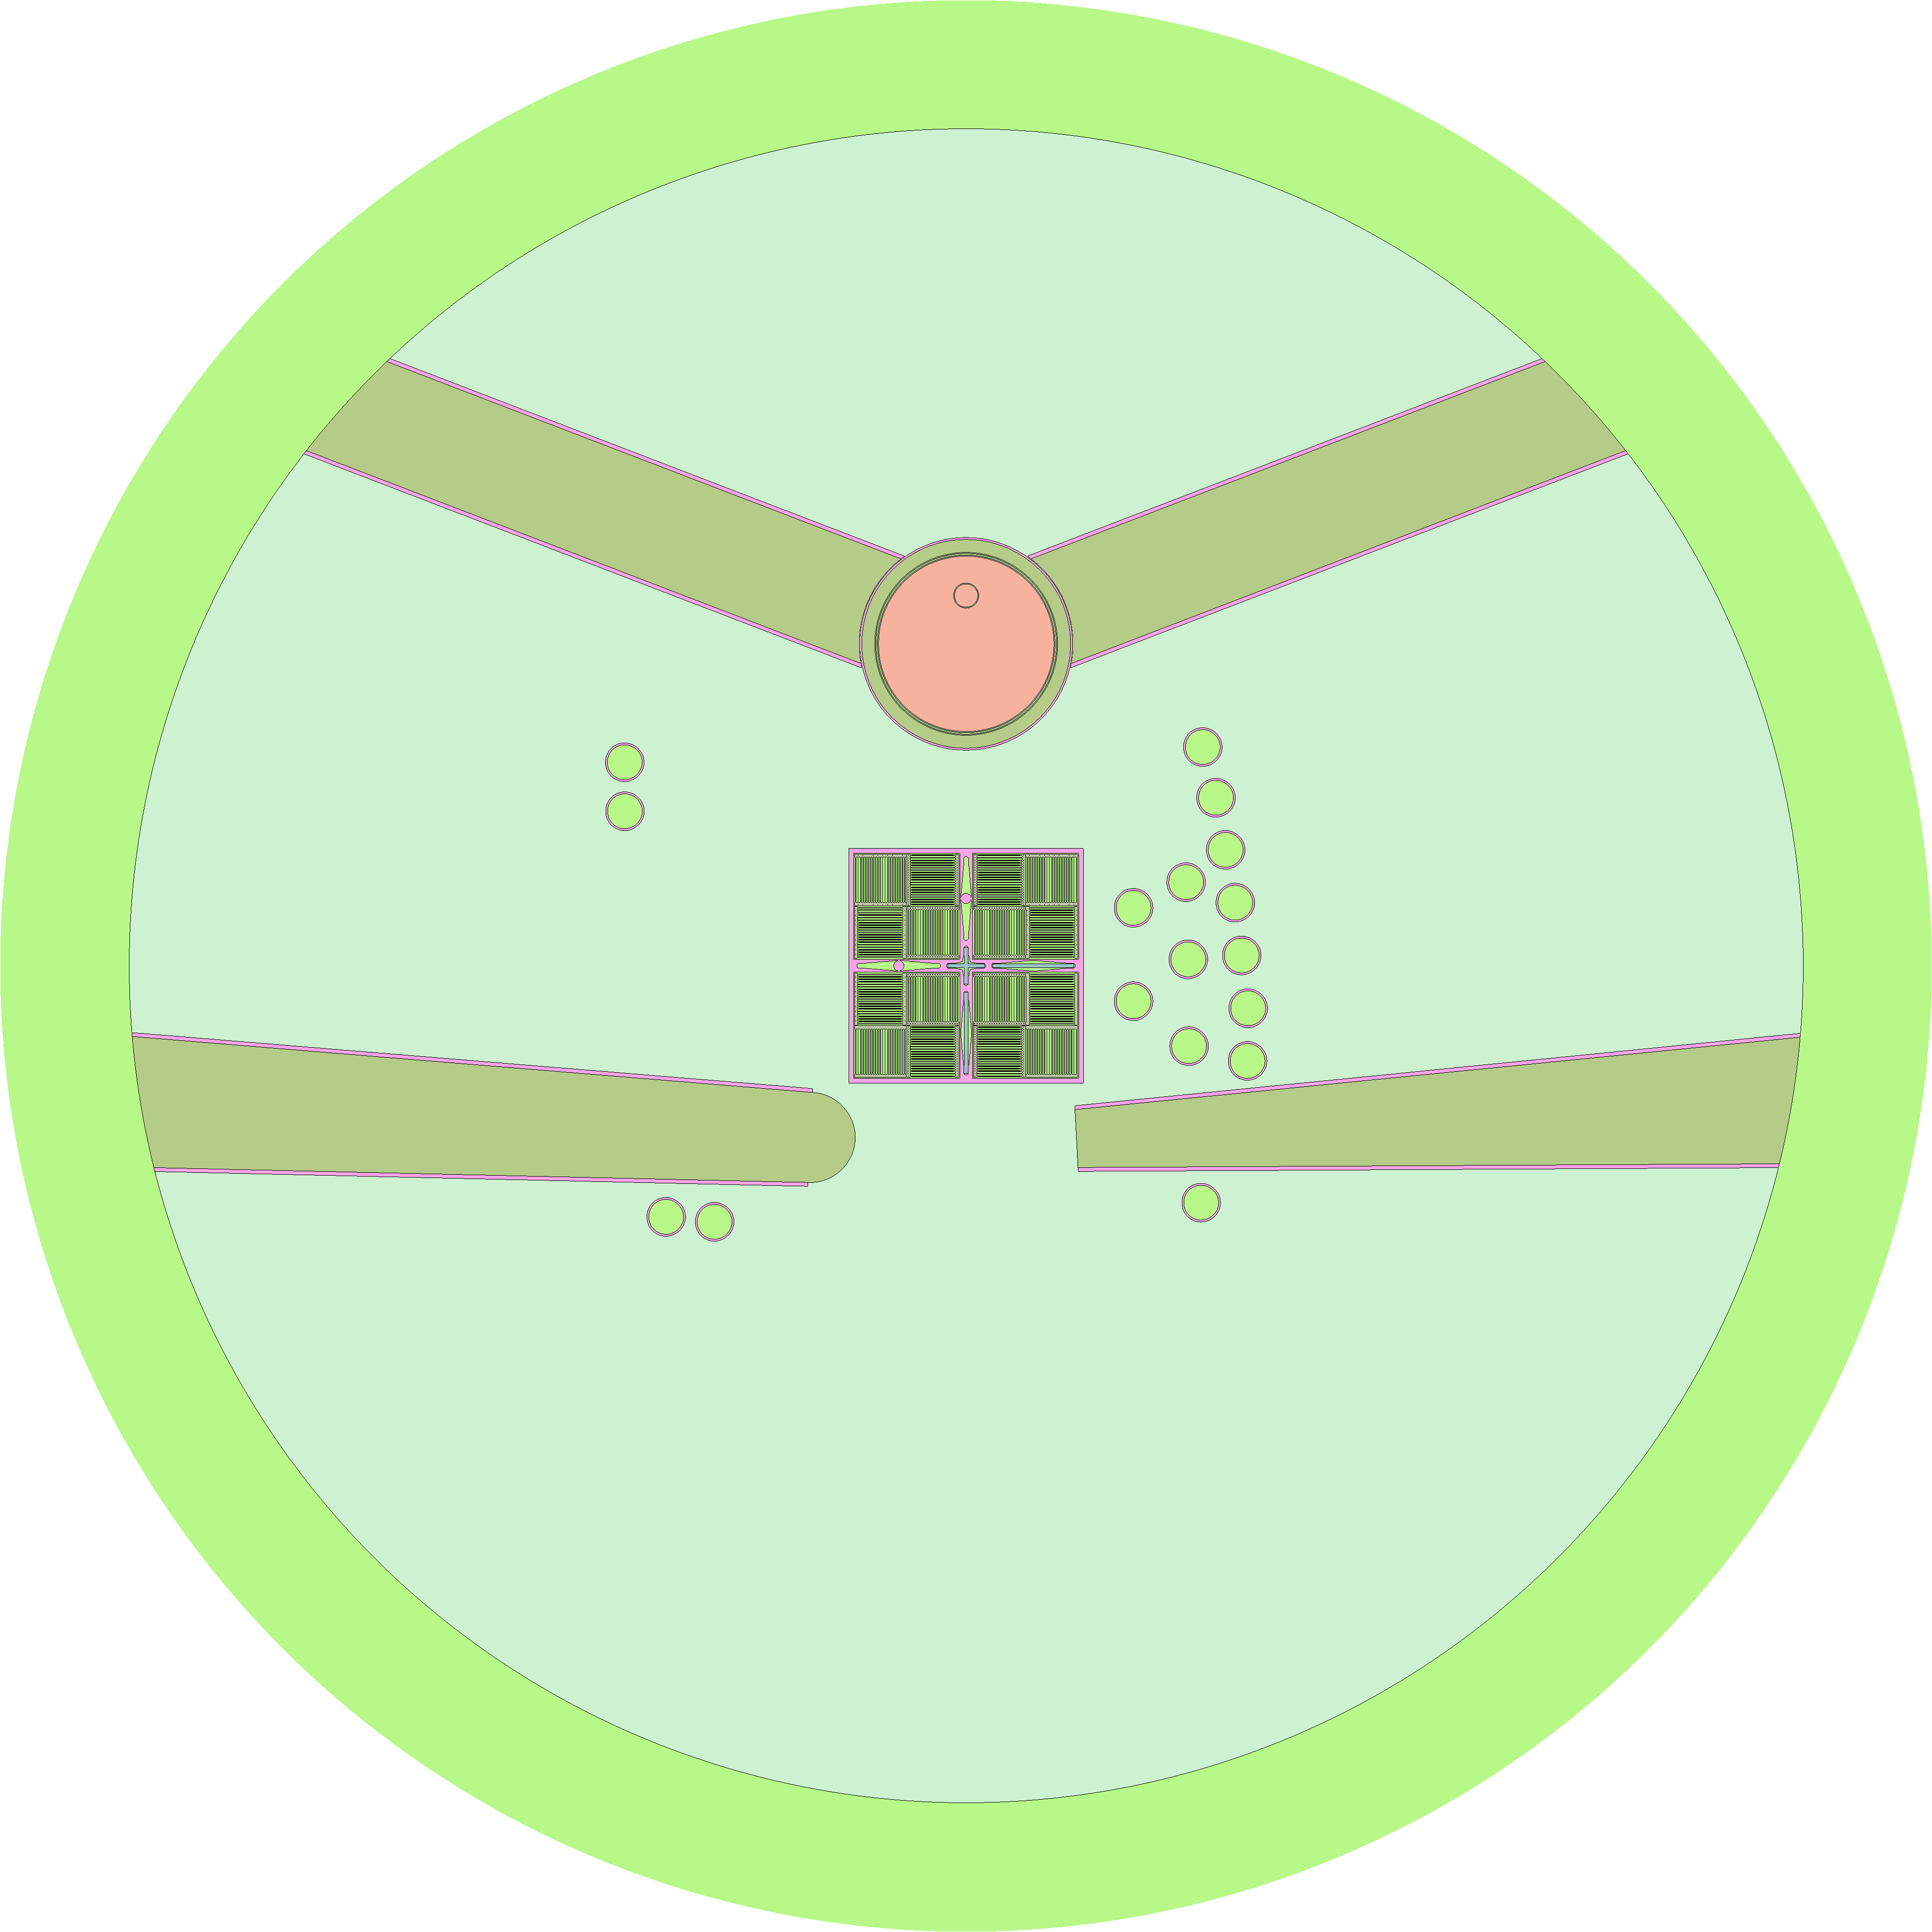  a) Full model x-y cut – centre of core | 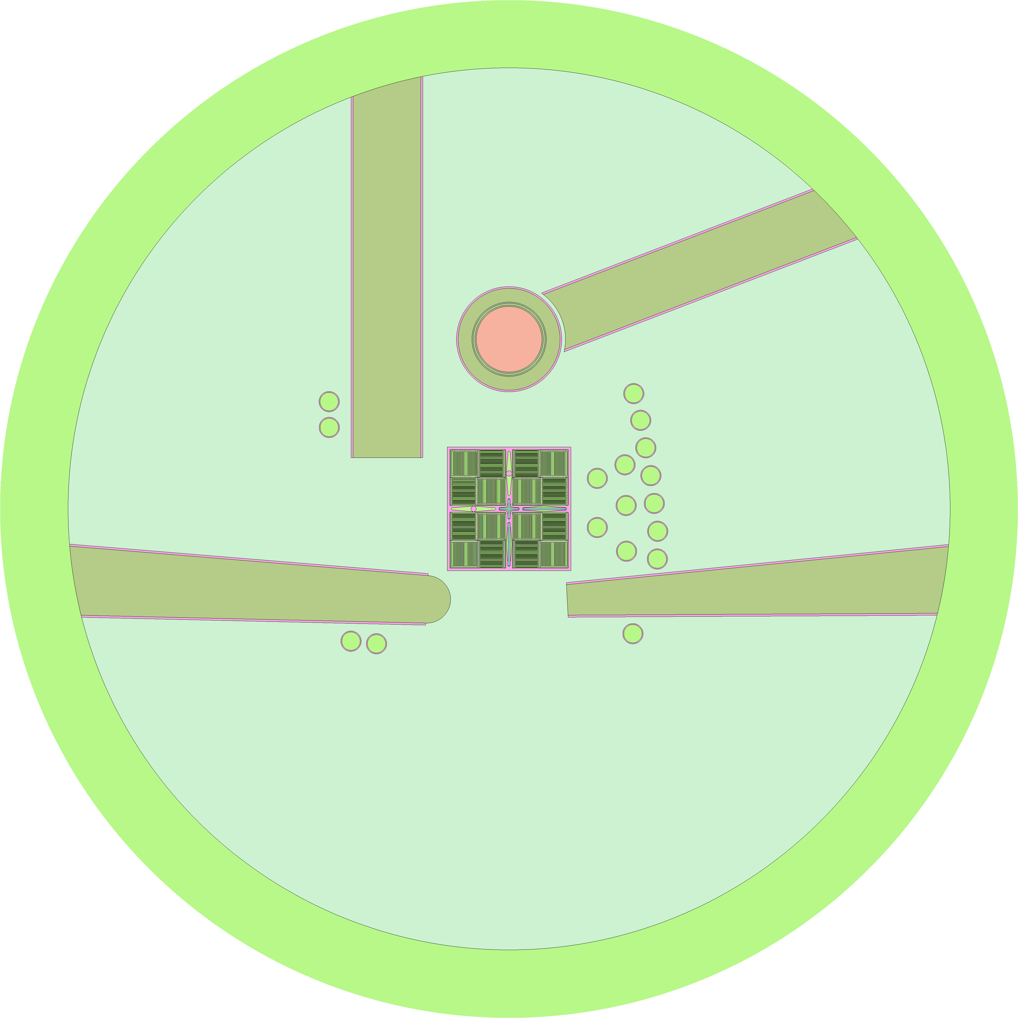  b) Full model x-y cut – 4 cm below core centre
FIGURE 1. Serpent 3-D full core model – Obtained with Serpent 2 geometry plotter.

Besides, the Control Rods (CR) absorber plates, the followers, guide boxes and Chimney were modeled explicitly as it is shown in Figure 2.

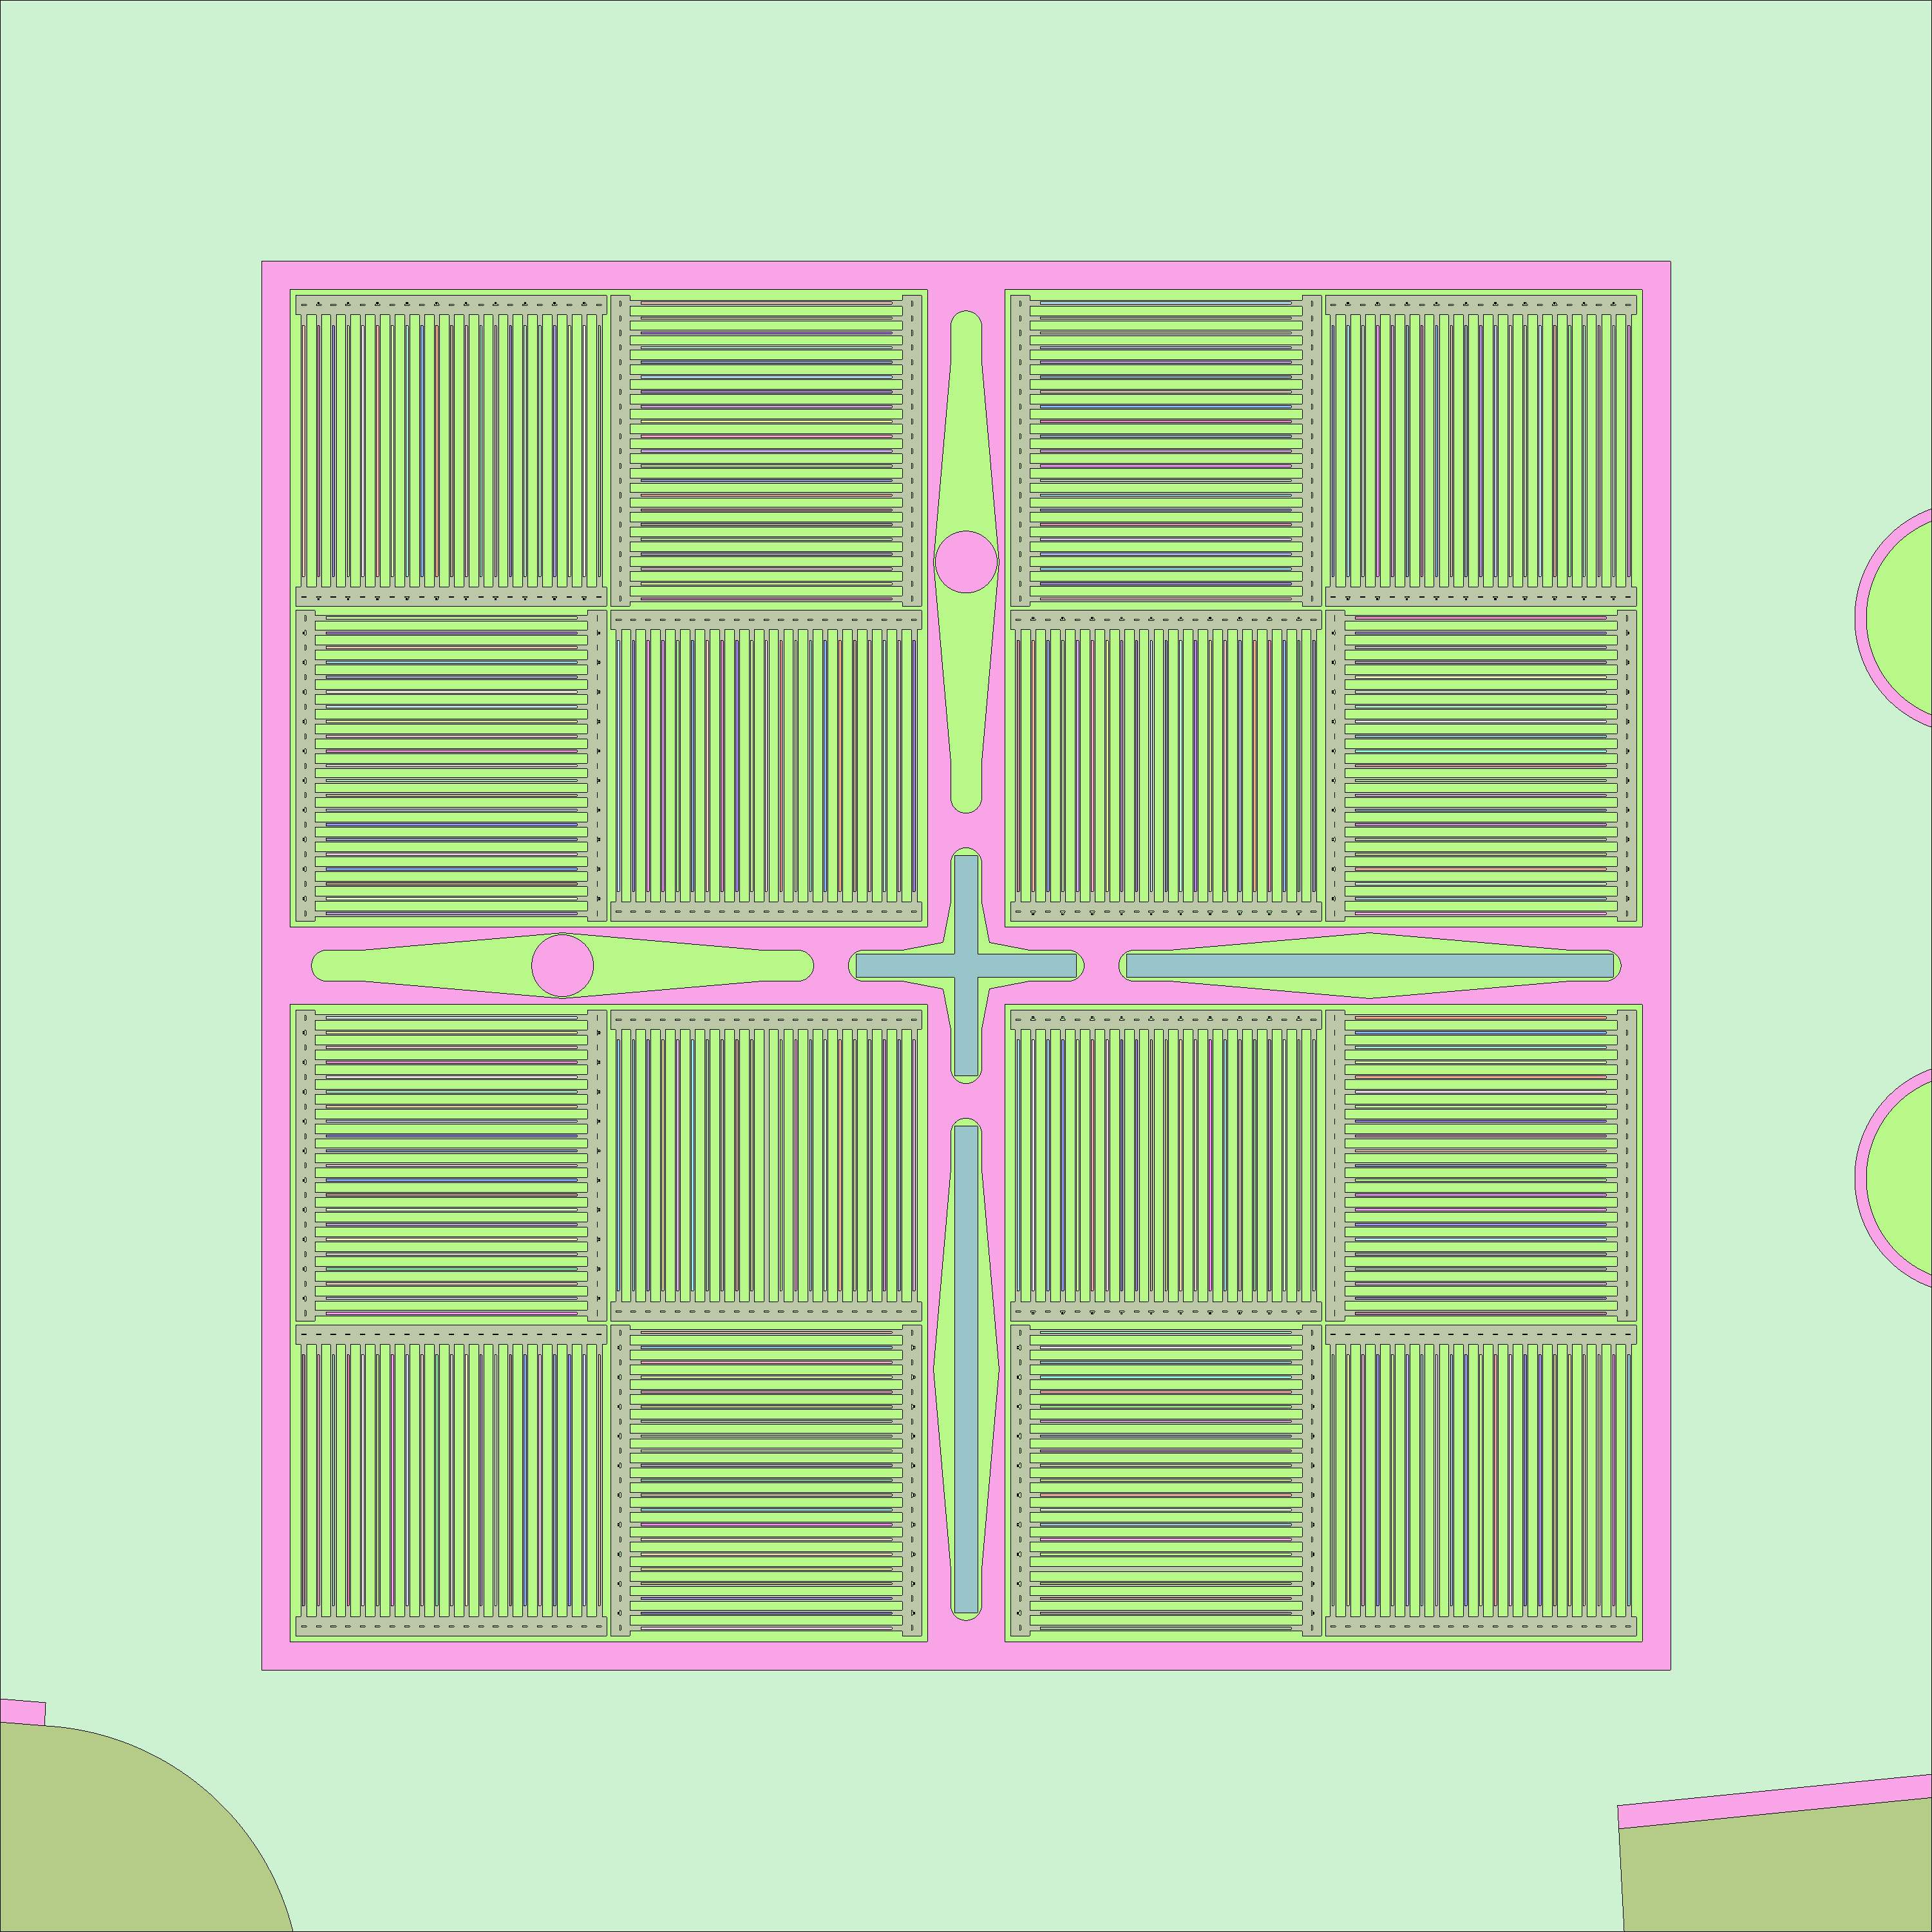  a) Full model x-y cut – 4 cm below centre of core – Core detail | 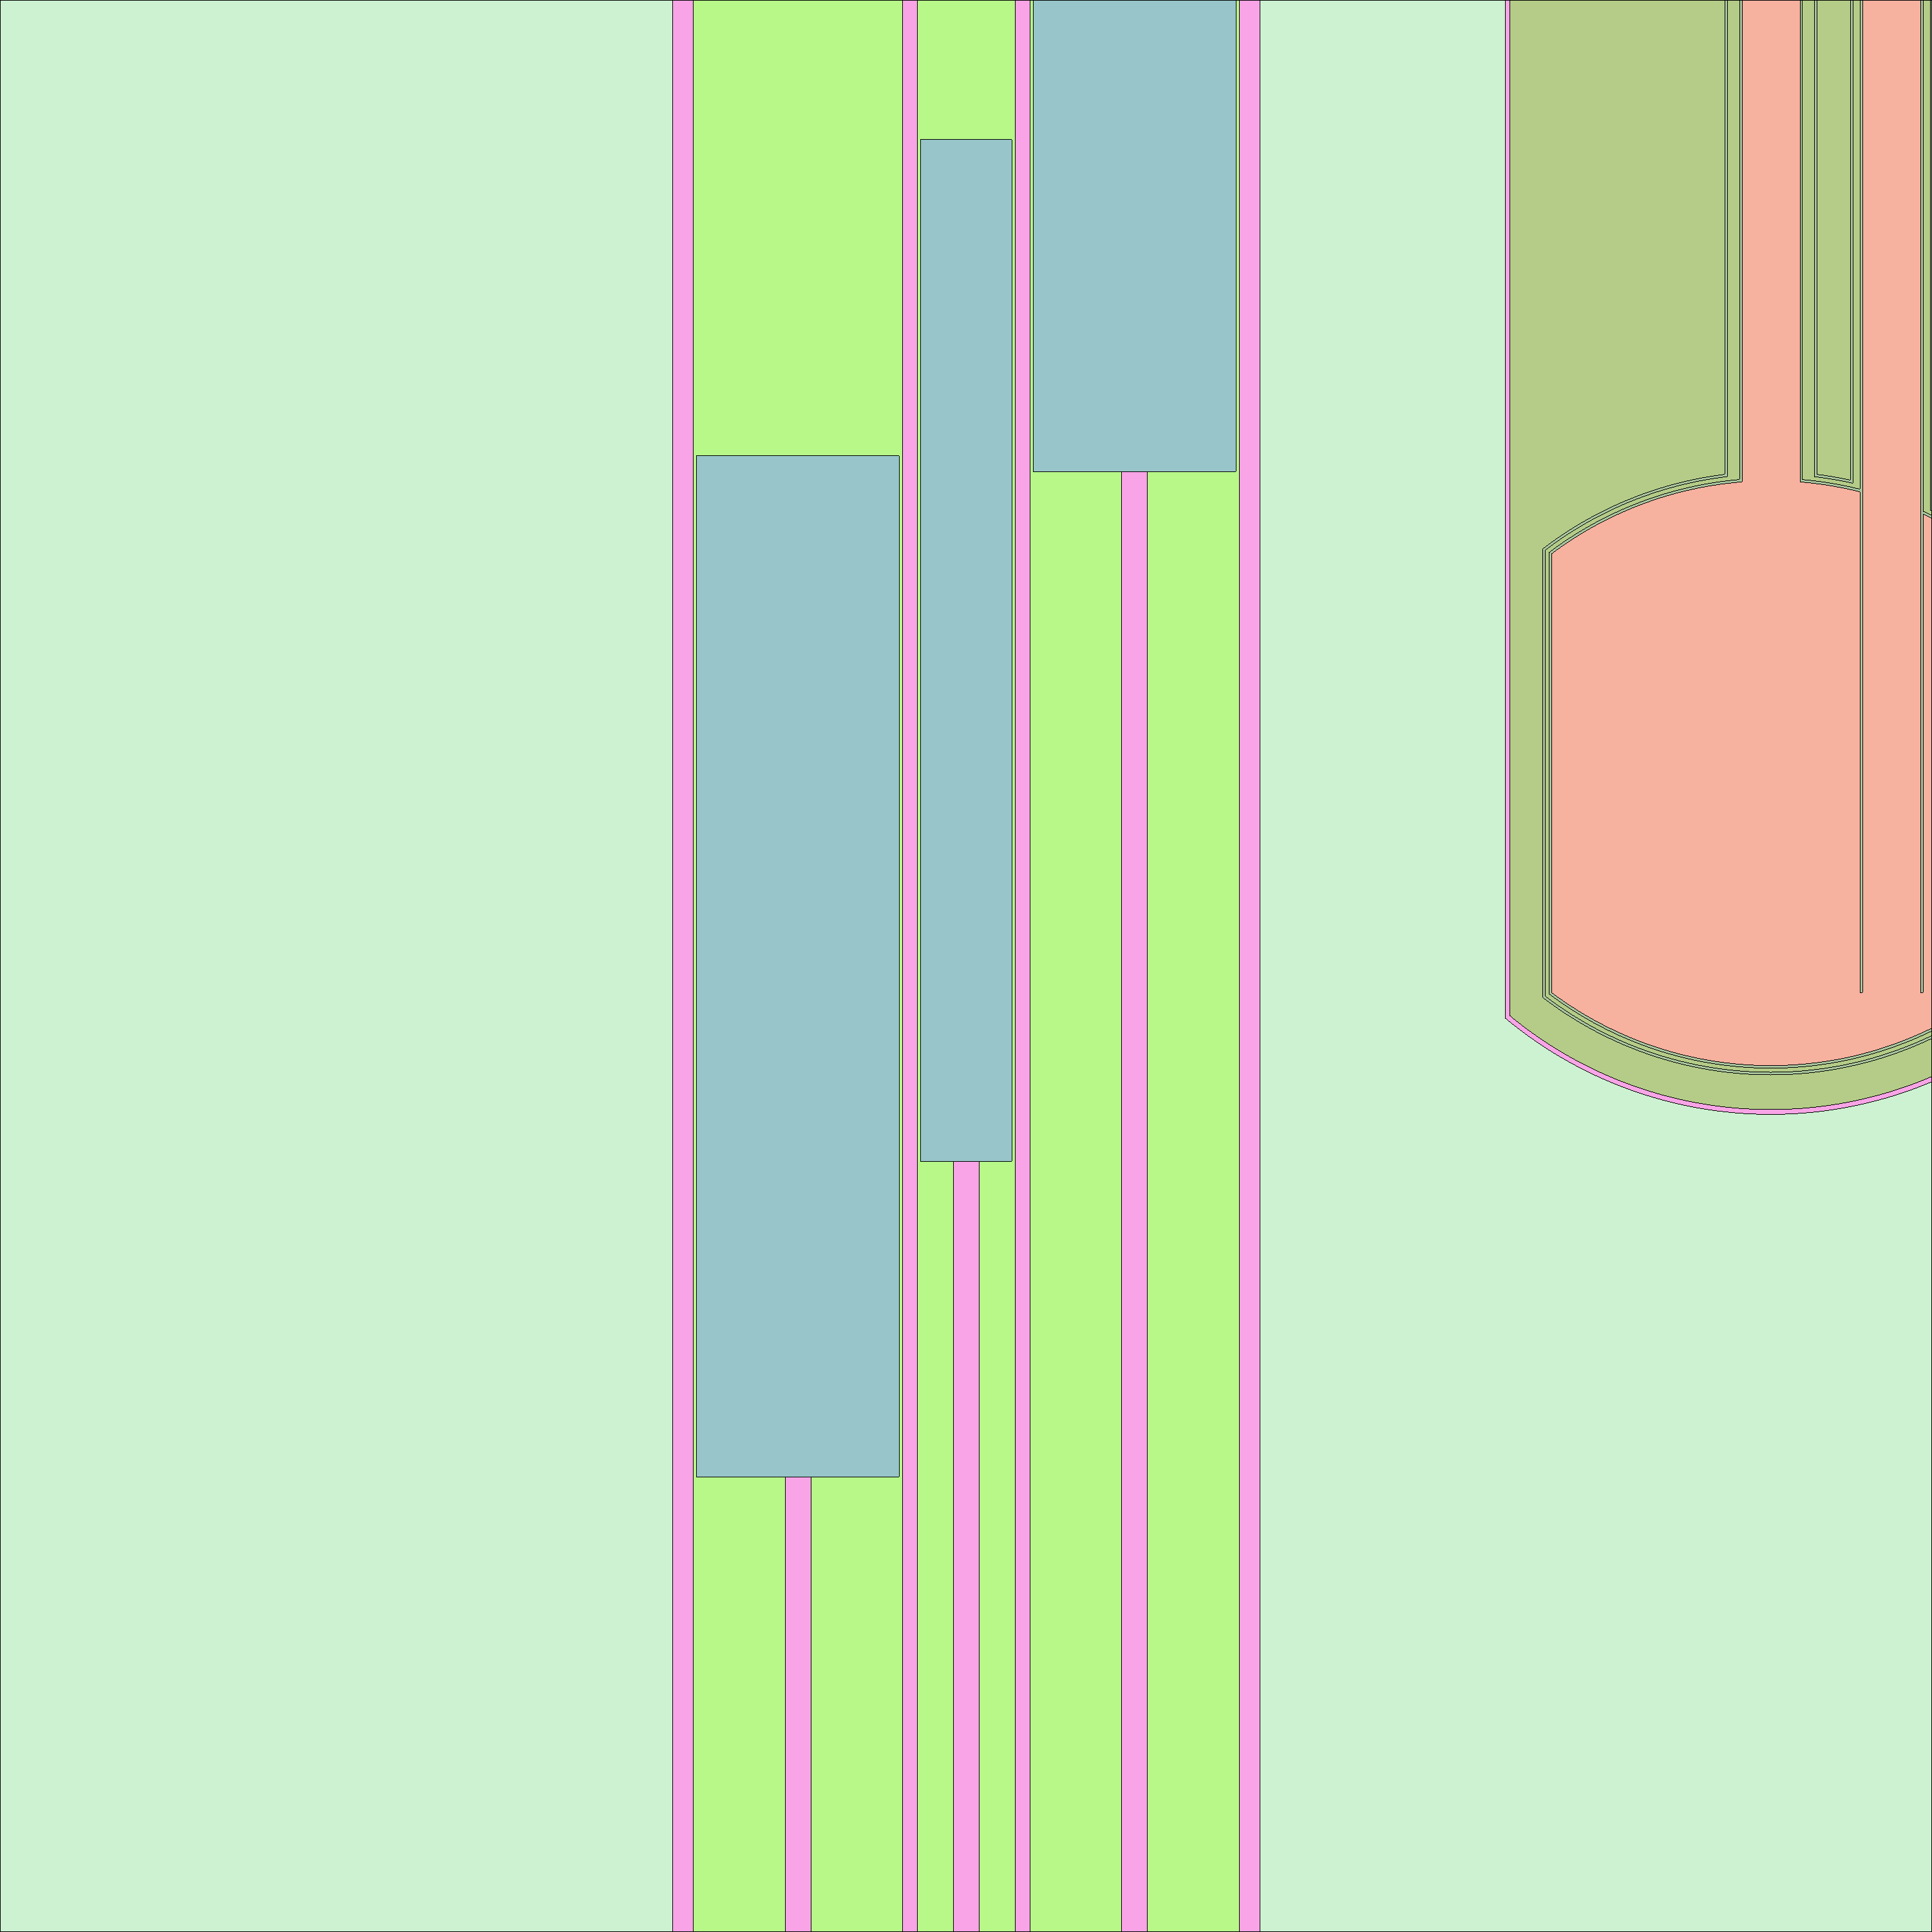  b) Full model y-z cut –centre of core – CR detail and simplified CNS
FIGURE 2. Serpent 3-D full core model – Detail for Core and CRs - Obtained with Serpent 2 geometry plotter.

The Fuel Assemblies were modeled including the meats, cladding frames and burnable poisons (Cd wires) for those cases were the poisons are present. Additionally, the model includes compositions for the First Core that comprise three kinds of FA:
- FA without Burnable poisons and low Uranium load in the meat.
- FA with Burnable poisons and medium Uranium load in the meat.
- FA with Burnable poisons and high Uranium load in the meat.
To take into account the material evolution for burnup calculations, ten axial zones were explicitly modeled and the meats and Cd wires were considered separately using the automatic material division capabilities included in Serpent 2 (modeling several radii for Cd wires). This consideration has a strong impact in the RAM memory requirements for the model, which was compensated with a reduction in the unionized energy grid tolerance [1], chosen in order to allow parallel calculations without high memory resources demand and no appreciable effects in results. Figure 3 shows a detail of the FA model, where the different materials definition can be appreciated together with the Cd wires for the cases where are modeled.

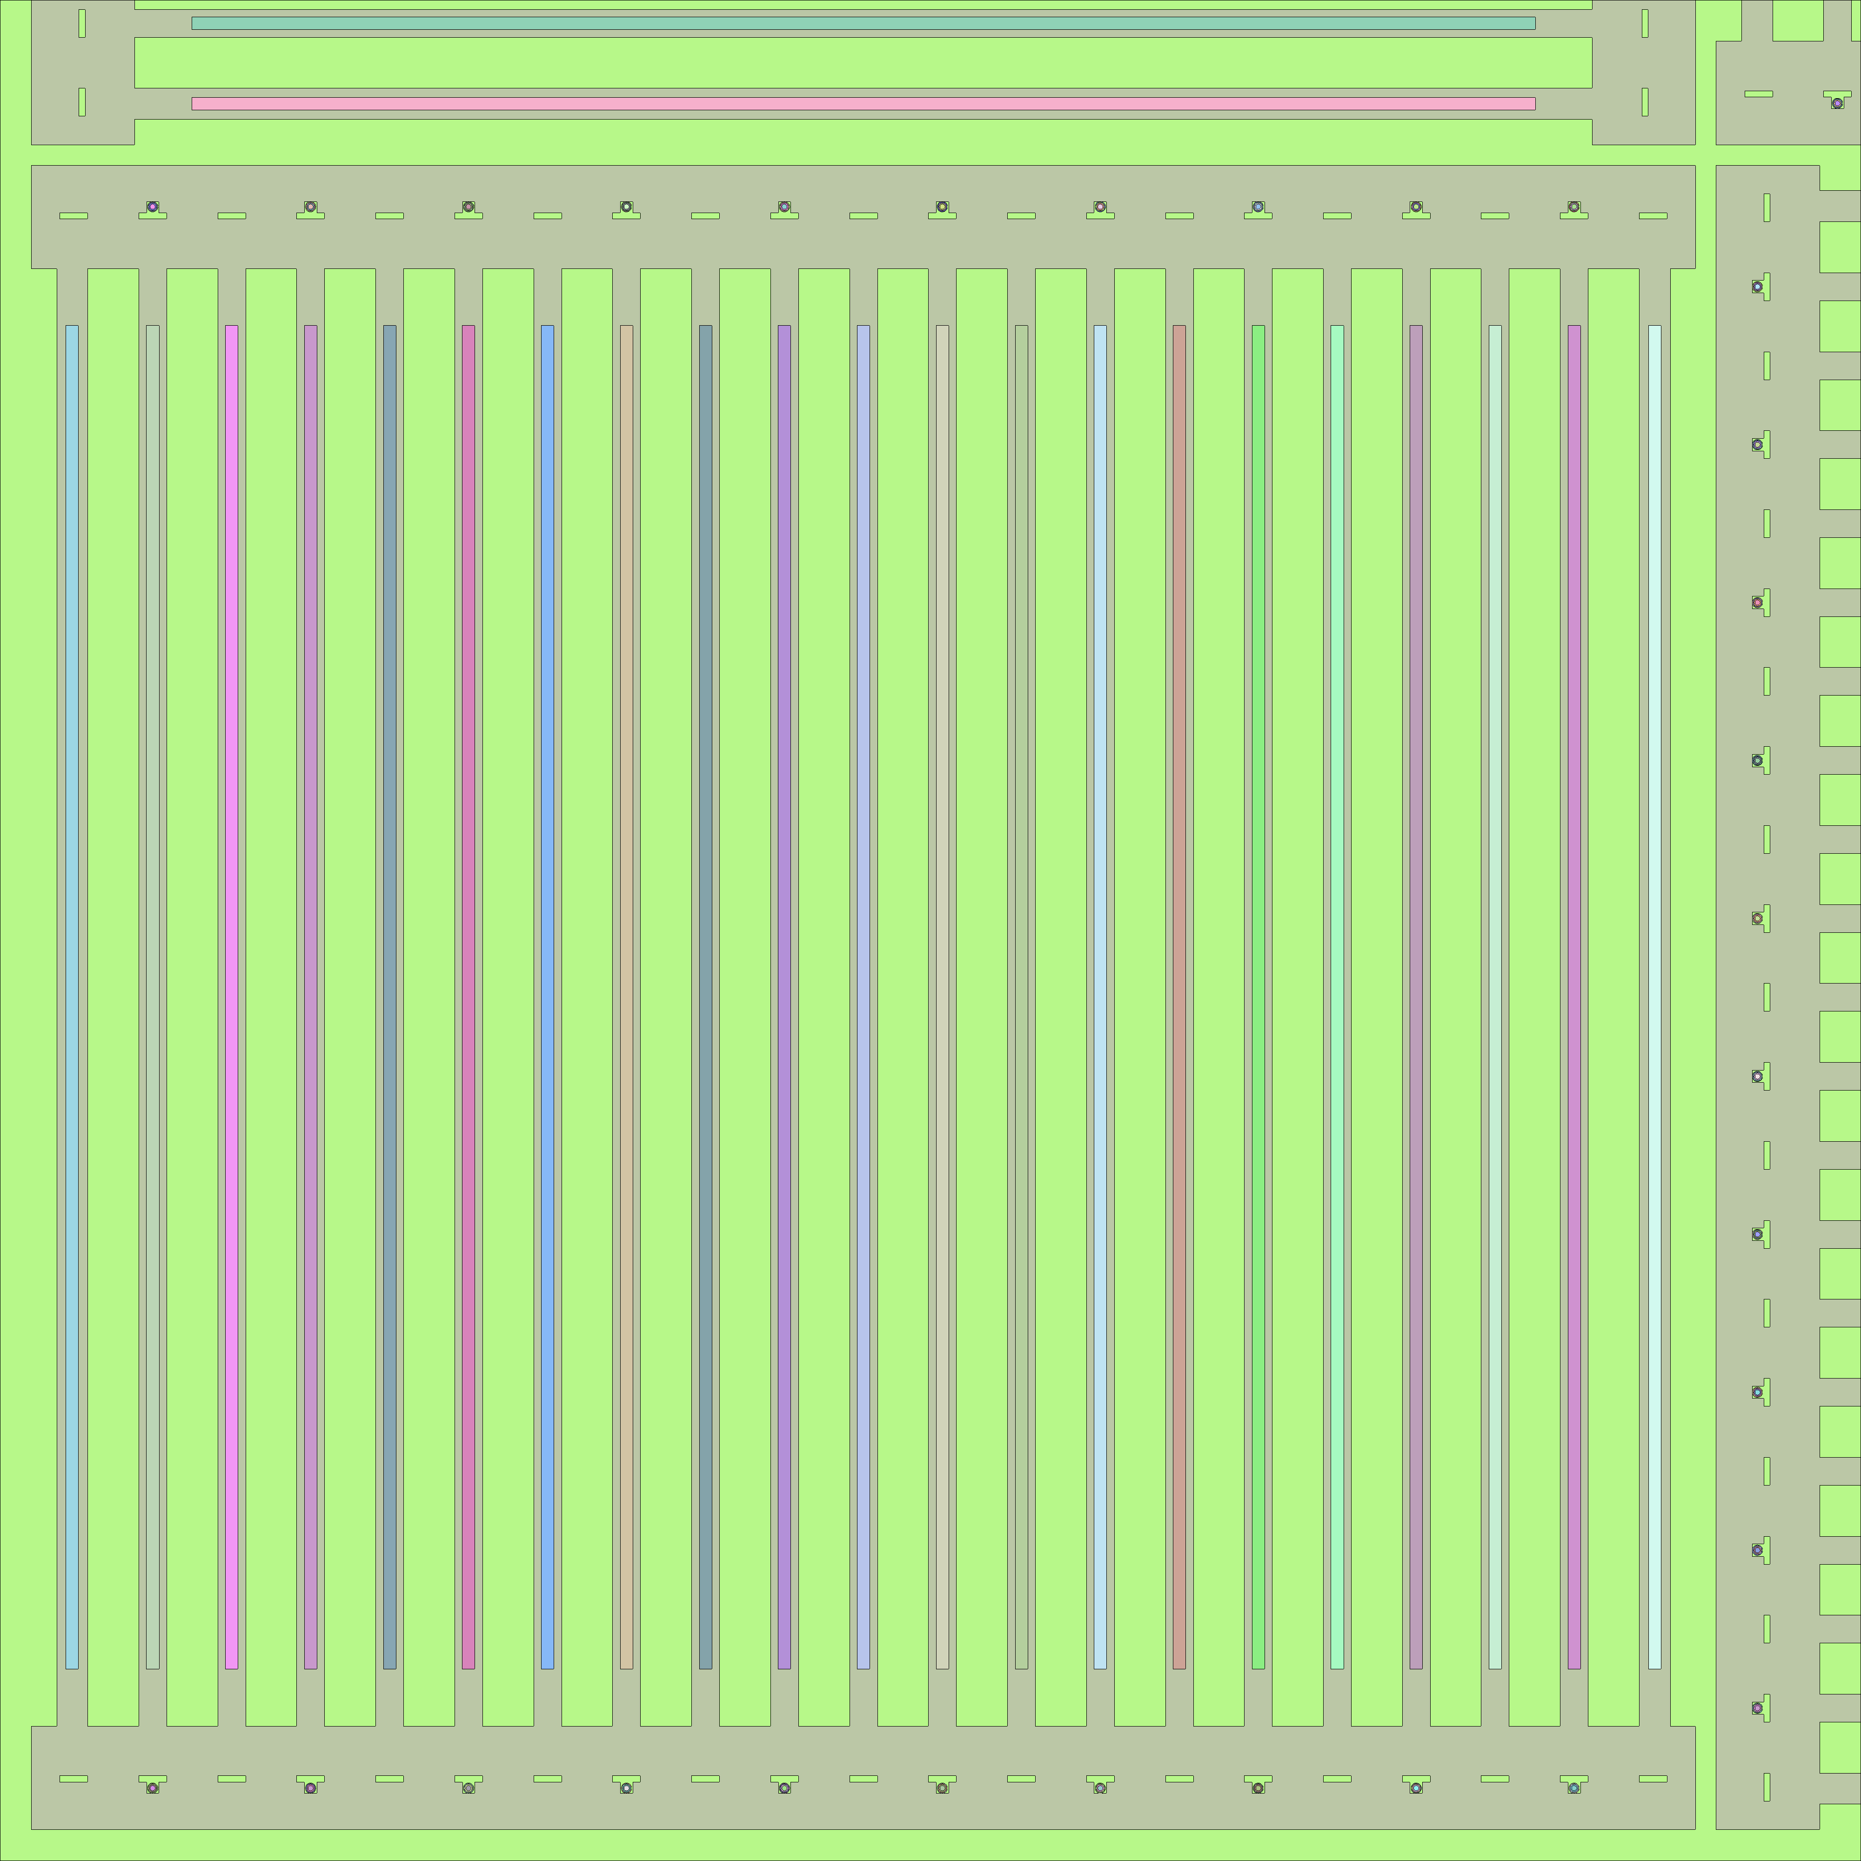  b) Full model x-y cut –centre of core – FA detail NE corner | 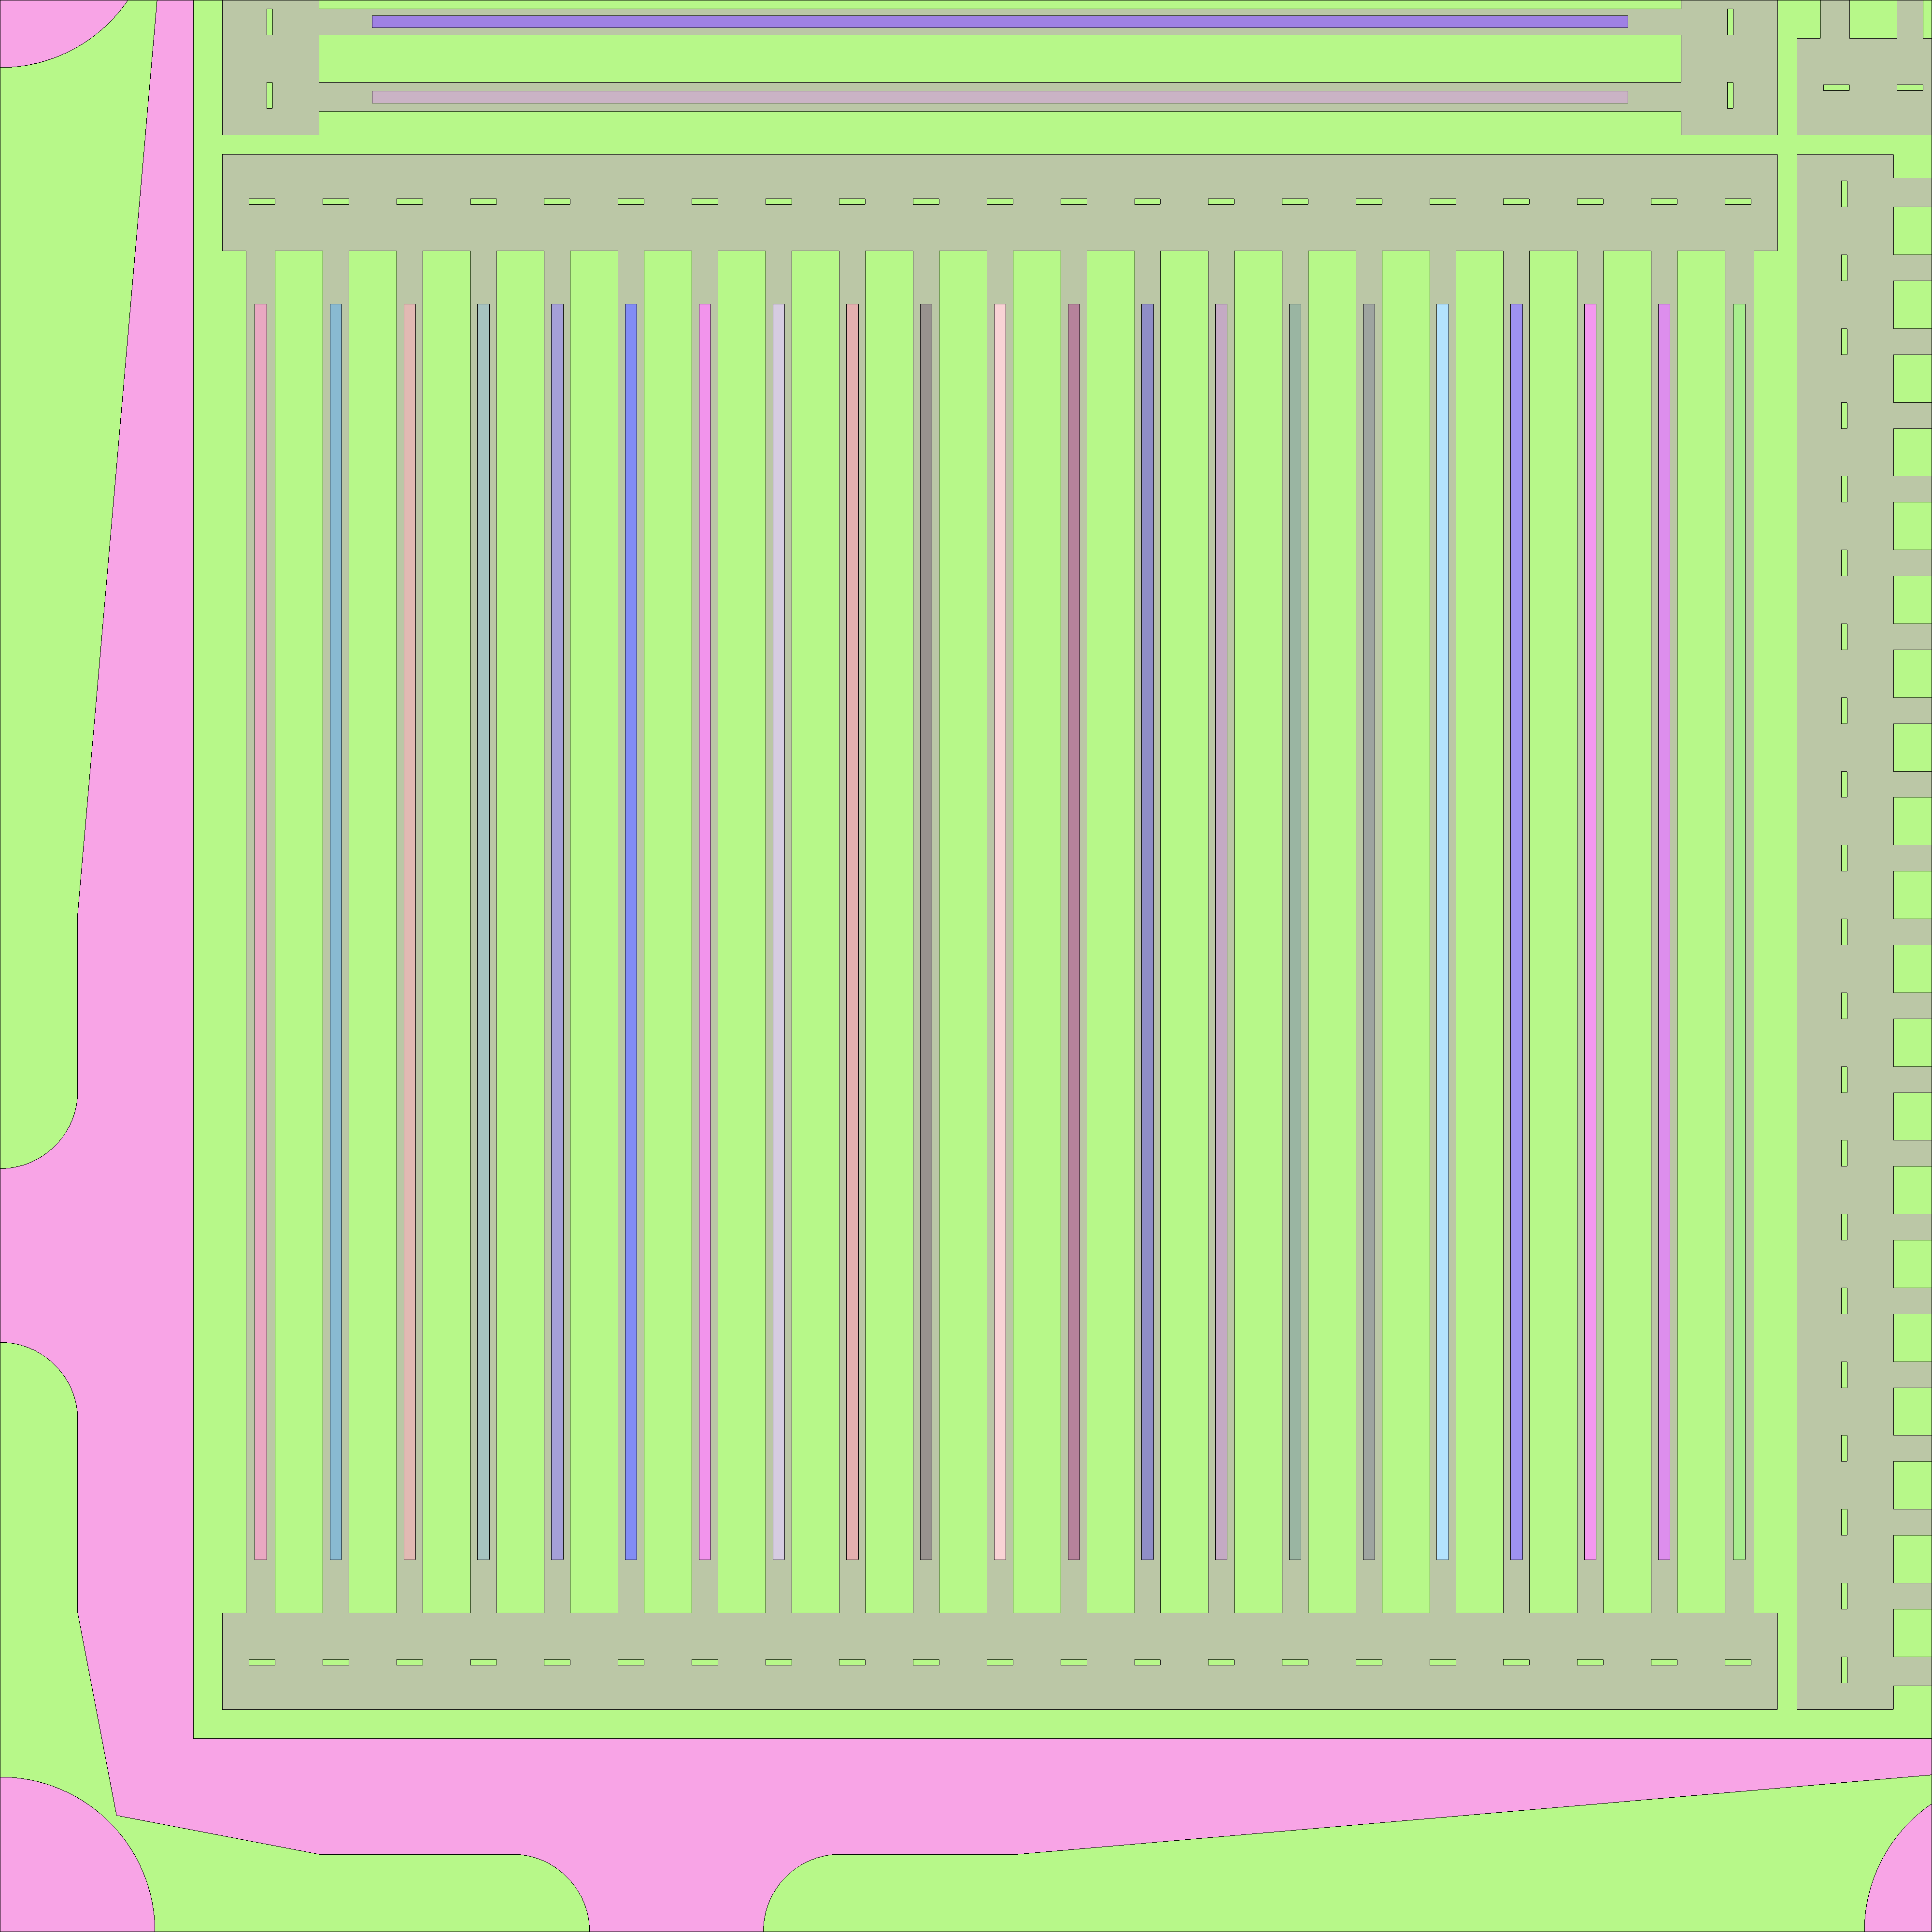  b) Full model x-y cut – 20 cm below centre of core – FA detail NE corner
FIGURE 3. Serpent 3-D full core model – FA detail - Obtained with Serpent 2 geometry plotter.

In order to be able perform several changes in the inputs in an easy – traceable way (such as CR positions, facilities, materials and FA included in the core, etc.) the model was developed in a Spreadsheet that automatically generates the input file.
Besides, to be able to compare with already reported values ([5] and [6]) minimizing the effect of the Nuclear Data Library, the data from ENDF/B-VI.8 was used.

3.1 Running times and memory requirements

All results presented in this work were obtained using Serpent2 v1.21, run in parallel (OMP) mode in a Linux cluster using nodes with up to 64 @ 2.6GHz processors each. The running time was reasonable for all fresh cases (i.e. 90 min for 32 processors to reach ∼10pcm of statistical error in effective multiplication factor or 300min for ∼2% in the flux values for 0.3cm³ meshes inside the core, with almost 99% of CPU usage for both cases).
In order to deal with memory requirements for burnup cases (due to the material subdivision, that lead up to 100GB of RAM if no optimization is performed for 64 processors in OMP), the unionized energy grid tolerance [8] was slightly diminished to allow full burnup calculations using OMP up to 64 processors. The observed impact of such reduction in the results was negligible.

3. Results

With the models described in Section 2, the main experimental parameters from Reactor Commissioning were calculated, namely:
- Critical positions from CR calibrations in Cold Fresh state.
- Thermal neutron Flux profiles inside the core.
- Kinetic Parameters.
- Critical positions with burnup (Hot Full Power state).
Finally, the results obtained with Serpent 2 models were also compared with those calculated during the Commissioning with the INVAP´s Calculation line [3], (i.e. using CONDOR cell code and CITVAP core code) reported in [5] and [6].

3.1 Results for Critical positions in CR calibrations

A total of 74 critical cases were measured during the Reactor Commissioning. These critical cases correspond to the calibrations of CR 1 and 4 (26 cases), CR 2 and 3 (27 cases) and CR 5 (21 cases). As far as each one has a different control rod pattern, the analysis allows the assessment of a wide number of critical cases with different shadow effects between the CR.
The reactivity results obtained with the models from section 2 with the critical CR positions is presented in Figure 4, identifying the CR calibrated.

FIGURE 4. Serpent 3-D full core model results for 74 critical positions. Error bars represent the statistical errors (3σ).

As it can be seen the calculated values have a good agreement with measured values showing a slight tendency in CR 1&4 calibration, already observed in [5].
The results were also compared with those from INVAP´s calculation line [6] and MCNP models calculated during the Reactor Commissioning (MCNP4C [11] was used in OPAL project). The results are presented in Table I.

TABLE I: Comparison of results between Serpent 2, CONDOR-CITVAP and MCNP models. All Serpent and MCNP cases have statistical errors < 10 pcm.
Cases | Serpent 2 [pcm] | MCNP [pcm] | CONDOR-CITVAP [pcm]
CR 1 & 4 | -400 | -360 | -300
CR 5 | -340 | -370 | -130
CR 2 & 3 | -500 | Not Calculated | -240
All 74 cases | -420 | -390 | -220

It can be seen from Table I that the differences between MCNP and Serpent are minor. Moreover the differences with CONDOR-CITVAP are lower than 300 pcm.

3.2 Flux profiles in the Core

During the reactor commissioning, extensive Thermal Neutron Flux (E<0.625eV) axial profiles measurements were performed using Au wires (with and without Cd) inside the core in several positions for a low power critical configuration. In those measurements, the reactor power was reported to be to 36±6kW [5] and the CR positions included CR 1, 2 & 5 with high insertion percentage.
In order to compare the measured Thermal Neutron Flux profiles (E<0.625eV), the four positions identified in Figure 5 were analyzed in Serpent models (namely near CR 2&3 and far from them), setting set the overall Reactor Power to 36kW.

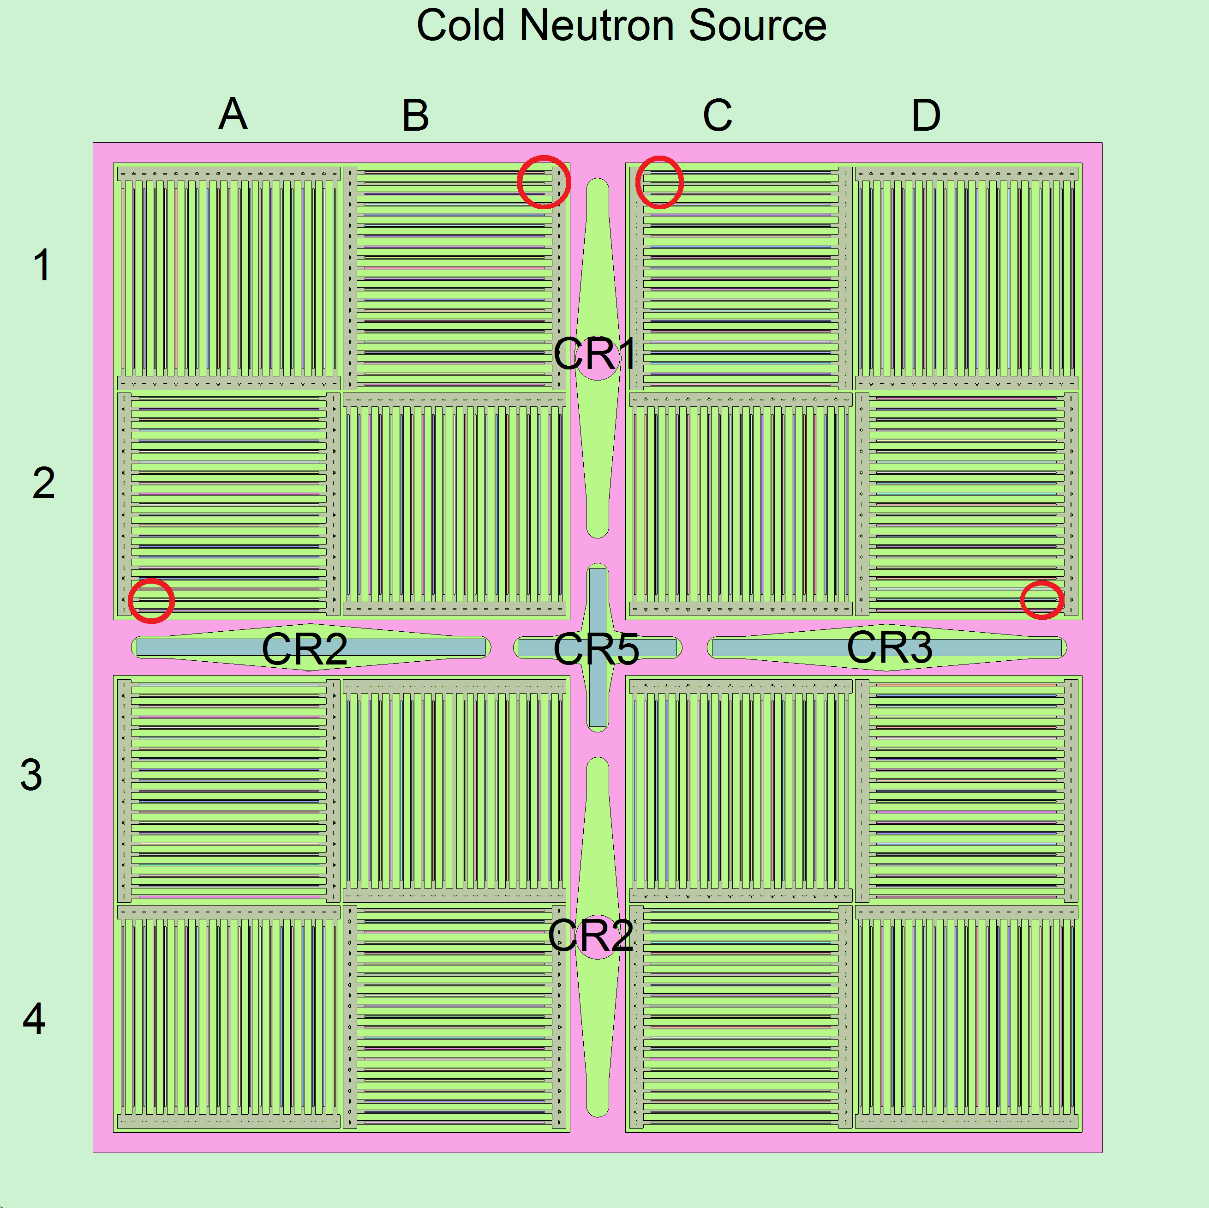

FIGURE 5. Positions selected to compare flux, identified by red circles.

The obtained values are presented in Figure 6 and compared with the measured ones and the results from CONDOR-CITVAP [5]. The calculated values for Serpent include the statistical error (reported as 3σ), while for measured values the Power error (±6kW) was included as an experimental error on flux measurement.

- B1 position
b) C1 position
c) A2 position
d) D2 position

FIGURE 6. Thermal flux Calculated and measured values for low Power (36kW). Error bars represent the statistical errors (3σ) for Serpent Calculations and Power uncertainty for measured values.

It can be seen that a fairly good agreement is encountered with measured values, where the differences with experimental data are below 5/8% in average and inside the Power uncertainty.

3.3 Kinetic Parameters

For the OPAL Commissioning, the kinetic parameters were calculated with CITVAP and MCNP for the full core configuration, namely 16 FA [6]. Accordingly, for the 74 critical cases presented in Section 3.1 the kinetic parameters were calculated with Serpent 2, using the Iterated Fission Probability (IFP) approach [10] included in Serpent 2 from version 15. Thus, the results for 16 FA are compared with those reported using CONDOR-CITVAP and MCNP [6] in Table II.

TABLE II: Comparison of results between kinetic parameters for 16FA core calculated in Serpent 2, CONDOR-CITVAP and MCNP models. All Serpent cases have statistical errors < 1%.

Kinetic Parameter | CONDOR-CITVAP [8] | MCNP [8] | Serpent 2 (IFP)
βeff [pcm] | 768 | 770 | 766
Λ [μs] | 171 | 172 | 177
α [1/s] | 45 | 45 | 44

It can be seen from Table II that a good consistency is encountered between all models and codes.
Unfortunately, due to the fact that the measurements of kinetic parameters require high absolute detector efficiency, during the Commissioning of the OPAL reactor, the neutron decay constant was measured for a 15FA core configuration, replacing one central FA by a Fission Chamber (FC) detector [6]. Thus the only available measured value is the α parameter, which was obtained using the Feynman-α method for this 15FA configuration.
Accordingly, the same 15FA configuration was modeled in Serpent 2, presented in Figure 7, where the near Critical CR position was used [6].

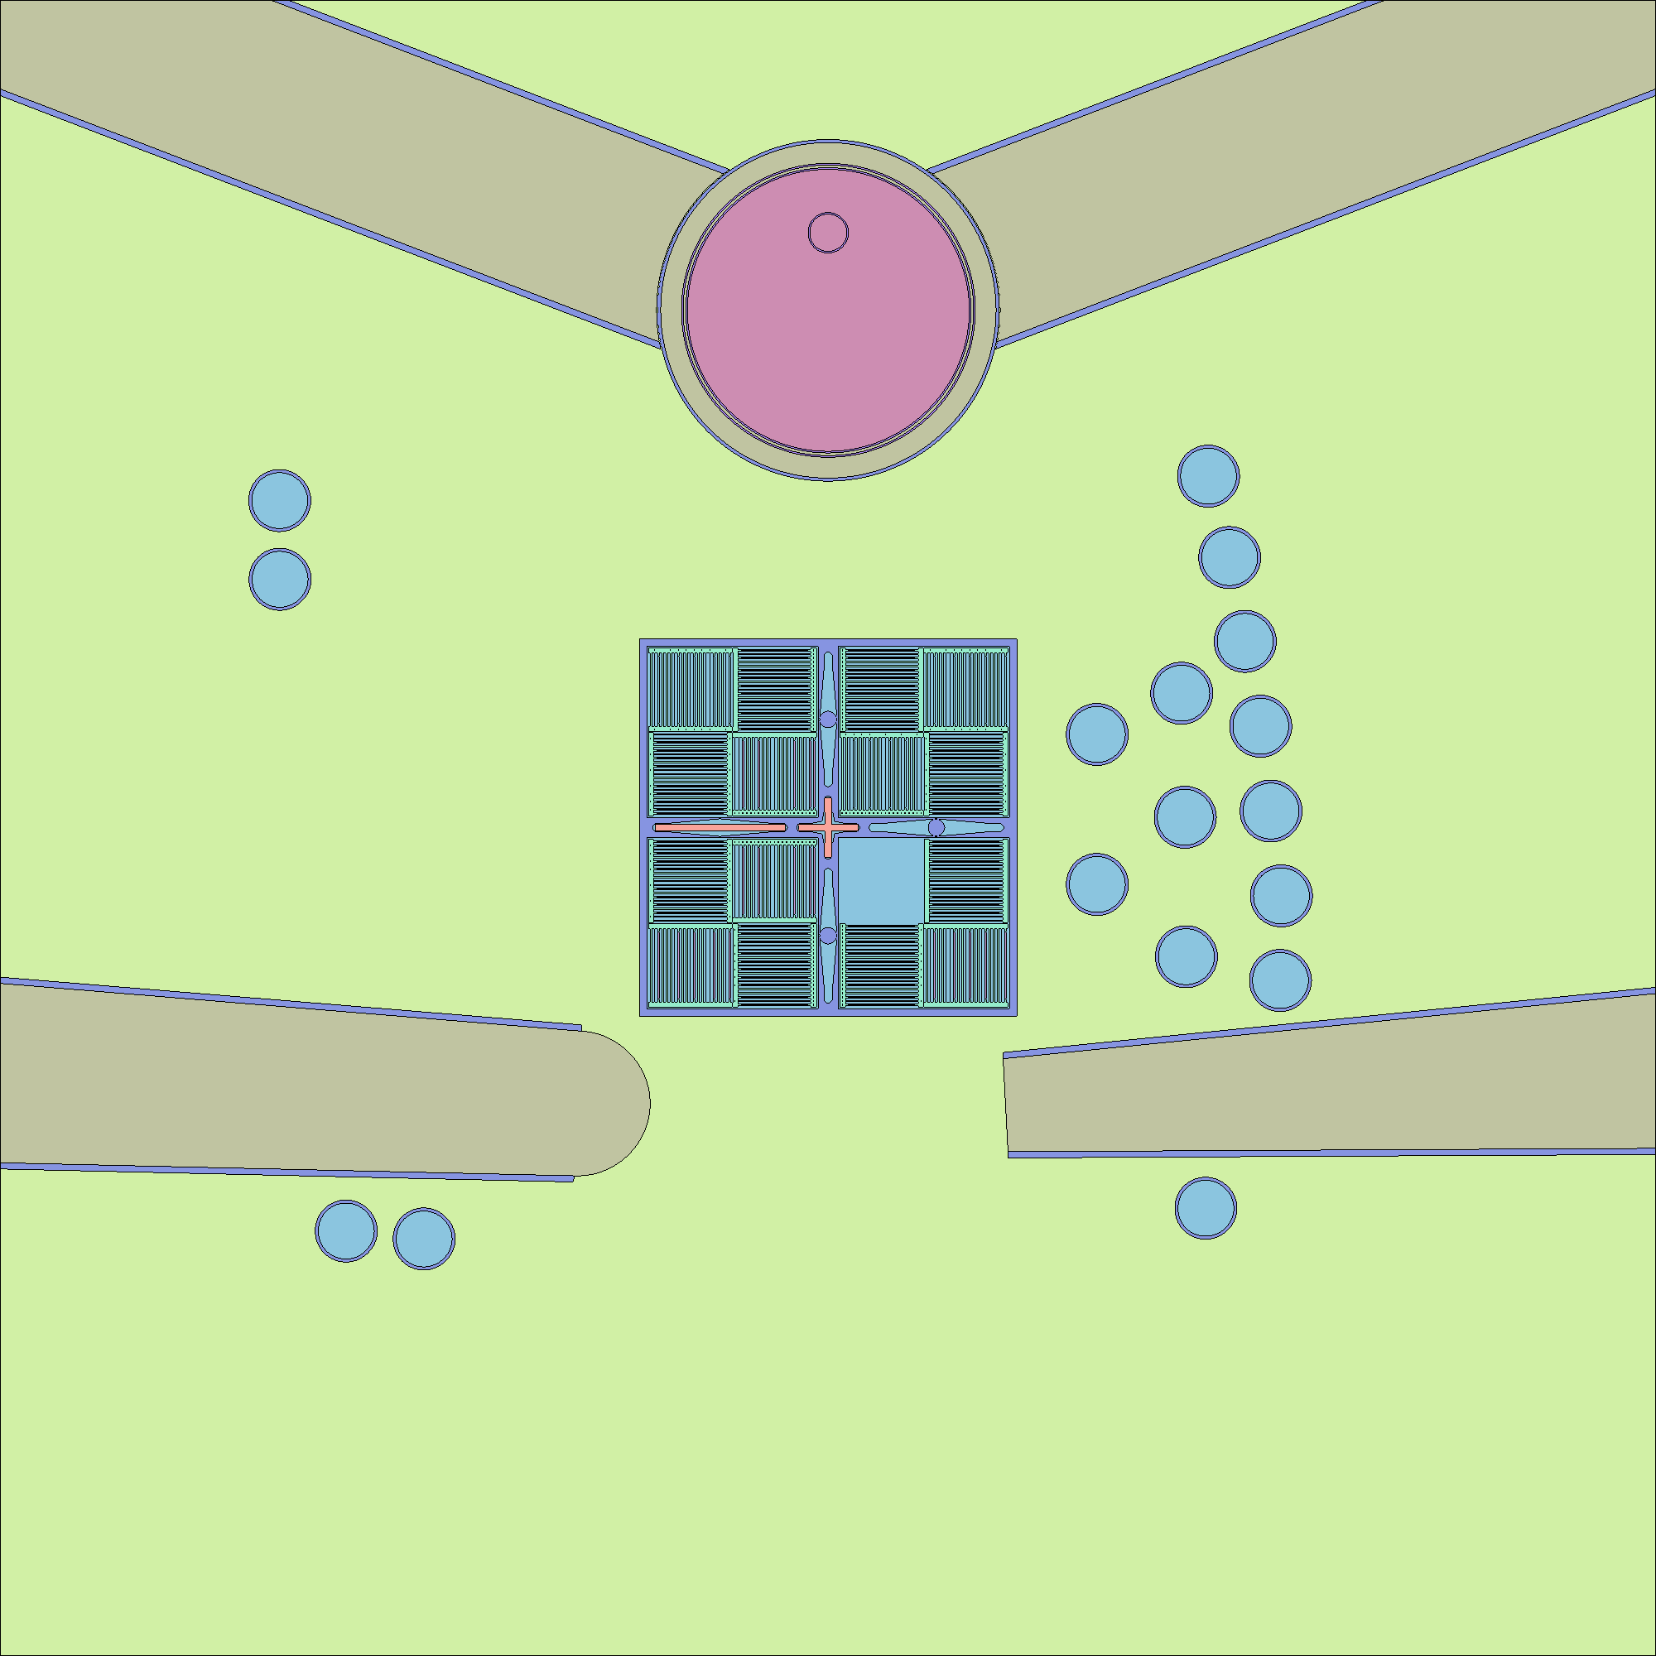
FIGURE 7. Serpent 2 Model with 15FA, used for α parameter measurement in OPAL commissioning.

For this 15FA core in Serpent 2, the α parameter was obtained using IFP and compared with experimental and calculated values [6], as it is presented in Table III.

TABLE III: Comparison of Serpent 2 calculated and measured values for α parameter. Serpent 2 case have a statistical error < 1%.

Kinetic Parameter | Measurement [6] | Serpent 2 (IFP) | MCNP [6]
α [1/s] | 38.1 | 38.8 | 37.2

It can be seen from Table III that a good consistency is encountered between Serpent 2 calculations, MCNP calculations and the measured values.

3.4 Critical positions with core burnup

The Critical positions for the First Core operating at full power for the Cycle 007, where a fresh new First Core was introduced, were analyzed. During this Cycle several Power variations took place, thus Xenon transients were significant for the first ∼16 Full Power Days (FPD). To model this scenario in Serpent 2 models, the following approach was used:
- FPD was considered instead of Real days to evolve the core. To do this, the power vs real days curve was integrated and a CR position vs FPD curve was obtained.
- The burnup was modeled in Serpent 2 at Full Power every 1 FPD up to 26 FPD and a restart case was saved, where the meat and Cd wires compositions for FA were dumped.
- The burnup file was uploaded in a further Serpent 2 model where the CR positions were set to the Cycle007 Operation (First Core) using the curve obtained in a).
- Critical CR positions were calculated for those FPD were Xe transients are negligible (>16FPD).
The obtained results are presented in Figure 8, where the statistical error is included (3σ).

FIGURE 8. Serpent 2 Results for full core burnup calculations - Critical positions for First Core. Error bars represent the statistical errors (3σ) for Serpent Calculations.

As it can be seen the calculated values have a good agreement with measured positions where the average value is around -500 pcm, similar to results presented in Section 3.1.

4. Conclusions

A full 3-D core model was developed in Serpent 2 v1.21 for the state of art - 20MWth OPAL Research Reactor. All main parameters measured during reactor commissioning were calculated, including 74 Cold-fresh critical positions from CR calibration, in-core Thermal Neutron Flux profiles and kinetic parameters. Good agreement was encountered when the results obtained with Serpent 2 models were compared with experimental data and with results from INVAP deterministic Calculation line and independent MCNP models ([5] and [6]).
Additionally, full 3-D burn calculations were performed, calculating critical positions at full Reactor Power, observing a fairly good agreement with experimental data.
Finally, some issues related to Serpent 2 modeling and its RAM memory and computational effort requirements have been discussed. Regarding the obtained results, it is shown that full core 3-D calculations including burnup for a state of art Research Reactor is nowadays feasible with actual Serpent 2 modeling capabilities.

5. Future Works

Encouraged by the results from last sections, it is intended to extend the burnup calculations to other cycles, i.e. perform Fuel Management from first 4/5 Cycles in order to deeply study the full 3-D core burnup behavior. To do this some additional material management scheme will have to be included in Serpent 2 models in order to be able to model the refueling scheme.
Additionally, comparisons to experimental data are intended to be extended to the reported neutron fluxes in bulk irradiation facilities, placed in the Reflector Vessel for several burnup steps and CR critical positions.

6. References

- Jaakko Leppänen, Maria Pusa, Tuomas Viitanen, Ville Valtavirta, Toni Kaltiaisenaho, VTT Technical Research Centre of Finland, "The Serpent Monte Carlo code: Status, development and applications in 2013", Annals of Nuclear Energy (2014).
- D. Ferraro, E. Villarino, "OPAL Reactor Calculations using the Monte Carlo Code Serpent", Proceedings of the 4th International Symposium on Material Testing Reactors December 5-9, 2011, Oarai, Japan.
- E. Villarino, I. Mochi, I, P. Sartorio; “INVAP Neutronic Calculation Line”, Mecánica Computacional Vol. XXXIII, pages from 3217 to 3226; Asociación Argentina de Mecánica Computacional.
- Sungjoong Shane Kim, (ANSTO, Australia) “The OPAL (Open Pool Australian Light-Water) Reactor in Australia”, Nuclear Engineering and Technology, Vol.38 NO.5.
- E. Villarino and D. Hergenreder (INVAP SE, Argentina ), G. Braoudakis and T. Ersez (ANSTO, Australia) "Calculation of the core parameters measured during the commissioning of the OPAL reactor", PHYSOR 2010 – Advances in Reactor Physics to Power the Nuclear Renaissance - Pittsburgh, Pennsylvania, USA, May 9-14, 2010.
- D. Hergenreder, C. Lecot and E. Villarino, "Kinetic Parameters calculation and measurements during the OPAL Commissioning " 11th International Topical Meeting Research Reactor Fuel Management (RRFM) and Meeting of the International Group on Reactor Research (IGORR),Lyon, France 11– 15 March 2007.
- D. Ferraro, E. Cuello and F. Sardella, INVAP S.E, “Low power Research Reactor Calculations Using Deterministic and Stochastical Transport Codes”, 6th International Symposium on Material Testing Reactors Bariloche, Río Negro, Argentina – October 28-31, 2013.
- Jaakko Leppänen, VTT Technical Research Centre of Finland, "Two practical methods for unionized energy grid construction in continuous-energy Monte Carlo neutron transport calculation", Annals of Nuclear Energy 36 (2009) 878–885.
- Briesmeister, J. F., Ed., MCNP - A General Monte Carlo N-Particle Transport Code, Version 4C, LA13709-M, Los Alamos National Laboratory (April 2000).
- Jaakko Leppanen (VTT Technical Research Centre of Finland), Manuele Aufiero (Politecnico di Milano, Department of Energy, CeSNEF), Emil Fridman, Reuven Rachamin (Helmholtz-Zentrum Dresden-Rossendorf), Steven van der Marck (Nuclear Research and Consultancy Group NRG), “Calculation of effective point kinetics parameters in the Serpent 2 Monte Carlo code”, Annals of Nuclear Energy 65 (2014) 272–279.

